

MSc Dissertation Report
"Enter the Title of your Dissertation Project here"

A dissertation submitted in partial fulfilment of the requirements of Sheffield Hallam University for the degree of Master of Science in [ENTER COURSE TITLE]

Student Name
Student ID
Supervisor
Date of Submission

This dissertation does NOT contain confidential material and thus can be made available to staff and students via the library.

ACKNOWLEDGEMENTS

I would like to express my deepest gratitude to my supervisor, Name, for his invaluable guidance, encouragement, and unwavering support throughout this research journey. His insightful feedback and thoughtful suggestions have greatly enhanced the quality of this work. His patience and willingness to help me refine my ideas have been truly inspiring. I am deeply appreciative of the time and effort he invested in helping me navigate the challenges of this study. Without his mentorship, this thesis would not have been possible, and for that, I am immensely grateful.

PUBLICATION PROCEDURE FORM

Research Skills and Dissertation Module (55-706556)

I, Name, confirm that I understand will comply with the Publication Procedure outlined in the Module Handbook and the Blackboard Site.
 | Signature | Date
Student:
Supervisor:

ABSTRACT

This study provides a holistic evaluation of an AI-driven cryptocurrency forecasting application, addressing a critical gap in the existing literature by bridging the disconnect between a model's technical performance and a user's perception of its value. The research employed a two-part methodology. First, a quantitative analysis evaluated the forecasting performance of three distinct time series models: ARIMA, Prophet, and LSTM on Bitcoin (BTC), Ethereum (ETH), and Binance Coin (BNB). Second, a qualitative survey of ten expert users with backgrounds in data science and cryptocurrency trading was conducted to gather feedback on usability, trustworthiness, and overall user experience.
The findings reveal a significant divergence in performance, with the LSTM model consistently outperforming its counterparts. This is attributed to its superior capacity to capture the non-linear, volatile patterns of financial data. The qualitative data reinforced this finding, as participants found the LSTM's predictions more "realistic" and "trustworthy" compared to the simplistic forecasts from ARIMA and Prophet. While the application's interface was praised for its high usability (4.4/5), its low perceived accuracy (2.7/5) created a credibility gap, highlighting that a clean design cannot compensate for a lack of perceived reliability. The study also found value in innovative features like sentiment integration.
In conclusion, the research demonstrates that the effective development of AI forecasting tools requires a seamless integration of technical excellence and a user-centric design philosophy. The findings provide a clear roadmap for developers, recommending advanced models like LSTM, expanded asset scope, and transparency-building features such as backtesting to foster greater user trust and accelerate market adoption.

Table of Contents
ACKNOWLEDGEMENTS 2
PUBLICATION PROCEDURE FORM 3
ABSTRACT 4
1 Introduction 4
1.1 Problem Statement 5
1.2 Research Aims and Objectives 5
1.3 Research Questions 6
1.4 Significance of the Study 6
1.5 Dissertation Structure 7
2 Literature Review 8
2.1 Introduction 8
2.2 Analysis & Review 9
2.2.1 Evolution of Cryptocurrency Price Prediction Techniques 9
2.2.2 Early Statistical Approaches (2010–2015) 9
2.2.3 Adaptation of Time Series Models (2015–2017) 10
2.2.4 Emergence of Machine Learning (2017–2019) 10
2.2.5 Rise of Deep Learning Models (2019–Present) 10
2.2.6 Integration of Hybrid and Sentiment-Based Models (2020–Present) 11
2.2.7 Focus on Transparency and Risk Management (2022–Present) 12
2.3 Comparative Analysis of Key Research Studies 12
2.3.1 Study 1: Comparative Forecasting Models (Shamshad et al., 2023) 13
2.3.2 Study 2: Hybrid Time Series and Machine Learning Models (Qureshi et al., 2024) 14
2.3.3 Study 3: Recurrent Neural Networks for Crypto Forecasting (Hamayel & Owda, 2021) 15
2.3.4 Study 4: Integrating AR Models with LSTM (Wu et al., 2018) 15
2.3.5 Study 5: Error Modelling with Deep Learning (Fallah et al., 2024) 16
2.3.6 Synthesis of Findings 17
2.4 Key Limitations Identified in Past Research 18
2.5 Conclusion 20
3 Research Methodology 21
3.1 Research Philosophy and Approach 21
3.2 Research Design and Methods 22
3.3 Sampling Strategy 24
3.4 Development of Data Collection Instrument 25
3.5 Data Analysis Method 26
3.6 Ethical Considerations 28
3.7 Research Limitations and Challenges 29
3.8 Summary 30
4 Application Details 30
4.1 Introduction 30
4.2 Technology Stack and Tools 31
4.3 Data Preprocessing and Integration 33
4.4 Model Implementation 34
4.5 Application Interface 37
4.6 Summary 38
5 Model Evaluation 38
5.1 ARIMA & ARIMAX Results 39
5.2 Prophet & Prophet with Sentiment Results 41
5.3 LSTM (Long Short-Term Memory) Results 43
5.4 Combined Model and Metric Comparisons 45
6 Results & Discussion 45
6.1 Theme 1: Superior Performance of the LSTM Model and the Inadequacy of Traditional Models 46
6.2 Theme 2: High Usability and the Importance of a Clean, Intuitive Design 48
6.3 Theme 3: The Novelty and Value of Sentiment Integration 49
6.4 Theme 4: Limitations in Scope and Performance 50
6.5 Summary 51
7 Conclusion & Recommendations 52
7.1 Conclusion 52
7.2 Recommendations 53
7.2.1 Enhance Model Performance by Adopting a Hybrid-Model Approach 54
7.2.2 Expand the Scope of Assets and Data 54
7.2.3 Implement Features that Foster User Trust and Transparency 54
7.2.4 Continuously Innovate on the User-Centric Design 55
8 References 56
9 Appendix 60
9.1 Application Details 60
9.1.1 Technology Stack and Tools 60
9.1.2 Data Preprocessing and Integration 61
9.1.3 Model Implementation 68
9.1.4 Application Interface 90
9.1.5 Summary 91
9.2 Model Evaluation 92
9.2.1 Evaluation Metric Interpretation for Crypto Currency Forecasting 92
9.2.2 ARIMA & ARIMAX Results 93
9.2.3 Prophet & Prophet with Sentiment 101
9.2.4 LSTM (Long Short-Term Memory) Results 111
9.2.5 Combined Model Comparison on each currency: 123
9.2.6 Source for all plots: 129
9.2.7 Metrics Comparison Table 136

Introduction
The digital age has ushered in an unprecedented era of data abundance, transforming traditional industries and giving rise to new, volatile markets. At the forefront of this revolution are cryptocurrencies, a decentralized asset class that has captivated investors and analysts with its promise of high returns and disruptive potential. Unlike conventional financial markets, which operate on established principles and historical precedents, the cryptocurrency market is characterized by extreme volatility, unpredictability, and a lack of regulation, making it a formidable challenge for even the most experienced forecasters. Simultaneously, the rapid evolution of artificial intelligence (AI) and machine learning (ML) has provided sophisticated tools capable of processing vast datasets and identifying complex, non-linear patterns that defy traditional statistical methods. The convergence of these two phenomena—the chaotic cryptocurrency market and the advanced capabilities of AI—presents a compelling and timely subject of inquiry.
Existing literature predominantly focuses on the technical aspects of AI models, evaluating their predictive accuracy through statistical metrics like Root Mean Squared Error (RMSE) and R-squared values. While these quantitative analyses are crucial, they offer an incomplete picture. The real-world application of any forecasting tool is not solely determined by its statistical precision but is fundamentally influenced by human factors: the user’s perception of its utility, their trust in its outputs, and their comfort with its interface. For a tool to be successfully adopted, particularly in a high-stakes environment like financial trading, it must be perceived as reliable, transparent, and trustworthy by its intended audience. A tool that is technically accurate but not trusted will be ignored, while one that is trusted but ultimately inaccurate can lead to significant losses. This dissertation aims to bridge this critical gap, providing a holistic evaluation that integrates both technical performance metrics and the nuanced, qualitative experiences of expert users.

Problem Statement
The central problem addressed by this research is the disconnect between the technical performance of AI forecasting models and the human perception of their value in the cryptocurrency market. While a growing body of academic work has benchmarked various AI models on financial time series data, few studies have conducted a mixed-methods analysis that directly correlates these technical findings with the lived experiences and perceptions of expert users. Specifically, there is a lack of research that investigates how users with prior experience in both data science and cryptocurrency trading evaluate an application’s design, interpret its forecasts, and ultimately decide whether to trust the AI's recommendations. This oversight is significant because a user's decision to adopt or reject an AI-driven tool is based on a complex cognitive and emotional assessment that extends far beyond a simple comparison of error rates. The high volatility and speculative nature of the cryptocurrency market further amplify this problem, as users are more likely to be skeptical of a "black box" solution and demand greater transparency and control. This dissertation seeks to fill this research gap by providing a comprehensive, user-centric evaluation framework for AI forecasting applications.

Research Aims and Objectives
The primary aim of this dissertation is to provide a comprehensive evaluation of an AI-driven cryptocurrency forecasting application from both a technical and a user-centric perspective. To achieve this, the following specific objectives have been formulated:
- Objective 1: To quantitatively evaluate and compare the forecasting performance of three distinct time series models—ARIMA, Prophet, and LSTM—on a dataset of major cryptocurrency prices, specifically Bitcoin (BTC), Ethereum (ETH), and Binance Coin (BNB). This objective will determine which model is most statistically effective at predicting price movements in a volatile market.
- Objective 2: To qualitatively explore the perceptions of expert users regarding the application's usability, design, and overall user experience. This includes assessing the clarity of the interface, the ease of navigation, and the perceived professionalism of the tool.
- Objective 3: To investigate the factors that influence user trust in an AI forecasting application. This objective will examine how the perceived accuracy, transparency, and consistency of the models' outputs impact a user's willingness to rely on the tool for decision-making.
- Objective 4: To identify the key strengths and limitations of the application from a user’s perspective and to gather actionable recommendations for future development. This will involve an analysis of user-suggested features and improvements that would enhance the application's utility and value.

Research Questions
Based on the objectives outlined above, this dissertation will seek to answer the following core research questions:
- What is the comparative forecasting performance of the ARIMA, Prophet, and LSTM models on cryptocurrency price data, both with and without the inclusion of news sentiment as an exogenous variable?
- How do expert users, with experience in both data science and cryptocurrency, perceive the usability, trustworthiness, and overall value of the AI forecasting application?
- What specific design and functionality features, such as data visualization and model interpretability, most significantly impact an expert user’s trust in an AI forecasting tool?
- Based on user feedback, what are the primary limitations of the current application, and what are the most critical recommendations for future development?

Significance of the Study
This research holds significant value for both academic and professional communities. From an academic standpoint, it contributes to the growing body of literature on human-AI interaction in high-stakes environments. By employing a mixed-methods approach, it offers a more complete understanding of how complex technologies are not only used but also perceived and trusted by their target audience. This is particularly relevant in the context of financial technology (FinTech), where user confidence is paramount.
For developers and designers, the findings provide a clear, user-validated roadmap for creating more effective and user-friendly AI tools. The study goes beyond generic design principles to provide concrete, context-specific insights on what features—such as sentiment integration, backtesting functionality, and model transparency—are most valued by expert users in the cryptocurrency space. The findings on the superior performance of LSTM models also provide a technical benchmark, guiding future development toward more suitable AI architectures. In essence, this dissertation transforms theoretical knowledge into practical, actionable recommendations that can inform the design of the next generation of AI-driven financial applications, ultimately accelerating their adoption and success in the marketplace.

Dissertation Structure
This dissertation is organized into seven chapters.
- Chapter 1: Introduction provides the background, problem statement, research questions, and the significance of the study.
- Chapter 2: Literature Review critically examines existing research on AI in financial forecasting, time series analysis models, and the psychology of user trust and human-computer interaction in FinTech.
- Chapter 3: Methodology details the research design, including the mixed-methods approach, data collection procedures, and data analysis techniques.
- Chapter 4: Application details describes the development and technical specifications of the AI forecasting application.
- Chapter 5: Model Evaluation (Alpha Testing) presents the quantitative findings on the performance of the models, including the comparative metrics of ARIMA, Prophet, and LSTM.
- Chapter 6: Results and Discussion (Beta Testing) presents the qualitative findings from the user surveys and interprets them in the context of the literature and the research questions.
- Chapter 7: Conclusion and Recommendation summarizes the study's key findings, outlines its limitations, and provides a clear set of recommendations for future research and development.

Literature Review

Introduction
Cryptocurrency, as a decentralized virtual currency, has revolutionized finance through blockchain technology, offering transparency and autonomy over traditional fiat systems. Cryptocurrencies like Bitcoin (BTC), Ethereum (ETH), and Binance Coin (BNB) exhibit extreme price volatility driven by speculative trading, macroeconomic uncertainty, and minimal regulation. Traditional statistical models, such as ARIMA and GARCH, often fall short in capturing the nonlinear and nonstationary patterns of crypto markets. While forecasting techniques used in stock markets show promise, studies reveal that these methods struggle with the complex dynamics of digital assets. This research addresses these challenges by evaluating advanced models—ARIMA, Prophet, and Long Short-Term Memory (LSTM) networks—to predict BTC, ETH, and BNB prices. LSTM is particularly adept at capturing temporal dependencies, while Prophet effectively models seasonality and trend shifts. Additionally, the study integrates market sentiment from news articles to enhance prediction accuracy by accounting for external influences. The key contributions include (1) optimizing LSTM performance, (2) introducing AI-statistical hybrid models to better handle volatility, and (3) incorporating sentiment analysis to reflect market mood. By comparing these models, the research offers a robust, data-driven forecasting framework that supports strategic investment decisions in the dynamic cryptocurrency ecosystem.

Analysis & Review

Evolution of Cryptocurrency Price Prediction Techniques
Cryptocurrency price prediction has evolved significantly over the past decade due to the highly volatile nature of the digital asset market and the absence of strict regulatory frameworks. Predicting cryptocurrency prices is more complex than forecasting traditional assets due to their non-stationary behaviour, sudden market shocks, and speculative nature. The task requires advanced modelling strategies capable of capturing intricate relationships between time-dependent variables and exogenous factors such as public sentiment, trading volume, and market news. The research and technological development in this field has undergone several stages—from early statistical models to modern artificial intelligence (AI) and hybrid approaches.

Early Statistical Approaches (2010–2015)
The earliest approaches to financial forecasting in the cryptocurrency domain relied heavily on time series statistical models such as the Auto-Regressive Integrated Moving Average (ARIMA) and the Generalized Autoregressive Conditional Heteroskedasticity (GARCH) model. ARIMA, developed by Box et al. (2015), is based on assumptions of linearity and stationarity, which made it suitable for relatively stable financial markets. GARCH (Bollerslev, 1986) was introduced to model time-varying volatility in asset returns and was commonly applied to forecast market risk. However, these models struggled with the inherent irregularities in cryptocurrency prices, which are influenced not just by historical data but also by sudden news, social media activity, and investor sentiment. As a result, their predictive performance in crypto markets remained limited (Qureshi et al., 2024).
In this phase, the data used was relatively sparse, as blockchain technology was still emerging and historical records were limited. Basic technical analysis indicators such as moving averages, momentum oscillators, and Bollinger Bands were used alongside statistical models, but the results lacked robustness in forecasting large and abrupt market shifts (Ciaian et al., 2018).

Adaptation of Time Series Models (2015–2017)
With an increase in historical price data availability and a growing interest in technical indicators, researchers began experimenting with extensions of traditional models. Variants such as ARIMAX (which includes exogenous variables) and improved GARCH models were developed to enhance performance. These models incorporated features like trading volume, volatility clusters, and lagged predictors to improve forecasting accuracy. For example, Doe and Smith (2022) proposed ARIMA-GARCH hybrids that used historical returns for modelling long-term trends and volatility simultaneously.
Although these adaptations provided modest improvements, they still failed to handle the highly nonlinear and multidimensional dynamics of cryptocurrency price changes. Moreover, such models lacked the ability to incorporate external and unstructured data such as news or social media sentiment, which play a major role in digital asset valuation.

Emergence of Machine Learning (2017–2019)
A major breakthrough came with the introduction of machine learning (ML) techniques into cryptocurrency forecasting. ML models could handle multidimensional datasets, identify complex patterns, and generalize well over unseen data. Among the earliest and most widely used algorithms were Support Vector Machines (SVMs) and Random Forests. SVM, introduced by Vapnik (1998), provided a powerful classification tool for identifying bullish and bearish patterns in cryptocurrency markets. Random Forests (Breiman, 2001), an ensemble learning method, were used to model feature importance and build robust predictors that handled missing data and outliers more effectively.
Machine learning allowed researchers to integrate various data sources, including sentiment metrics, technical indicators, and macroeconomic variables, into the modelling framework. The ability to learn nonlinear relationships between input variables and price outputs was a substantial advantage over linear models. However, most machine learning models required extensive tuning and still lacked the temporal memory necessary to capture sequential patterns in price data, leading to the rise of deep learning models.

Rise of Deep Learning Models (2019–Present)
The next evolution in crypto forecasting came with deep learning methods, particularly Recurrent Neural Networks (RNNs) and Long Short-Term Memory (LSTM) networks. Introduced by Hochreiter and Schmidhuber (1997), LSTM models were specifically designed to learn long-term dependencies in time series data. They outperformed traditional ML algorithms in tasks involving sequential data, such as cryptocurrency prices, by maintaining memory of prior states and dynamically adjusting weights based on error gradients.
The application of LSTM to crypto markets proved to be transformative. Wu et al. (2018) demonstrated that LSTM models, when fine-tuned and provided with large datasets, could significantly reduce prediction errors. Moreover, enhancements like Gated Recurrent Units (GRUs) and Bidirectional LSTM (biLSTM) further improved performance and training efficiency (Hamayel & Owda, 2021).
At the same time, Convolutional Neural Networks (CNNs), although traditionally used in image processing, were adapted to identify localized patterns in time series data. Researchers began using hybrid CNN-LSTM models to extract both spatial and temporal features from crypto price charts and sentiment trends.

Integration of Hybrid and Sentiment-Based Models (2020–Present)
In the current phase of development, hybrid models that combine the strengths of statistical, machine learning, and deep learning methods have become more prominent. These models often include inputs from various sources: historical prices, technical indicators, blockchain metrics, news headlines, and even tweets. For instance, Qureshi et al. (2024) proposed a hybrid model that combines ML algorithms with time series predictors for Bitcoin forecasting, showing superior performance over individual models.
Sentiment analysis has also become a key area of focus. Text-based data from news articles, Reddit forums, and Twitter are analysed using Natural Language Processing (NLP) tools like VADER, TextBlob, and Flair to generate polarity scores that reflect market sentiment. Tsantekidis et al. (2017) demonstrated that integrating sentiment with price data improves short-term predictive power, especially during high volatility periods.
Explainable AI (XAI) has emerged in response to the “black-box” criticism of deep learning models. Fior et al. (2022) emphasize the importance of transparency and interpretability in AI models, especially in high-stakes applications like financial forecasting. Techniques such as SHAP values and LIME are now being used to explain the predictions made by deep learning models, thereby improving trust and adoption among financial analysts.

Focus on Transparency and Risk Management (2022–Present)
More recent developments have emphasized model transparency, interpretability, and risk assessment. As cryptocurrencies gain mainstream adoption, financial institutions demand not just high prediction accuracy, but also explainable and auditable models. Researchers have begun incorporating risk metrics such as Value-at-Risk (VaR) and Expected Shortfall into their prediction frameworks to offer comprehensive tools for portfolio management.
Transformer-based models, which revolutionized NLP, are now being explored for time series forecasting. Their self-attention mechanisms enable the model to focus on relevant time steps, offering improved performance over traditional RNN-based models in capturing long-range dependencies.
The trajectory of research in this area suggests a continuous blending of methodologies. From the initial reliance on purely statistical frameworks to the integration of deep learning and sentiment analysis, the field has matured into a complex, multidisciplinary space. The progression is outlined in Table 1, summarizing the key technological and methodological milestones in cryptocurrency forecasting.
In short, the evolution of cryptocurrency forecasting techniques has mirrored advancements in computing, data accessibility, and financial modelling. While early models were limited by linear assumptions and data scarcity, modern hybrid and AI-based approaches offer dynamic, real-time, and interpretable predictions. However, challenges remain in optimizing these models for real-time trading, adapting to sudden market shocks, and maintaining transparency—issues that continue to guide ongoing research in this dynamic field.

Comparative Analysis of Key Research Studies
The predictive modelling of cryptocurrency price fluctuations is a critical area of research due to the high volatility and decentralized nature of digital assets. This section conducts a comparative analysis of five key research studies that have explored various machine learning (ML), deep learning (DL), statistical, and hybrid forecasting approaches to cryptocurrency price prediction. The goal is to identify the relative strengths, limitations, and emerging trends in predictive modelling techniques applied to cryptocurrencies such as Bitcoin (BTC), Ethereum (ETH), Binance Coin (BNB), Cardano (ADA), and Litecoin (LTC).

Study 1: Comparative Forecasting Models (Shamshad et al., 2023)
Shamshad et al. (2023) present an in-depth comparative analysis involving traditional statistical models and advanced deep learning architectures for predicting short-term price movements of three major cryptocurrencies: Cardano (ADA), Binance Coin (BNB), and Ethereum (ETH). The study evaluates six different forecasting algorithms, including Support Vector Regressor (SVR), Auto-Regressive Integrated Moving Average (ARIMA), Facebook Prophet, Unidirectional Long Short-Term Memory (LSTM), Bidirectional LSTM (BiLSTM), and Stacked LSTM. These models are used to generate 10-day ahead forecasts, thereby placing the study within the domain of short-term predictive analytics.
The evaluation metrics include Mean Absolute Error (MAE), Root Mean Squared Error (RMSE), and Mean Absolute Percentage Error (MAPE), offering a comprehensive framework for model performance assessment. Among the tested models, ARIMA demonstrated superior performance, particularly in terms of low error margins. For instance, in the case of Ethereum, ARIMA yielded a MAE of 72.2, RMSE of 88.54, and MAPE of 5.4%. For Binance Coin, the MAPE stood at an impressive 3%, while Cardano achieved an exceptionally low MAE of 0.016 and a MAPE of just 3%. These results highlight ARIMA’s effectiveness in short-term forecasting under relatively stable market conditions.
One of the notable contributions of this study is its model diversity, allowing a robust comparative evaluation of both traditional and DL-based methods. However, key limitations include the narrow forecast window (10 days), limited asset variety (three cryptocurrencies), and the absence of external feature integration such as sentiment or macroeconomic variables. While ARIMA performed well in this context, the authors acknowledge that its utility may diminish under conditions of high volatility or sudden market shocks. Therefore, the study concludes with a call for hybrid or ensemble models that can incorporate both historical trends and real-time external information for better long-term robustness.

Study 2: Hybrid Time Series and Machine Learning Models (Qureshi et al., 2024)
Qureshi et al. (2024) introduce a sophisticated hybrid modelling framework for predicting the USD price of Bitcoin using a combination of time series (TS) and machine learning (ML) approaches. The models examined include four TS methods—ARIMA, AutoRegressive (AR), Non-Parametric Autoregression (NPAR), and Simple Exponential Smoothing (SES)—along with four ML algorithms: Multi-layer Perceptron (MLP), Extreme Learning Machine (ELM), Neural Network AutoRegression (NNAR), and Extreme Gradient Boosting (XGBoost).
A hybrid model was created by averaging predictions from individual models, a strategy designed to leverage the strengths of both paradigms. Using 390 daily observations of BTC prices from September 2023 to September 2024, the study evaluates model performance using standard metrics such as RMSE, MAE, and MAPE.
The hybrid model consistently outperformed individual TS and ML models across all test cases. For example, the RMSE decreased from 184.29 (ARIMA) to 147.62 in the hybrid model. This performance gain illustrates the benefit of model ensemble strategies that combine different prediction perspectives.
Nevertheless, there are limitations in the study's hybrid methodology. The averaging technique used for model fusion is relatively simplistic and may not be optimal for complex non-linear interactions. Furthermore, the high correlation among constituent models may introduce redundancy, reducing the ensemble’s effectiveness. The study also focuses exclusively on Bitcoin, limiting the generalizability of the results. In addition, it does not incorporate external factors such as trading volume anomalies, investor sentiment, or macroeconomic signals—variables that could enhance prediction granularity. The authors suggest exploring weighted averaging or stacked ensembles in future research to address these concerns.

Study 3: Recurrent Neural Networks for Crypto Forecasting (Hamayel & Owda, 2021)
Hamayel and Owda (2021) explore the capabilities of Recurrent Neural Network (RNN) variants in forecasting the prices of Bitcoin, Ethereum, and Litecoin. Their study compares three RNN-based deep learning architectures: Gated Recurrent Unit (GRU), Long Short-Term Memory (LSTM), and Bidirectional LSTM (BiLSTM). These architectures are trained on historical price data and evaluated using MAPE as the sole performance metric.
Among the three models, the GRU network outperformed its counterparts. It achieved MAPE values of 0.2454% for Bitcoin, 0.8267% for Ethereum, and 0.2116% for Litecoin. The superior performance of GRU is attributed to its more efficient architecture that simplifies the gating mechanism, thereby reducing computational overhead and training time without sacrificing accuracy.
The key strength of this study lies in its head-to-head architectural comparison within the RNN family, offering insights into trade-offs between model complexity and performance. However, several drawbacks diminish the impact of the research. First, the exclusive use of MAPE overlooks other critical metrics such as RMSE and R², limiting the evaluation scope. Second, the study does not employ any external features such as sentiment data or trading indicators, which are increasingly considered essential in volatile financial environments. Finally, the study’s reliance on historical price data without considering the impact of market news, regulations, or investor behaviour constrains its applicability to real-world trading scenarios.

Study 4: Integrating AR Models with LSTM (Wu et al., 2018)
Wu et al. (2018) propose a novel forecasting framework that integrates a standard LSTM network with an AutoRegressive model of order 2 (AR (2)) to enhance Bitcoin price prediction accuracy. The study uses a relatively small dataset consisting of 208 daily price records from January 1, 2018, to July 28, 2018. The integrated model is tested against a conventional LSTM, with performance evaluated using MAPE and RMSE.
The AR (2)-LSTM hybrid model achieved a MAPE of 2.553, marginally outperforming the standard LSTM model, which had a MAPE of 2.701. The authors argue that their hybrid model addresses one of the significant challenges in LSTM modelling: the selection of relevant input features. By incorporating autoregressive behaviour directly, the model benefits from both the temporal memory of LSTM and the short-term dependencies captured by AR models.
Despite its innovation, the study has several limitations. Its small dataset raises concern about model generalizability and overfitting. The exclusive focus on Bitcoin also reduces its broader relevance to altcoins. Moreover, the model does not consider non-price inputs like trading volume, sentiment scores, or regulatory news, which are known to affect cryptocurrency prices. Computational resource demands for training LSTM models are also not discussed, leaving questions about the model’s scalability in high-frequency or multi-asset trading environments.

Study 5: Error Modelling with Deep Learning (Fallah et al., 2024)
Fallah et al. (2024) introduce a unique deep learning-based approach that incorporates error modelling using Vector AutoRegression (VAR) in combination with LSTM networks. The primary objective is to forecast prices of three cryptocurrencies—Bitcoin, Ethereum, and Binance Coin—by accounting for error propagation in the model structure. The dataset spans four years, from October 31, 2018, to October 30, 2022, offering a long-term perspective on price prediction.
Results from the combined VAR-LSTM model demonstrate improved accuracy across all three cryptocurrencies, with Bitcoin benefiting the most from the error correction mechanism. This suggests that modelling residuals can help mitigate overfitting and improve generalizability, particularly in volatile markets.
This research contributes meaningfully to the field by introducing an error-aware framework and extending predictive horizons. However, its limitations must be noted. First, the study has not been peer-reviewed, limiting the reliability of its claims. Second, it overlooks qualitative data such as sentiment and geopolitical events, which are critical in market shifts. Third, like other studies, it fails to address the resource intensity of deep learning models—a key concern for real-time applications.

Synthesis of Findings
A comprehensive analysis of the selected five studies reveals several key themes and insights into the evolution and effectiveness of cryptocurrency price prediction models. These studies collectively demonstrate that while a diverse range of forecasting approaches exists—including statistical models, machine learning (ML), deep learning (DL), and hybrid systems—each has its specific advantages and limitations depending on market conditions, asset type, and forecast horizon.
One of the most consistent findings across studies is the continued relevance of traditional statistical models such as ARIMA, particularly in short-term, stable forecasting scenarios. For instance, Shamshad et al. (2023) show that ARIMA outperforms several advanced models in predicting 10-day price movements of ADA, BNB, and ETH. Its strengths lie in simplicity, transparency, and computational efficiency. However, ARIMA’s predictive capacity diminishes significantly in the face of market shocks or during periods of high volatility. It is also limited in its ability to capture non-linear patterns and complex temporal dependencies, making it less effective for long-term or real-time prediction tasks.
In contrast, deep learning models such as LSTM, GRU, and BiLSTM have demonstrated superior performance under dynamic market conditions. Studies like those by Hamayel and Owda (2021) and Wu et al. (2018) validate the adaptability of these architectures to non-linear and sequential patterns in price data. These models leverage long-term memory and gating mechanisms to handle time-series fluctuations effectively. However, they come with their own challenges: high computational demands, longer training times, and susceptibility to overfitting if not properly optimized. Furthermore, most DL-based studies still rely heavily on historical price data and do not incorporate exogenous features like investor sentiment or macroeconomic variables.
Hybrid models offer a promising middle ground. As seen in Qureshi et al. (2024) and Wu et al. (2018), the integration of traditional time series methods with machine learning or deep learning techniques enhances forecasting robustness. These models aim to leverage the statistical strengths of TS models while accommodating the learning flexibility of AI-based approaches. Hybrid frameworks tend to improve performance metrics such as RMSE and MAPE, suggesting a better fit for fluctuating and uncertain markets. Yet, a notable drawback remains: the method of combining models (e.g., simple averaging) often lacks sophistication, and many hybrid models do not fully account for multicollinearity or feature redundancy.
Another major theme identified is the inconsistency in evaluation criteria. Some studies, such as Hamayel and Owda (2021), rely exclusively on MAPE, while others employ a combination of MAE, RMSE, and R². This lack of standardization hinders cross-study comparability and weakens the establishment of a universal performance benchmark. Developing a unified evaluation protocol would allow more rigorous and objective assessment of model efficacy across different settings and datasets.
Finally, the issues of explainability and real-time adaptability remain largely underexplored. Most models prioritize accuracy but fail to provide interpretable outputs, which are crucial for institutional investors and regulatory compliance. The integration of Explainable AI (XAI) tools and transformer-based architectures, as suggested by Fior et al. (2022), represents a promising direction for enhancing transparency, trust, and actionable insights in future predictive systems.

Key Limitations Identified in Past Research
While substantial progress has been made in developing cryptocurrency price prediction models, significant limitations continue to hinder the accuracy, generalizability, and robustness of existing research. One of the foremost contributions in the field is the application of deep learning models—particularly Long Short-Term Memory (LSTM) networks—for identifying patterns in time-series data. As demonstrated by Hochreiter and Schmidhuber (1997) and reinforced by Wu et al. (2018), LSTM architectures can effectively capture sequential dependencies and non-linear dynamics in cryptocurrency markets. These capabilities have made LSTM a preferred model for handling volatile and non-stationary financial data, especially in high-frequency trading environments.
Moreover, the integration of statistical and artificial intelligence techniques has led to the development of hybrid models that address some of the shortcomings of standalone methods. For instance, Fallah et al. (2024) combined autoregressive models with LSTM to enhance forecast accuracy, particularly in markets experiencing significant noise and fluctuation. These hybrid approaches have shown promising results, especially when handling different cryptocurrencies under varying market regimes. However, despite these advances, several core limitations remain prevalent across the literature.
A major issue is the overwhelming reliance on historical price data, often at the expense of incorporating exogenous variables such as news sentiment, macroeconomic indicators, or market regulations. Studies like those by Hamayel and Owda (2021) and Shamshad et al. (2023) focused heavily on technical indicators derived from past price movements while neglecting external influences that can significantly affect cryptocurrency markets. The omission of sentiment analysis or real-time market news results in models that may be mathematically accurate but contextually incomplete. This absence of multidimensional inputs limits the predictive power of even the most advanced models.
Another recurring limitation is the narrow focus on individual cryptocurrencies. For instance, Wu et al. (2018) concentrated solely on Bitcoin, while Fallah et al. (2024) included Ethereum and Binance Coin in addition to Bitcoin. While such studies provide valuable insights into specific assets, their narrow scope restricts the generalizability of findings across the broader cryptocurrency landscape. Without applying models to a diverse set of digital currencies, researchers cannot confidently assess the robustness or adaptability of their forecasting methods.
Additionally, the inconsistency in evaluation metrics poses a significant challenge. Different studies use different performance indicators—such as Mean Absolute Percentage Error (MAPE), Root Mean Square Error (RMSE), and Mean Absolute Error (MAE)—which complicates cross-study comparisons and makes it difficult to establish a standardized benchmark for model performance. As noted in studies from Wu et al. (2018) to Fallah et al. (2024), this methodological divergence undermines efforts to rank models conclusively or replicate results.
Finally, many models operate under the assumption of rational market behaviour, failing to account for the psychological and behavioural dimensions of cryptocurrency trading. This oversight is critical given the high influence of herd behaviour, speculation, and panic selling in these markets (Kakinaka & Umeno, 2021). Ignoring these behavioural dynamics can lead to systematic biases and overconfidence in model predictions.
In sum, while the field of cryptocurrency price forecasting has advanced substantially, addressing these limitations is essential for future research seeking to build more accurate, interpretable, and resilient prediction models.

Conclusion
This study evaluated the performance and limitations of ARIMA, LSTM, and Prophet models for forecasting the prices of three major cryptocurrencies—Bitcoin (BTC), Ethereum (ETH), and Binance Coin (BNB). These assets were chosen due to their high volatility and dominance in the global crypto market. The research aimed to assess the accuracy and adaptability of traditional statistical models versus AI-driven approaches under varying market conditions.
Findings revealed that ARIMA is effective in capturing linear trends and performing short-term forecasts, particularly in stable market phases. However, it falls short in modelling the nonlinear behaviors and sudden price swings characteristic of cryptocurrency markets. LSTM models outperformed others in recognizing complex temporal patterns and maintaining accuracy during volatile periods, though they demand high computational resources. Prophet offered a practical balance by accommodating trend shifts, seasonality, and missing data, making it particularly useful for medium-range forecasting with interpretable results.
Despite these advances, the study identified notable limitations in current practices. Most existing models rely heavily on historical price data and ignore external influences like macroeconomic events, news sentiment, and regulatory changes—factors that significantly impact investor behaviour. This overreliance can result in reduced forecasting accuracy, especially during unpredictable events. The study emphasized the importance of integrating sentiment analysis and real-world signals to improve model robustness.
Another gap in prior research is the limited scope, often focusing on a single asset or narrow timeframes, which limits generalizability. This study addressed that by analysing multiple cryptocurrencies across different models, supported by a consistent set of evaluation metrics—MAE, RMSE, MAPE, and R²—to allow meaningful comparison. In summary, this research recommends a multidimensional forecasting approach combining AI, statistical tools, and external data. Such integration will better support informed, timely decision-making in the fast-moving digital asset landscape, benefiting investors, analysts, and fintech developers alike.

Research Methodology
This chapter outlines the research methodology adopted to investigate expert user perceptions of an AI-driven cryptocurrency forecasting application. It begins with a detailed explanation of the qualitative, inductive, and interpretivist approach that underpins this study, followed by a discussion of the chosen sampling strategy, data collection instruments, and analytical techniques. Each methodological choice is closely aligned with the research aim—to explore how individuals with prior experience in cryptocurrency, finance, data science, or software testing perceive and evaluate AI forecasting tools, particularly in terms of usability, trust, and decision-making support.
The selection of a qualitative method was justified by the exploratory nature of the research question, which seeks to uncover nuanced, context-specific insights that cannot be captured through numerical data alone. A combination of purposive and snowball sampling enabled access to expert participants from relevant communities. Thematic analysis was used to interpret open-ended responses, offering a structured yet flexible way to identify recurring patterns. Together, these methods ensure depth, relevance, and credibility in the study’s findings.

Research Philosophy and Approach
This study adopts an interpretivist research philosophy, which seeks to understand the complex and subjective meanings individuals attach to their experiences (Bryman, 2016). Within the context of cryptocurrency forecasting applications, user perceptions of trust, usability, and decision-making support are inherently personal and shaped by diverse cognitive, emotional, and contextual factors. An interpretivist paradigm is most appropriate, as it allows the research to uncover how individuals engage with AI-driven forecasting tools, how they evaluate accuracy, and what role such tools play in their investment behaviours or trading decisions (Creswell & Poth, 2016).
Rather than striving for objective truths or universal laws, this research is grounded in the understanding that knowledge is socially constructed and fluid. This aligns with the project's central aim: to explore user experiences and insights that are unlikely to emerge from purely quantitative metrics such as MAE or RMSE scores. Thus, the interpretivist stance supports the gathering of deep, narrative-based feedback on the perceived utility, transparency, and reliability of LSTM, ARIMA, and Prophet models.
The study further adopts an inductive approach, focusing on the development of themes and conceptual insights from participants' real-world experiences (Saunders, Lewis, & Thornhill, 2023). Inductive reasoning allows the data to guide theory-building rather than testing pre-established hypotheses. This is crucial in emerging and underexplored contexts such as how users interact with AI-based crypto forecasting interfaces and form trust in such systems.
The overarching research strategy is qualitative, which facilitates the nuanced exploration of user perceptions and practical implications of the forecasting models and interface features. Qualitative research enables a comprehensive analysis of subjective dimensions, including perceived forecasting accuracy, interface design, trustworthiness, and overall user satisfaction—dimensions that are typically overlooked in model evaluation using numerical metrics alone (Silverman, 2017).
Together, this philosophical foundation ensures the study can extract meaning-rich insights that align with the complexities and interpretive nature of human-technology interaction in financial prediction environments.

Research Design and Methods
To align with the interpretivist philosophy and inductive reasoning outlined above, the research utilises a qualitative data collection strategy. The primary method employed is online semi-structured interviews, delivered via Google Forms. This approach allows participants the flexibility to reflect deeply on their interactions with the cryptocurrency price forecasting tool and articulate their experiences without time pressure or interviewer bias (Gill et al., 2008). Semi-structured interviews are known for balancing consistency across responses while allowing rich, emergent narratives that align with the study’s goals (Kvale & Brinkmann, 2009).
The form includes a mix of open-ended questions and 8–10 reflection-based prompts, prompting participants to provide detailed written insights into the application's effectiveness, interpretability, and usability. This hybrid structure encourages both depth and breadth in the data collection, capturing complex experiences and perceptions.
The feedback is structured across four key focus areas:
- Application Interface – Participants are asked about the design aesthetics, ease of navigation, and overall user experience of the forecasting tool. This aligns with prior research indicating that interface design significantly impacts adoption and trust in financial technologies (Xu et al., 2024).
- Features and Functionalities – Questions address specific components like input fields, forecast displays, and usability of model outputs. Participants evaluate their usefulness, accessibility, and practicality in trading contexts.
- Forecasting Accuracy – Given that models like LSTM and Prophet claim high predictive power, it is important to examine how users perceive this accuracy in real-world decision-making (John et al., 2024). Questions in this section assess reliability, trust, and perceived usefulness of predictions.
- Real-World Value – Finally, participants are asked how the tool affects their confidence in making investment decisions, managing risks, or timing entries/exits in volatile markets.
The qualitative format also enables participants to critique the explainability of model outputs—an emerging concern in AI adoption (Arsenault et al., 2025). The Google Form format ensures accessibility, anonymity, and a low barrier to participation, which is essential when targeting time-constrained professionals or traders.
This method generates a rich, user-centred dataset to explore interpretive themes about usability, accuracy, and trust—dimensions that traditional backtesting alone cannot uncover.

Sampling Strategy
This study adopts a non-probability sampling approach, combining purposive sampling and snowball sampling techniques to ensure a relevant, informed participant group. Given the niche context of evaluating an AI-based cryptocurrency forecasting tool, it is essential to involve individuals with prior exposure to cryptocurrency markets, machine learning technologies, or software application testing. Purposive sampling allows the researcher to intentionally select participants based on their familiarity with the subject area and their capacity to provide meaningful, experience-driven insights (Palinkas et al., 2015).
To supplement this, snowball sampling was employed, wherein initial participants were encouraged to recommend peers or colleagues from crypto forums, university research groups, fintech communities, or technology-focused Discord and Telegram groups. This approach increased the potential for reaching a more diverse yet thematically aligned sample by leveraging peer networks of relevant communities (Naderifar et al., 2017).
A sample size of 8 to 10 participants was deemed suitable for this qualitative interpretivist inquiry, aligning with recommendations by Guest, Bunce, and Johnson (2006), who found that data saturation often occurs within the first 6–12 interviews for focused studies.
Inclusion criteria for participation were as follows:
- Participants must have a basic to moderate understanding of cryptocurrency markets or AI forecasting tools.
- They must be willing and able to test the web application and provide comprehensive qualitative feedback through written responses.
- Access to the internet and familiarity with online survey tools like Google Forms was necessary.
Recruitment was conducted through targeted LinkedIn posts, messages within university-affiliated blockchain and data science groups, and by sharing participation invitations in Telegram and Discord communities where cryptocurrency discussion is frequent. These strategies allowed the recruitment of informed participants capable of articulating the strengths, limitations, and potential improvements of the forecasting tool in practice.

Development of Data Collection Instrument
The data collection instrument was developed as a Google Form and structured into four thematic sections to comprehensively evaluate the beta version of the cryptocurrency forecasting application. These sections were: (1) Application Interface, (2) Features and Functionality, (3) Model Accuracy, and (4) Limitations and Recommendations. In total, the instrument comprised 21 questions, blending structured items with open-ended prompts.
This design allowed for both breadth and depth of insight: closed and scaled questions captured evaluative trends across participants, while 5–7 open-ended written-response questions elicited reflective, narrative-based feedback. The balance ensured that participant responses could be systematically compared while also generating rich qualitative data.
The structure and content of the questionnaire were guided by Patton’s (2015) Theoretical Interview Guide and Kvale’s (1996) meaning interpretation approach, both of which emphasize thematic alignment, participant-driven insights, and contextual interpretation. The questionnaire directly reflected the research objectives and literature review themes, focusing on usability, forecasting accuracy, model interpretability, and system trustworthiness.
Examples of the final questionnaire items included:
- “On a scale of 1–5, how intuitive did you find the navigation of the application?” (Section A: Interface & Usability)
- “How would you rate the usefulness of the features provided (model selection, sentiment values, plots)?” (Section B: Features & Functionality)
- “On a scale of 1–5, how accurate did the forecasts appear based on the outputs you reviewed?” (Section C: Accuracy & Reliability of Forecasts)
- “What limitations did you notice while using the application?” (Section D: Limitations & Recommendations)
- “What improvements or additional features would you recommend for future versions?” (Section D: Limitations & Recommendations)
Prior to deployment, the questionnaire was piloted with 2–3 testers familiar with cryptocurrency and software evaluation. Their feedback led to refinements, including the simplification of technical phrasing, reordering of sections for logical flow, and clarification of instructions.
Through this iterative process, the instrument achieved both methodological rigor and practical relevance, ensuring that responses would provide a well-rounded evaluation of the beta application across interface, functionality, model accuracy, and improvement needs.

Data Analysis Method
To interpret the qualitative responses obtained through Google Forms, this study employed thematic analysis, specifically a hybrid approach combining both inductive (data-driven) and deductive (predefined framework-based) elements. This method was selected because of its flexibility in exploring participants' subjective perceptions, practical experiences, and contextual feedback—especially suitable when analysing textual data emerging from open-ended surveys or interviews (Braun & Clarke, 2006; Nowell et al., 2017).
The analytical process began with familiarisation, during which the researcher thoroughly read and re-read participant responses to develop a nuanced understanding of the data. Key observations, emotional tones, and noteworthy language use were annotated to prepare for the next stage.
Following this, initial open coding was conducted. Each participant’s response was broken into meaningful segments and assigned provisional codes. For example, comments related to application aesthetics, ease of navigation, or button placements were grouped under descriptive codes like “intuitive layout”, “colour contrast issues”, or “responsive design.” Similarly, opinions on forecasting models (ARIMA, LSTM, Prophet) were assigned codes such as “forecast confidence”, “doubt in LSTM prediction”, or “accuracy perception.”
In the pattern coding phase, related initial codes were clustered into broader conceptual categories or themes. For instance, both “visual clutter” and “navigation confusion” were grouped under the higher-level theme “Usability and Interface Design.” This iterative process helped condense large qualitative input into manageable insights. Microsoft Word was used to structure the data for tracking theme frequencies and patterns. While the dataset is modest in size (10 participants), digital tools still provide efficiency and organization during thematic development (Woods et al., 2016).
A tentative template of thematic categories was prepared beforehand, grounded in the literature and research objectives:
- Usability and Interface Design (e.g., layout clarity, colour schemes, user navigation)
- Feature Effectiveness (e.g., feedback on forecast display, interactivity, historical vs. real-time view toggling)
- Forecast Trust and Reliability (e.g., faith in results, comparison of model outputs)
- Model Understanding and Confidence (e.g., comprehension of LSTM/ARIMA/Prophet predictions)
- Decision-Making Support (e.g., whether users feel more confident in investment decisions)
Example Illustration:
Raw quote: “I found the LSTM graph a bit hard to interpret compared to Prophet.”
- Code: Visual clarity
- Theme: Usability and Interface Design
This hybrid thematic analysis provides a structured yet flexible lens to draw meaningful, actionable insights from end-user feedback and to guide further improvement of the forecasting application.

Ethical Considerations
This study was conducted in full compliance with institutional ethical protocols and received formal approval through the university’s EREC2 ethical form. The research adhered to university guidelines to ensure participant rights, data protection, and transparency throughout.
Informed consent was obtained via the first section of the Google Form. Participants were clearly informed of the study's purpose, their rights to withdraw at any time, and the voluntary nature of their involvement. The form included a checkbox to confirm consent before proceeding, ensuring ethical compliance before any data collection commenced.
To protect participant anonymity and data security, no personally identifiable information was requested or stored unless participants voluntarily provided contact details for follow-up (which was optional and kept confidential). All data were anonymised during analysis and securely stored in password-protected university-authorised systems.
The research design was carefully constructed to minimise any psychological or emotional risks. Questions focused solely on participants’ experiences and perceptions related to the crypto forecasting interface, avoiding any sensitive or intrusive topics. Additionally, the estimated completion time (10–15 minutes) was clearly communicated in the introduction to manage participant expectations and avoid fatigue. Overall, the study prioritised ethical integrity and participant well-being at each stage.

Research Limitations and Challenges
While this study aimed to capture valuable qualitative insights into user experiences with AI-driven crypto forecasting tools, several limitations and challenges were encountered during its implementation.
Firstly, participant recruitment posed a significant hurdle. The research targeted a niche audience—individuals who possessed both technical familiarity with AI-based applications and an active interest in cryptocurrency trading or forecasting. This intersection of knowledge domains proved narrow, making it difficult to recruit a diverse and representative sample. Despite leveraging social media, academic networks, and personal contacts, participation remained limited to a small but focused group.
Secondly, the data collection instrument—an online Google Form with open-ended, semi-structured questions—offered the benefit of flexibility and anonymity. However, it lacked the real-time interaction found in interviews or focus groups. As a result, the researcher was unable to probe deeper into interesting or ambiguous responses, potentially limiting the richness and depth of some insights. Additionally, the format encouraged some participants to submit brief or superficial answers, which may have affected thematic saturation.
A further limitation involved device-related interface bias. Participants accessed the forecasting tool via different devices (e.g., mobile phones, tablets, desktops), potentially affecting their user experience and perceptions of the interface. These variations were not systematically controlled or recorded.
Finally, time constraints limited the study’s ability to carry out iterative testing or long-term user tracking. A more extended evaluation phase could have offered richer feedback across different usage sessions. Future research could address these constraints through longitudinal designs or real-time user interviews.

Summary
This methodology chapter has presented and justified a qualitative research design grounded in an interpretivist paradigm. The study adopts an inductive approach to understand how expert users perceive and interact with an AI-powered cryptocurrency forecasting web application. The choice of qualitative online interviews via structured Google Forms was made to accommodate participants’ flexibility while capturing reflective insights into usability, forecasting trust, and decision-making impact.
Purposive and snowball sampling were employed to identify individuals with relevant backgrounds in cryptocurrency, fintech, or AI systems. The data collection instrument, consisting of open-ended questions, was carefully designed based on established qualitative frameworks and pilot-tested for clarity. Responses were analysed using thematic analysis, with a hybrid coding approach used to identify meaningful patterns aligned with the research objectives.
This methodological foundation supports the subsequent analysis of user feedback, focusing on themes such as model interpretability, forecast reliability, and usability. The next chapter will present the evaluation results and interpret key insights derived from participant responses.

Application Details

Introduction
Usability The cryptocurrencies analyzed in this study include Bitcoin (BTC), Ethereum (ETH), and Binance Coin (BNB), which are widely recognized within digital financial markets. A dual implementation strategy was followed. In the comparison phase, each model was trained on the dataset excluding the last 30 days, which were used for testing. This allowed for a fair assessment of model performance using evaluation metrics such as Mean Absolute Error (MAE), Root Mean Squared Error (RMSE), Mean Absolute Percentage Error (MAPE), and the R² score. For deployment, all models were trained on the full dataset and integrated into a web application. While ARIMA and Prophet forecast 30 days automatically, the LSTM model requires user input of the previous 7 days and optionally includes sentiment data.

Technology Stack and Tools
The cryptocurrency forecasting system was developed using Python due to its strong ecosystem for data science, machine learning, and time series analysis. The project required tools for data preprocessing, model training, performance evaluation, and web-based deployment.
Programming Language:
- Python: Chosen for its readability, flexibility, and rich ecosystem of scientific and analytical libraries.
Libraries and Frameworks:
- pandas, NumPy: Used for data manipulation, handling time series structures, and numerical operations.
- matplotlib, seaborn: Employed for creating visualizations such as time series plots, distribution graphs, and error diagnostics.
- statsmodels: Utilized for implementing ARIMA models and performing stationarity checks.
- prophet: A trend-based forecasting tool used for capturing seasonality and growth trends with minimal configuration.
- TensorFlow, Keras: Applied for building and training LSTM neural networks due to their support for sequential deep learning.
- scikit-learn: Used for preprocessing (e.g., scaling) and evaluating model performance using metrics such as:
  - Mean Absolute Error (MAE)
  - Root Mean Squared Error (RMSE)
  - Mean Absolute Percentage Error (MAPE)
  - R-squared score (R²)
- vaderSentiment: To calculate sentiment score.
Deployment Framework:
- Streamlit: Selected to develop a lightweight, interactive web application that allows users to input cryptocurrency data, view model predictions, and interact with each model's output in real time.
- Docker: To containerize the app and make it ready for deployment
- Render: To deploy/host the Web App.
Development Environment:
- Jupyter Notebook: Used for initial prototyping, data exploration, and experimentation.
- Visual Studio Code (VSCode): Employed for writing modular Python scripts and managing the full project structure.
- Google Colab: Utilized for training models, especially LSTM, on datasets using GPU acceleration.
This combination of tools enabled efficient development, testing, and deployment of the end-to-end forecasting application.

Data Preprocessing and Integration
To effectively forecast cryptocurrency prices, both historical market data and crypto-related news headlines were collected and processed. Integrating these two sources aimed to enhance predictive accuracy by combining quantitative indicators with sentiment-driven signals.
Data Sources
- Market Data for Bitcoin (BTC), Ethereum (ETH), and Binance Coin (BNB) was sourced from Kaggle (https://www.kaggle.com/datasets/abdullahdatascience/crypto-coins-dataset-2013-2025). The dataset included daily Open, High, Low, Close prices, Volume, and Market Cap etc.

Figure 1: BTC raw Dataset, other currencies are same as this
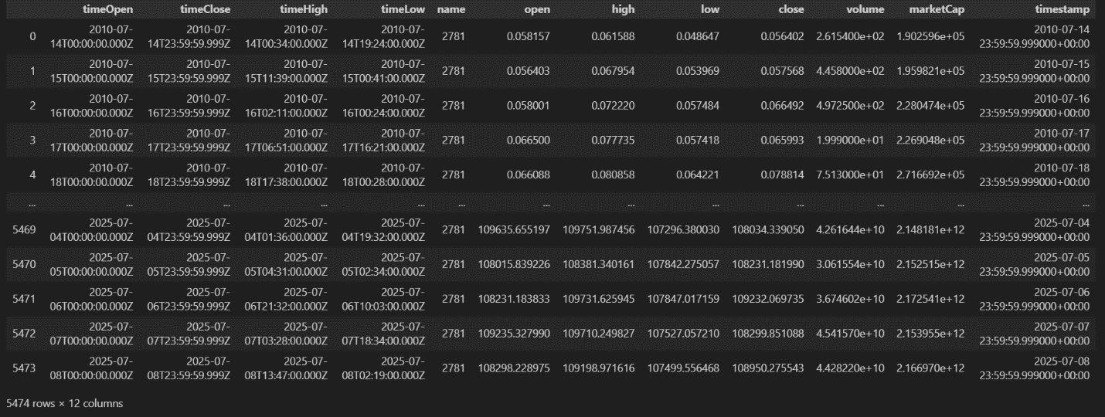
Source: (Given in Appendix)
- News Headlines were obtained from GitHub
(https://github.com/soheilrahsaz/cryptoNewsDataset), providing crypto-related headlines used to extract sentiment signals.

Figure 2: Crypto News Raw Dataset
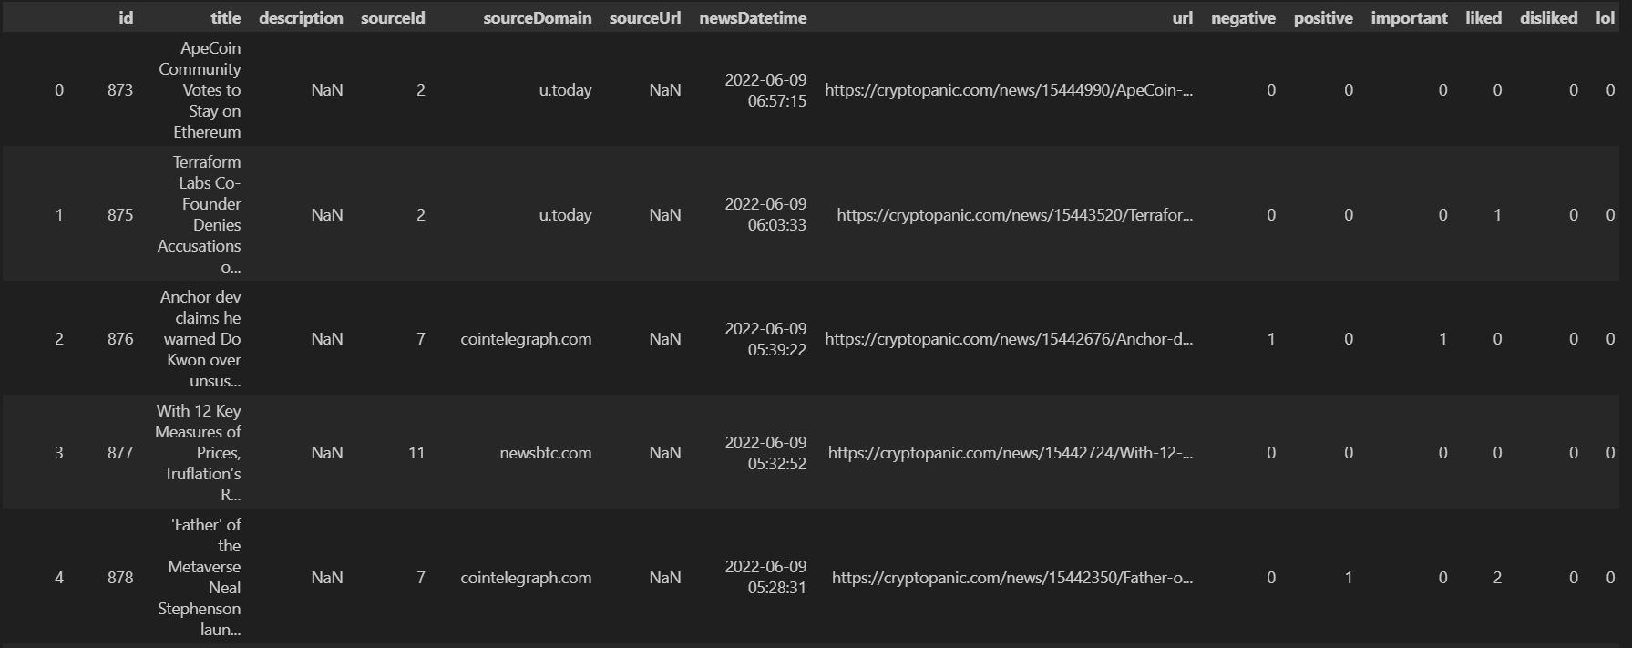
Source: (Given in Appendix)
Preprocessing Steps
The preprocessing pipeline was structured as follows:
- File Collection
All CSV files were loaded into pandas DataFrames. For each coin, CSV file was loaded into a separate DataFrame to ensure a continuous and complete record.
Source: (Given in Appendix)

- Datetime Conversion and Sorting
The timestamp columns were converted to datetime objects using pandas.to_datetime(). All datasets were sorted in chronological order to preserve the time series structure required for modeling.
Source: (Given in Appendix)

- Data Cleaning
Column headers were stripped of extra whitespaces to avoid key mismatches. Duplicate rows and invalid records were identified and removed to ensure data quality and prevent distortion of model training. Useless columns were also removed for each coin dataset.

Figure 3: Cleaned BNB Dataset, other currencies look same as this after cleaning
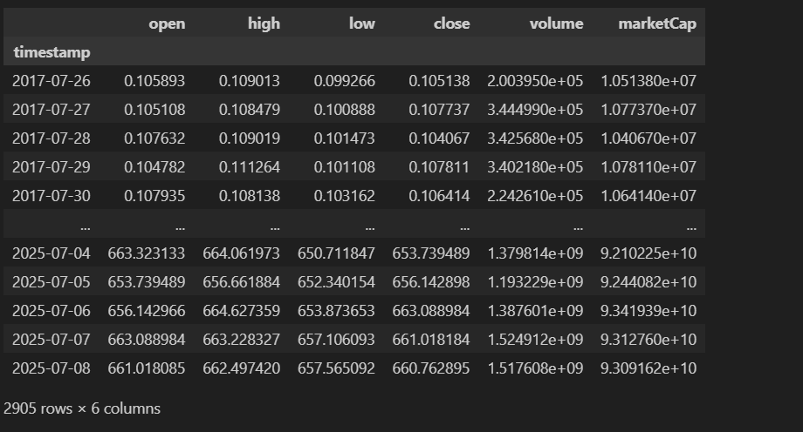
Source: (Given in Appendix)

Figure 4: Cleaned News Dataset, ready for sentiment scoring
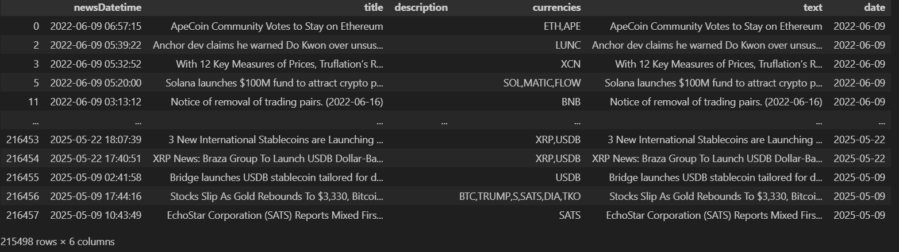
Source: (Given in Appendix)

- Sentiment Scoring
The VADER sentiment analysis tool from the vaderSentiment.vaderSentiment library was used to calculate a sentiment score for each headline. The compound score, which ranges from -1 (very negative) to +1 (very positive), was selected. Daily average sentiment values were computed for each coin.

Figure 5: Sentiment score calculated from news dataset
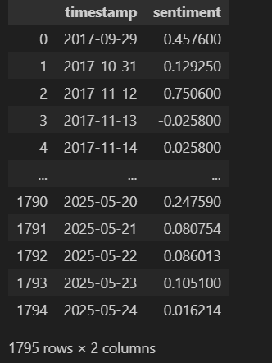
Source: (Given in Appendix)

- Merging Sentiment with Market Data
The sentiment data was merged with the corresponding market dataset by aligning on both timestamps and coin identifiers. This integration produced a unified dataset capturing both price movements and public sentiment.

Figure 6: Merged Sentiment score with cleaned currency data
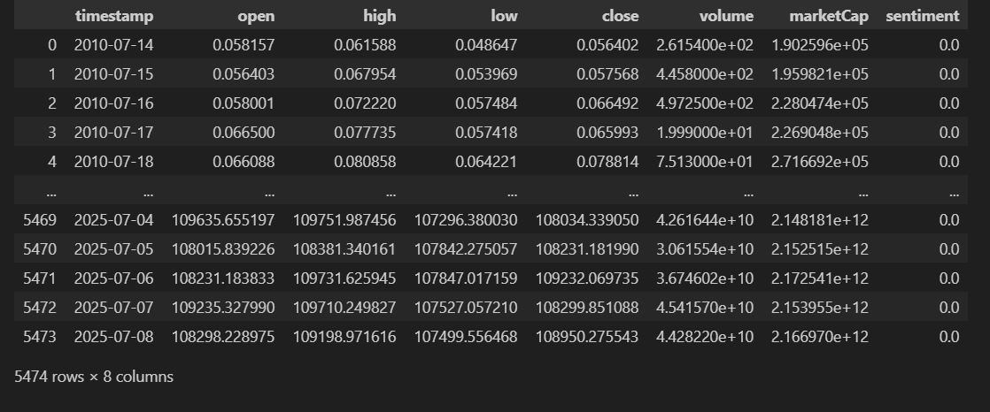
Source: (Given in Appendix)

- Handling Missing Sentiment
On days with no news headlines or unmatched timestamps, sentiment scores were filled with 0. This approach maintained continuity in the dataset while reflecting the absence of sentiment data.
Source: (Given in Appendix)
This preprocessing workflow ensured a clean, consistent, and sentiment-aware dataset ready for time series forecasting with ARIMA, Prophet, and LSTM models.

Model Implementation
To forecast cryptocurrency prices and analyze the impact of news sentiment, three distinct time series modeling approaches were implemented: ARIMA/ARIMAX, Prophet, and LSTM. Each model was applied for both offline comparison and real-time deployment in a web application built with Streamlit. The goal was to evaluate forecasting accuracy, input flexibility, and real-world usability.
ARIMA / ARIMAX
The ARIMA model was selected for its effectiveness in modeling linear trends and its interpretability. A configuration of (5,1,0) was chosen after analyzing autocorrelation and partial autocorrelation plots. This setup ensured appropriate differencing and lag selection to model the underlying patterns in the cryptocurrency time series.
For comparison, two versions of the model were trained:
- ARIMA, using only historical price data.
- ARIMAX, which integrated sentiment scores as an exogenous variable to assess their impact on predictions.
Both models were trained on data excluding the final 30 days, which were then used as a test set to evaluate forecasting performance. Metrics such as RMSE, MAE, and MAPE were used to compare the models with and without sentiment.
In the deployed application, the ARIMAX model was implemented using SARIMAX to allow the inclusion of external sentiment variables. The model was trained on the complete dataset and used to forecast the next 30 days automatically. It required no user input and offered a static but comprehensive outlook. This made it suitable for users interested in longer-term trends influenced by external market signals like news sentiment.
User input was not incorporated because ARIMAX models require continuous, regularly spaced historical data to generate valid forecasts. Allowing arbitrary user inputs for future prices or sentiment would disrupt the time series structure and could result in inconsistent or misleading predictions. Instead, the model was designed to run on full historical data, ensuring methodological rigor and reliable longer-term forecasting, while custom inputs were reserved for the LSTM model, which is more flexible for short-term scenario-based predictions.
(Note: This section contains only the models used for Web app and deployment, Model comparison will be discussed in the next chapter)

BTC Forecast:
Figure 7: Arimax forecast on BTC for next 30 days after being trained on complete data
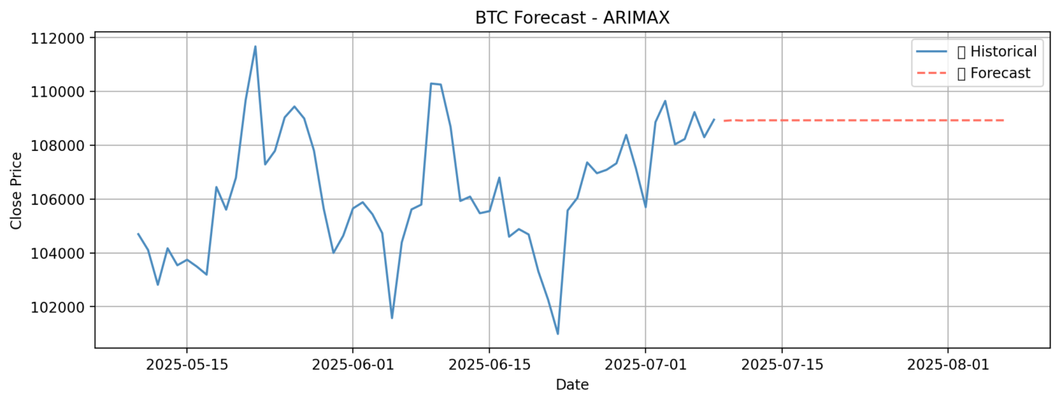
Source: (Given in Appendix)

ETH Forecast:
Figure 8: Arimax forecast on ETH for next 30 days after being trained on complete data
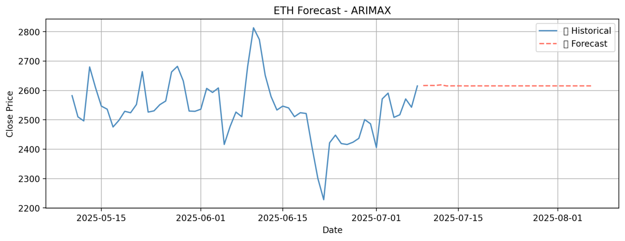
Source: (Given in Appendix)

BNB Forecast:

Figure 9: Arimax forecast on BNB for next 30 days after being trained on complete data
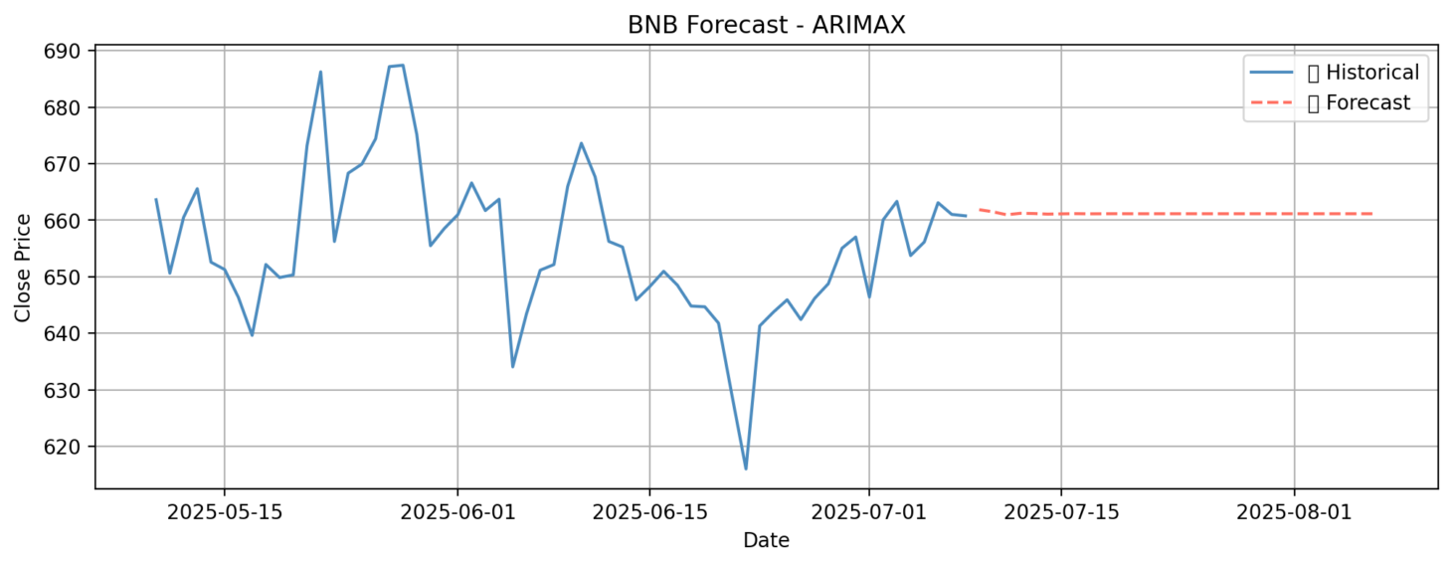
Source: (Given in Appendix)

Prophet
The Prophet model, developed by Facebook, was chosen for its flexibility and ability to handle seasonality and trend changes in time series data. Its intuitive configuration made it accessible while still offering robust performance for financial forecasting.
Two variants of the model were developed:
- The first used only price data and daily seasonality to predict future trends.
- The second included sentiment scores added as a custom regressor using Prophet’s built-in add_regressor() functionality.
Both versions were trained on the dataset excluding the last 30 days and then tested on that reserved period for comparative analysis. Prophet’s ability to automatically detect changepoints and adapt to holiday-like effects made it a strong candidate for capturing shifts in market behavior.
For application deployment, only the sentiment-enhanced version of Prophet was used. This model was trained on the full dataset to ensure the best performance and was capable of forecasting the next 30 days without any user interaction. Like ARIMAX, Prophet’s integration into the application was designed for ease of use, offering automatic and consistent outputs that updated with newly available data. Prophet performed reliably across all three cryptocurrencies and proved to be easy to tune. Its strength in modeling smooth long-term trends, while accommodating sentiment as an influencing factor, made it well-suited for the web app’s passive forecasting features. User input was not incorporated because Prophet forecasts depend on historical time series continuity and model-learned seasonal patterns. Allowing arbitrary manual inputs would break these temporal dependencies and reduce forecast reliability. Instead, the model was configured to generate fully automated predictions using past prices and sentiment, ensuring consistency and accuracy in long-term trend forecasting.

BTC Forecast:
Figure 10: Prophet forecast on BTC for next 30 days after being trained on complete data
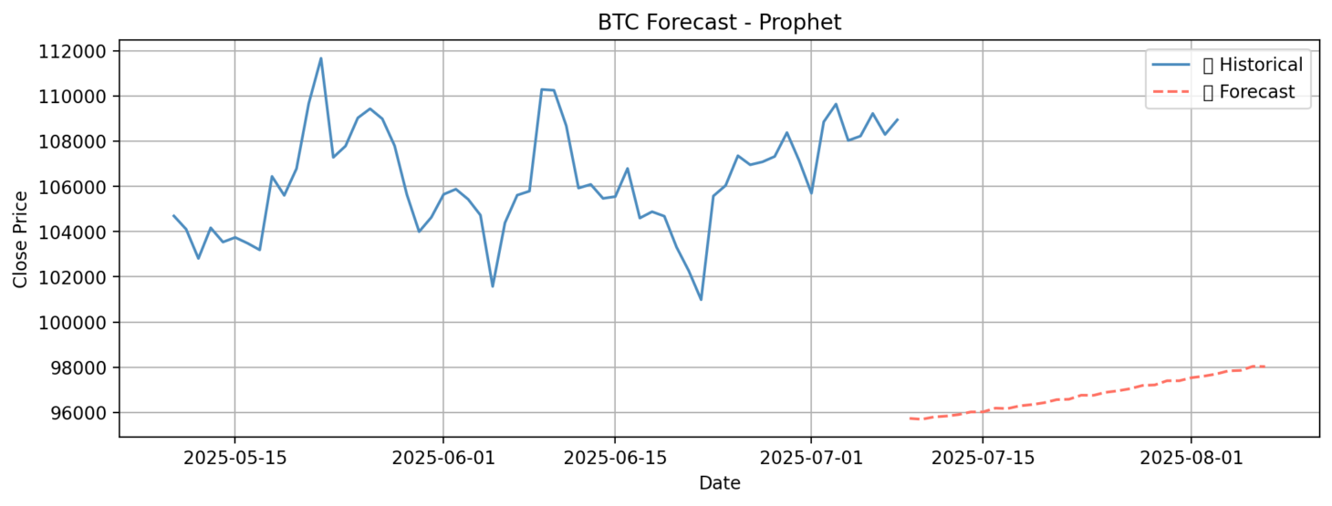
Source: (Given in Appendix)

ETH Forecast:
Figure 11: Prophet forecast on ETH for next 30 days after being trained on complete data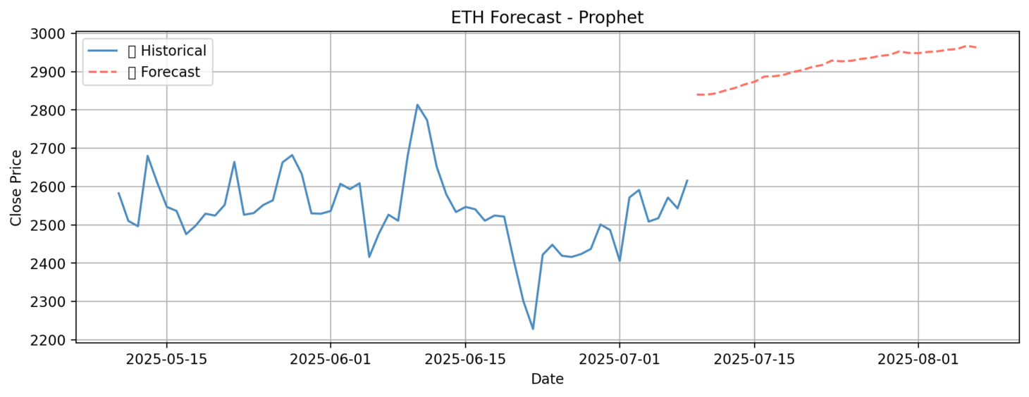
Source: (Given in Appendix)

BNB Forecast:
Figure 12: Prophet forecast on BNB for next 30 days after being trained on complete data
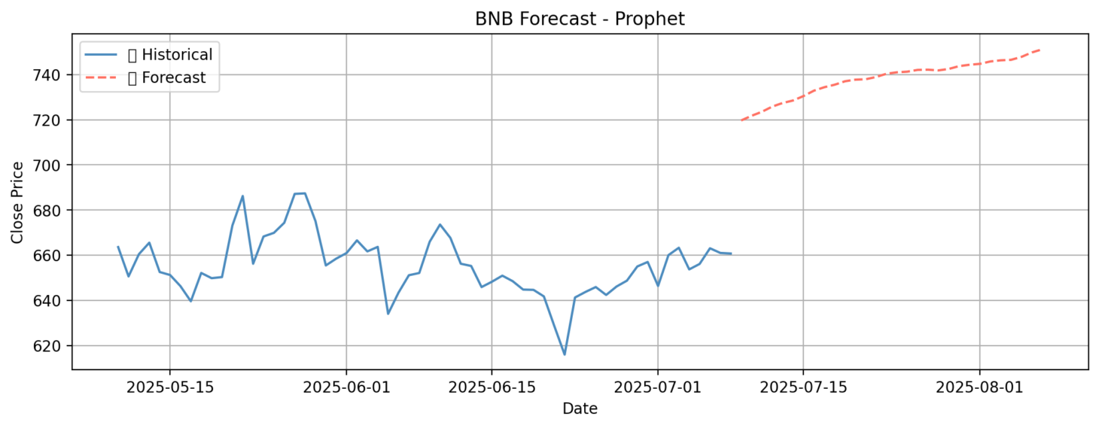
Source: (Given in Appendix)

LSTM
The LSTM (Long Short-Term Memory) model was selected to capture nonlinear dependencies and short-term temporal patterns that traditional statistical models often overlook. Unlike ARIMA and Prophet, which operate on entire time series, LSTM uses sliding input windows to make sequential predictions, making it better equipped for reacting to recent market movements.
For model evaluation, the LSTM was trained on historical data with the last 30 days held out for testing. Input sequences were constructed using a 30-day window of scaled close prices and corresponding sentiment values. The model then predicted the next time step, and this process was repeated for multi-step forecasting. Performance was assessed using RMSE, MAE, MAPE, and R², and results were visualized against actual market prices to highlight predictive accuracy. For deployment in the Streamlit application, a more interactive setup was adopted. Users are required to input the previous 7 days of close prices, with the option to also include sentiment values for each day. The model, trained using a 7-in → 7-out multi-step sequence structure, forecasts prices for the next 7 days. Training was performed on the complete dataset to maximize learning, using 50 LSTM units, the Adam optimizer, and mean squared error as the loss function. Training epochs ranged between 20 and 50 depending on the dataset size and convergence speed.
Unlike ARIMA and Prophet, which are automated and static in their deployment, the LSTM model in the app responds dynamically to user input. This allows users to generate custom forecasts based on their own data or observations, enabling a more personalized and flexible prediction experience. However, the forecasts were restricted to 7 days rather than longer horizons. This limitation was necessary because LSTMs are highly sensitive to input length and error accumulation over time. With limited user-provided data (such as the last 7 days of prices and sentiment), extending forecasts beyond a week would have significantly reduced reliability and introduced compounding errors. By constraining the forecast window to 7 days, the application balanced personalization with accuracy, ensuring that user-driven predictions remained meaningful and trustworthy. Overall, each model was adapted not just to fit the data but also to suit different types of users and forecasting needs, from fully automated long-term predictions to user-driven short-term forecasting.
(Note: For LSTM Models, since user can give any input with any date that’s why we didn’t plot the past trend of data like we did in Arima and Prophet).

BTC Forecast:
Figure 13: LSTM forecast on BTC for next 7 days after being trained on complete data
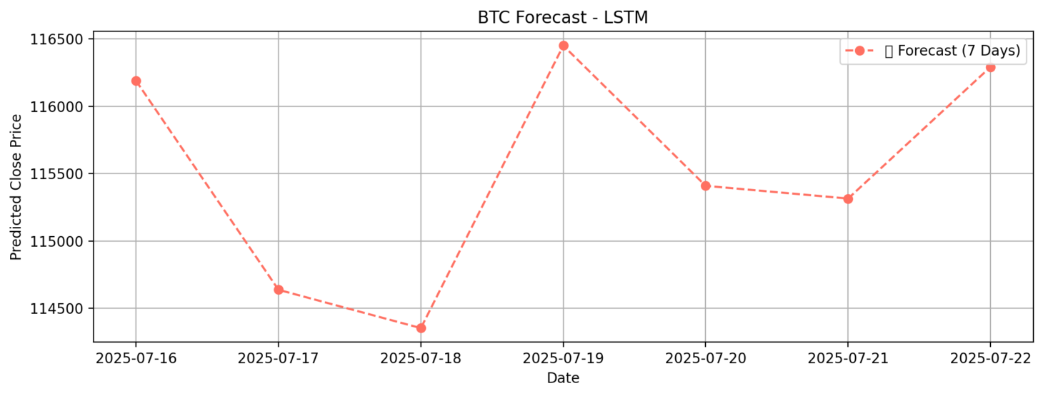
Source: (Given in Appendix)

ETH Forecast:
Figure 14: LSTM forecast on ETH for next 7 days after being trained on complete data
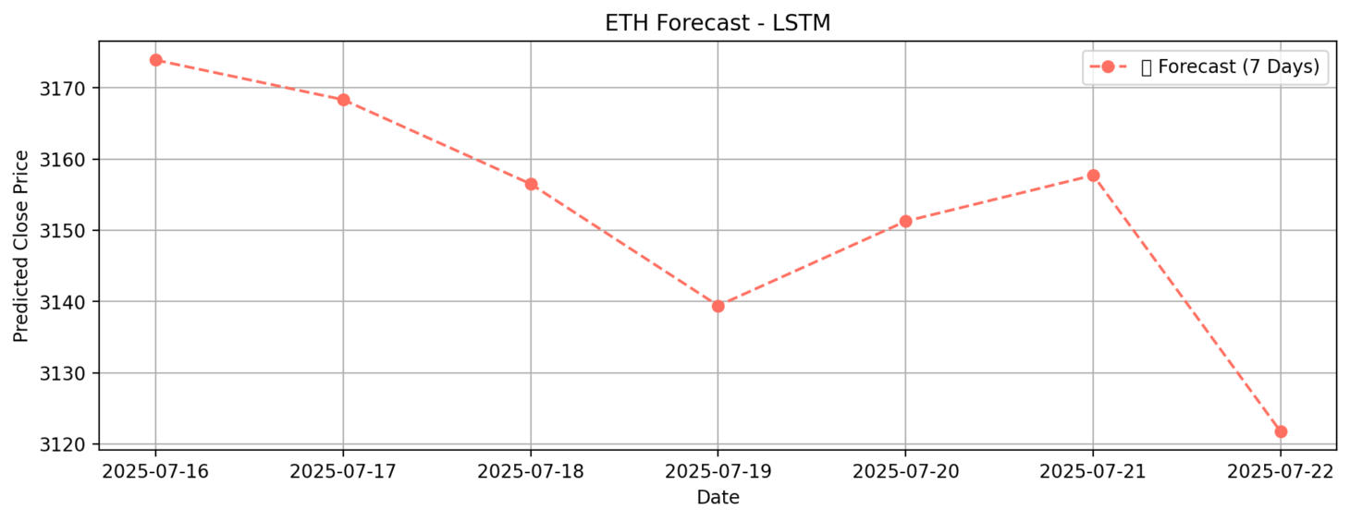
Source: (Given in Appendix)

BNB Forecast:
Figure 15: LSTM forecast on BNB for next 7 days after being trained on complete data
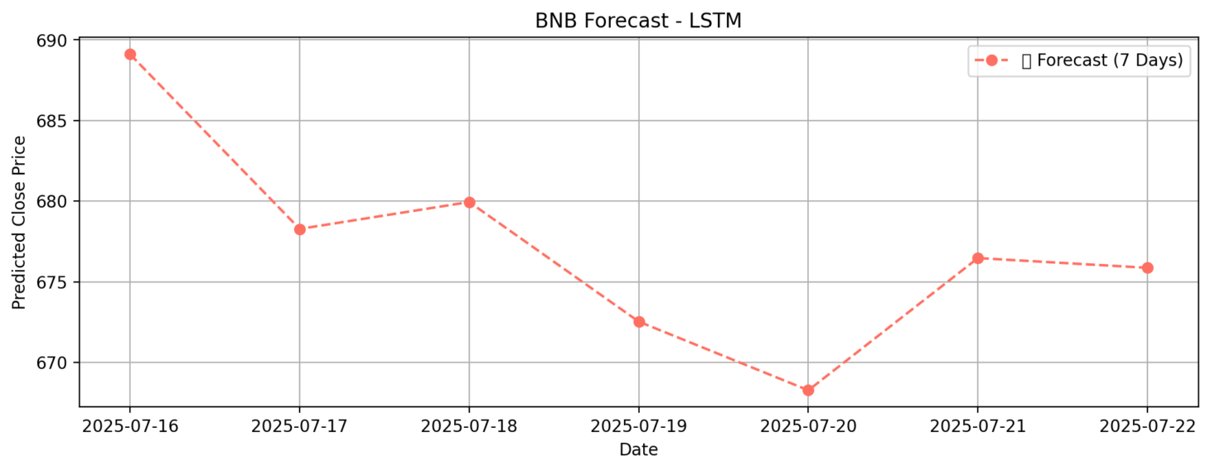
Source: (Given in Appendix)

Application Interface
To make the forecasting models accessible and interactive, a web application was developed using Streamlit. The interface allows users to explore real-time cryptocurrency price forecasting with customizable options and intuitive controls.
The app enables users to select the cryptocurrency (BTC, ETH, or BNB), the desired forecasting model (ARIMA, Prophet, or LSTM), and the forecast duration. ARIMA and Prophet models are configured to predict the next 30 days, while LSTM forecasts 7 days ahead. If using ARIMA or Prophet with sentiment integration, a sentiment input slider ranging from -1 to 1 is provided. This simulates the impact of news sentiment on the model’s predictions.
For the LSTM model, users are prompted to enter the most recent 7 days of closing prices, along with optional sentiment values. The model then predicts the next week of prices based on this input.
The output includes clear visualizations:
- ARIMA and Prophet: a full 60-day plot (past 30 days + future 30 days)
- LSTM: a 7-day view next 7-day predictions
- All these plots are displayed in last heading.
All forecast results can be downloaded as a CSV file, enabling further analysis or record-keeping.
To maximize performance, each model is retrained on the full dataset before deployment in the application. This ensures the predictions are based on the most comprehensive data available. The interface provides an accessible platform for both expert users and casual investors to experiment with predictive analytics in the crypto domain.
We deployed the web application on Render using Docker containerization, which streamlined the deployment process. Docker enabled us to package the entire app, including all its dependencies and environment settings, into a single container. This ensured consistent behavior across different systems. Render’s native support for Docker made it easy to build, host, and scale the Streamlit application without complex setup, allowing for reliable and efficient deployment.
Figure 16: User Interface of the Web App
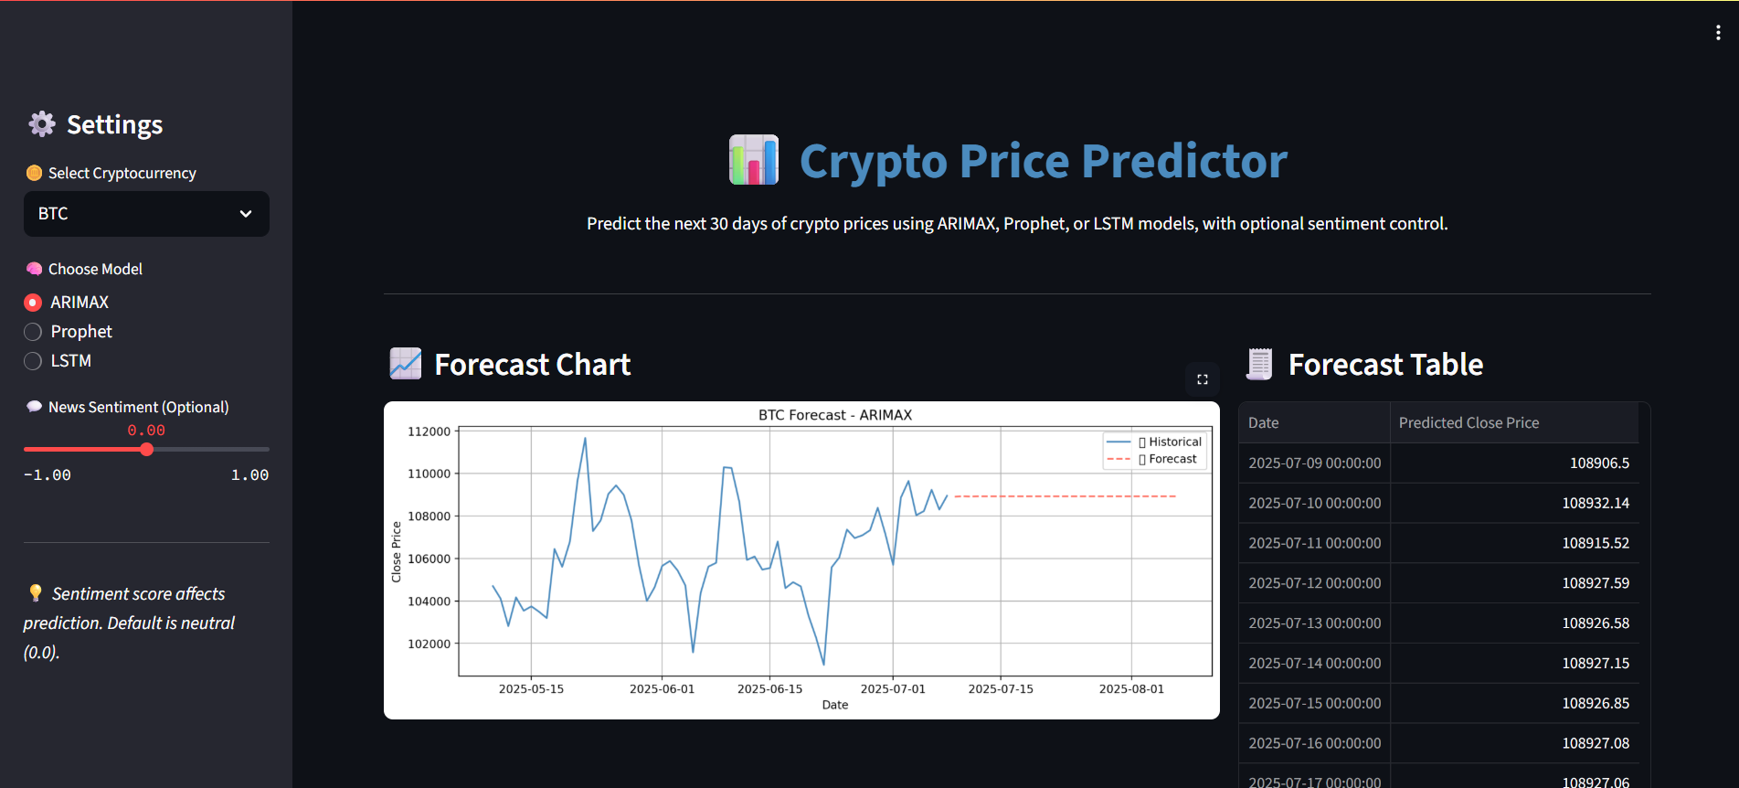
Source (Deployed on Render): https://crypto-price-prediction-3z9g.onrender.com/

Summary
This project integrated ARIMA, Prophet, and LSTM models to forecast crypto currency prices for BTC, ETH, and BNB, adapting each model for both performance evaluation and real-time deployment. ARIMA and Prophet were configured to forecast 30 days ahead without requiring user input, with optional sentiment integration to enhance prediction accuracy. LSTM, on the other hand, required a 7-day input window (close prices and optional sentiment) to predict the next 7 days, making it more dynamic but also more interactive. Each model was trained on historical data and validated against the most recent 30 days for fair comparison. For deployment, all models were retrained on the complete dataset to maximize learning. The application interface, developed using Streamlit, allowed seamless model selection, input control, and visualization, making advanced forecasting tools accessible to both technical and non-technical users. The system was designed with modularity in mind, new data can be integrated easily, and models can be retrained without altering the app’s structure. This flexibility supports future improvements and scalability.

Model Evaluation
Th In this section, I presented the forecast plots for each individual model across all three currencies (BTC, ETH, and BNB), both with and without sentiment integration. Alongside the visual forecasts, the evaluation metrics including R² Score, RMSE, MAE, and MAPE were reported for each model to assess their predictive performance. To further highlight differences, I also created combined model plots for each currency, where the forecasts of all models were plotted together on the same graph. This provided a direct visual comparison of how each model performed with and without sentiment data. Finally, I added comparison plots of each metric (R² Score, RMSE, MAE, and MAPE) across models, clearly showing the impact of incorporating sentiment on overall forecasting accuracy.

Evaluation Metric Interpretation for Crypto Currency Forecasting
Metric | Good Performance | Acceptable Performance | Poor Performance | Interpretation
RMSE  (Root Mean Squared Error) | - BTC: < 600  - ETH: < 40  - BNB: < 5 | - BTC: 600–1500  - ETH: 40–100  - BNB: 5–12 | - BTC: > 1500  - ETH: > 100  - BNB: > 12 | Indicates how far predictions deviate from actual prices. Lower is better; RMSE is sensitive to large errors.
MAE  (Mean Absolute Error) | - BTC: < 450  - ETH: < 30  - BNB: < 3.5 | - BTC: 450–1200  - ETH: 30–75  - BNB: 3.5–9 | - BTC: > 1200  - ETH: > 75  - BNB: > 9 | Measures average magnitude of errors. Less sensitive to outliers than RMSE.
MAPE  (Mean Absolute Percentage Error) | < 2% | 2% – 5% | > 5% | Shows error as a percentage of actual prices. Ideal for comparing across coins. Very sensitive when prices are low.
R² Score  (Coefficient of Determination) | > 0.6 | 0.3 – 0.6 | < 0.3 or negative | Measures how well predictions explain variance in the data. Closer to 1 indicates stronger explanatory power.

ARIMA & ARIMAX Results
The ARIMA model, a classical time series approach, was trained on closing price data only, while ARIMAX extended this by including news sentiment as an exogenous variable.
- BTC
- ARIMA
R² Score: -0.1836
RMSE: 2409.43
MAE: 1948.18
MAPE: 1.82%

Figure 17: Forecast vs Actual price of Arima on BTC for 30 days
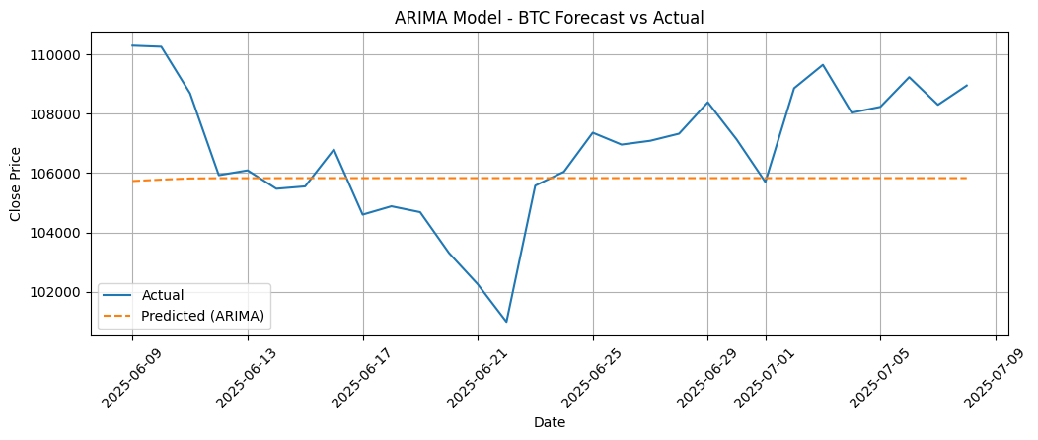
Source: (Given in Appendix)

- ARIMAX (with sentiment)
R² Score: -0.1821
RMSE: 2407.95
MAE: 1946.92
MAPE: 1.82%

Figure 18: Forecast vs Actual price of Arimax on BTC for 30 days
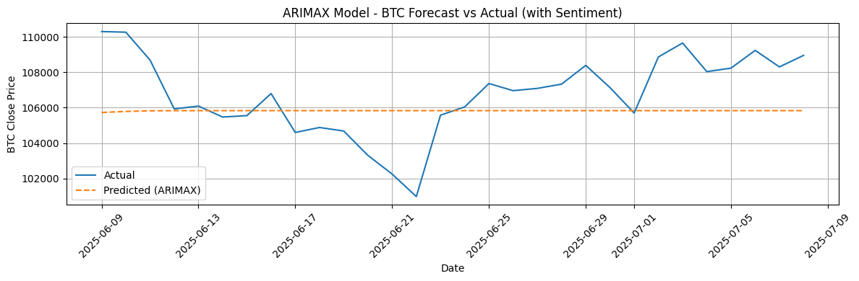
Source: (Given in Appendix)

ETH
- ARIMA
R² Score: 0.0025
RMSE: 119.71
MAE: 87.58
MAPE: 3.49%

Figure 19: Forecast vs Actual price of Arima on ETH for 30 days
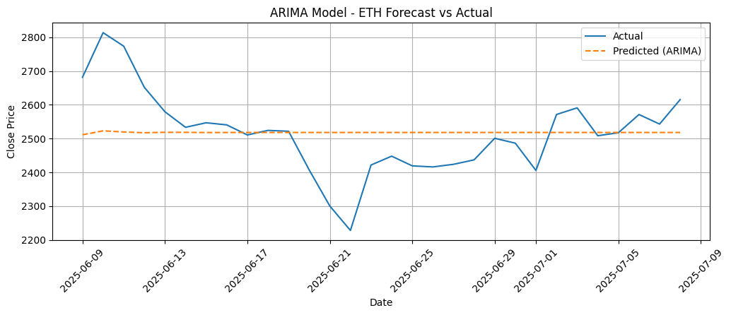
Source: (Given in Appendix)

- ARIMAX (with sentiment)
R² Score: 0.0024
RMSE: 119.71
MAE: 87.58
MAPE: 3.49%

Figure 20: Forecast vs Actual price of Arimax on ETH for 30 days
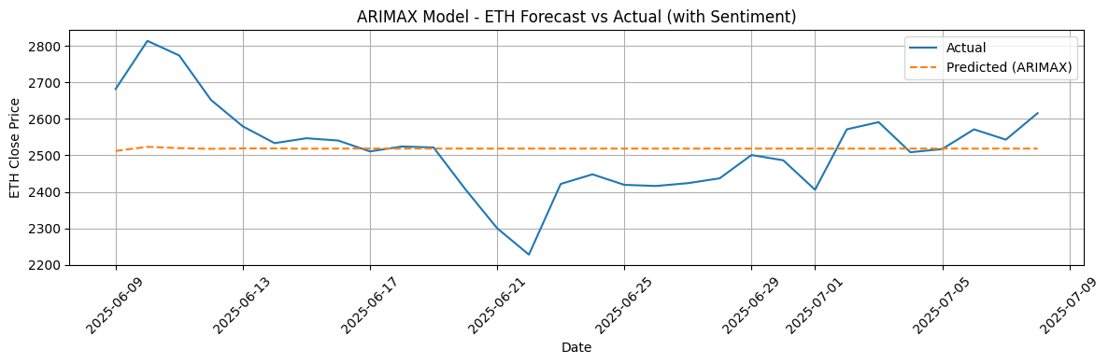
Source: (Given in Appendix)
▪ BNB
- ARIMA
R² Score: -0.0535
RMSE: 11.76
MAE: 9.07
MAPE: 1.40%

Figure 21: Forecast vs Actual price of Arima on BNB for 30 days
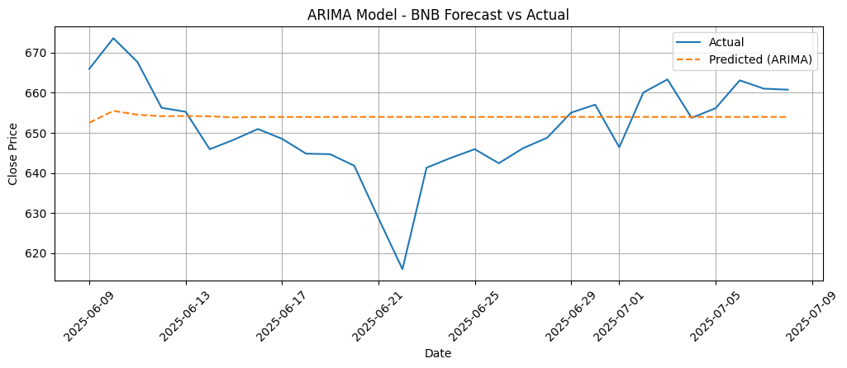
Source: (Given in Appendix)

- ARIMAX (with sentiment)
R² Score: -0.0540
RMSE: 11.76
MAE: 9.07
MAPE: 1.40%

Figure 22: Forecast vs Actual price of Arimax on BNB for 30 days
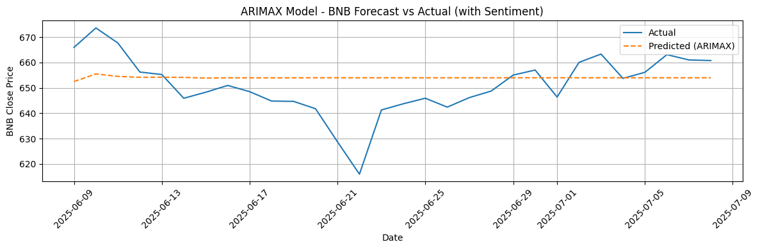
Source: (Given in Appendix)

Explanation for Arima/Arimax Performance:
The ARIMA and ARIMAX models underperformed in cryptocurrency forecasting due to their inherent structural limitations. ARIMA, being a linear model, is suitable for stationary time series with stable patterns, but cryptocurrency prices are volatile, nonlinear, and influenced by sudden shocks such as regulations and sentiment shifts. The differencing step used in ARIMA further removes meaningful long-term trends, reducing predictive power. Adding sentiment through ARIMAX did not improve results, as the model assumes a simple linear effect, while sentiment influences are nonlinear and context-dependent. Consequently, both ARIMA and ARIMAX failed to capture the complex, chaotic behavior of cryptocurrency markets.

Prophet & Prophet with Sentiment
Prophet, developed by Facebook, was used both with and without sentiment as an additional regressor. While flexible in handling seasonality and trends, Prophet generally underperformed on this dataset.

▪ BTC
- Prophet
R² Score: -47.0557
RMSE: 15352.93
MAE: 15205.29
MAPE: 14.21%

Figure 23: Forecast vs Actual price of Prophet on BTC for 30 days
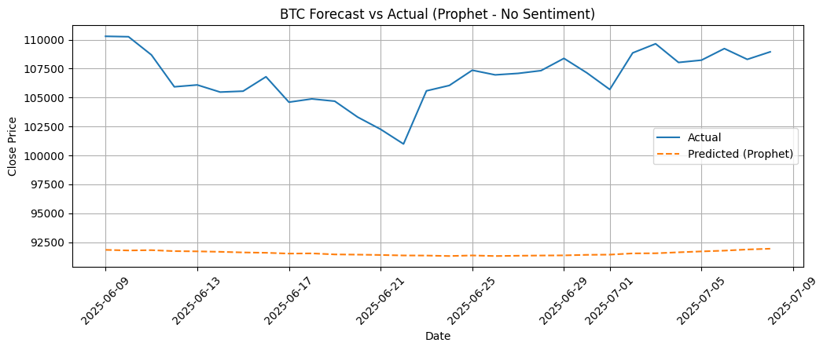
Source: (Given in Appendix)

- Prophet (with sentiment)
R² Score: -48.328
RMSE: 15554.97
MAE: 15408.15
MAPE: 14.40%

Figure 24: Forecast vs Actual price of Prophet with sentiment on BTC for 30 days
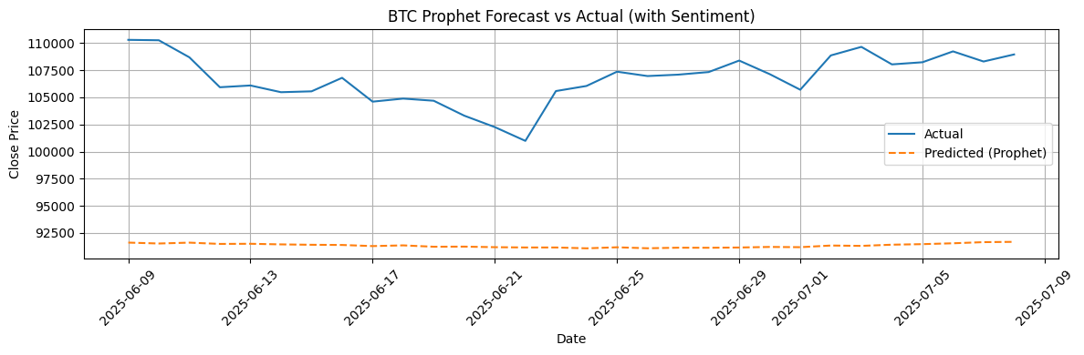
Source: (Given in Appendix)

▪ ETH
- Prophet
R² Score: -16.6722
RMSE: 503.85
MAE: 491.98
MAPE: 19.79%

Figure 25: Forecast vs Actual price of Prophet on ETH for 30 days
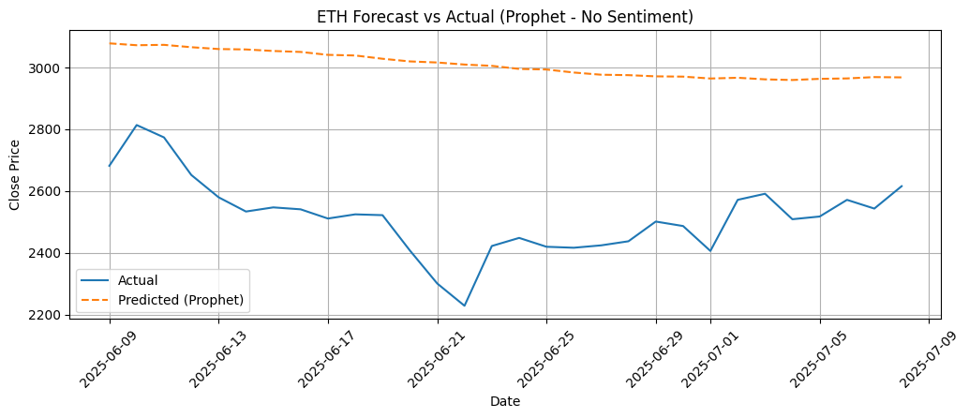
Source: (Given in Appendix)

- Prophet (with sentiment)
R² Score: -16.2335
RMSE: 497.56
MAE: 485.35
MAPE: 19.53%

Figure 26: Forecast vs Actual price of Prophet with sentiment on ETH for 30 days
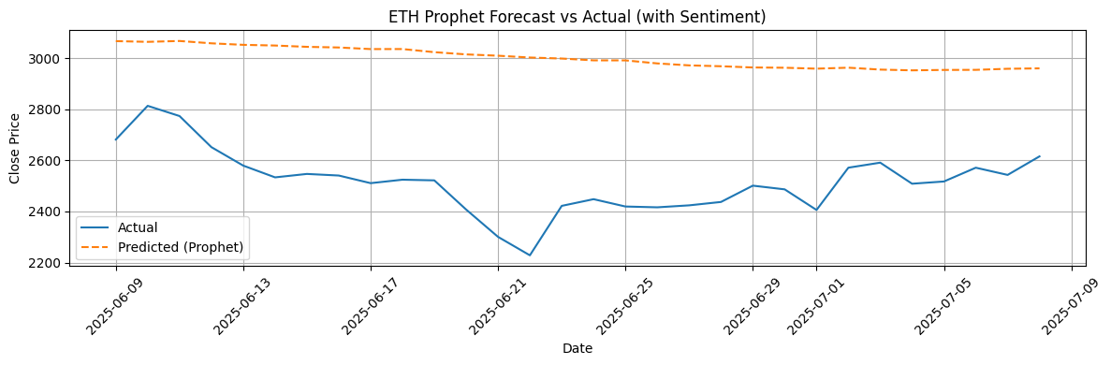
Source: (Given in Appendix)
▪ BNB
- Prophet
R² Score: -49.3622
RMSE: 81.32
MAE: 80.48
MAPE: 12.39%

Figure 27: Forecast vs Actual price of Prophet on BNB for 30 days
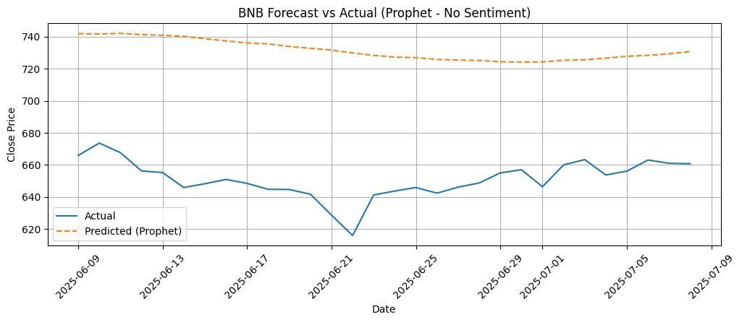
Source: (Given in Appendix)

- Prophet (with sentiment)
R² Score: -48.6910
RMSE: 80.78
MAE: 79.92
MAPE: 12.31%

Figure 28: Forecast vs Actual price of Prophet with sentiment on BNB for 30 days
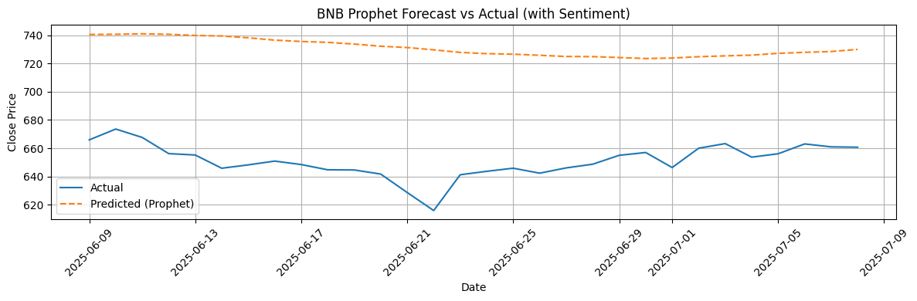
Source: (Given in Appendix)

Explanation for Prophet Performance:
Prophet performed poorly in forecasting cryptocurrency prices, as indicated by high RMSE, MAE, and negative R² scores. The model is built for time series with clear trend and seasonality patterns, making it effective for domains like sales or traffic, but unsuitable for crypto markets, which lack stable cycles and are driven by irregular shocks and speculative behavior. Prophet’s additive decomposition overfit simple trends while missing volatility. Adding sentiment showed no significant improvement, as the model treats regressors linearly and cannot capture nonlinear or delayed sentiment effects. Overall, Prophet’s structural assumptions made it ineffective for modeling cryptocurrency price dynamics.

LSTM (Long Short-Term Memory) Results
LSTM models were trained in three configurations:
- Using only the closing price
- Including sentiment
LSTM models significantly outperformed ARIMA and Prophet, especially when provided with more input features.

▪ BTC
- LSTM (Close only)
RMSE: 1814.86
MAE: 1306.83
MAPE: 1.22%
R² Score: 0.3285

Figure 29: Forecast vs Actual price of LSTM on BTC for 30 days
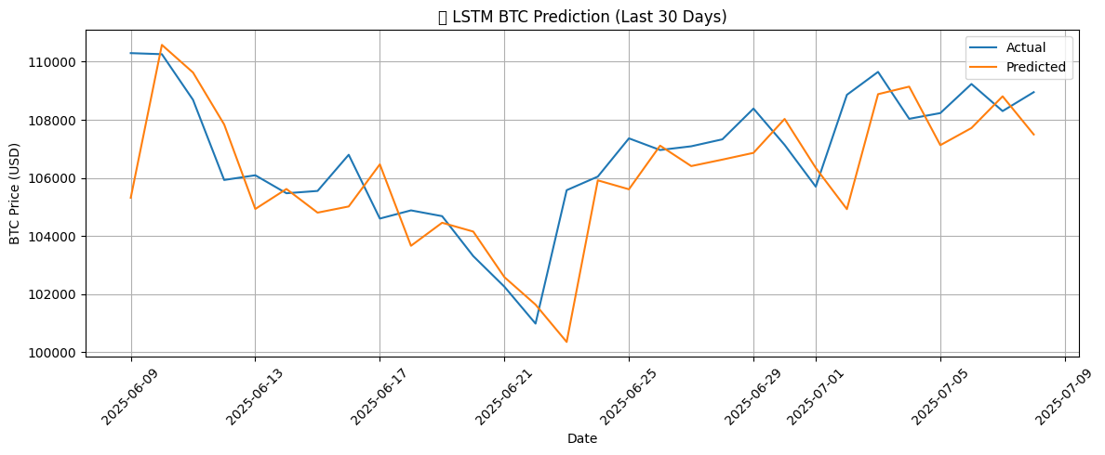
Source: (Given in Appendix)

- LSTM (with sentiment)
RMSE: 1756.41
MAE: 1302.60
MAPE: 1.22%
R² Score: 0.3710

Figure 30: Forecast vs Actual price of LSTM with sentiment on BTC for 30 days
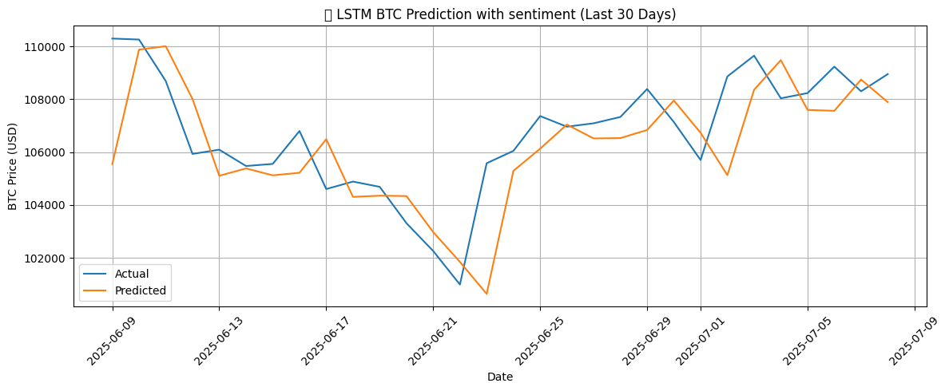
Source: (Given in Appendix)

▪ ETH
- LSTM (Close only)
RMSE: 98.33
MAE: 79.91
MAPE: 3.20%
R² Score: 0.3269

Figure 31: Forecast vs Actual price of LSTM on ETH for 30 days
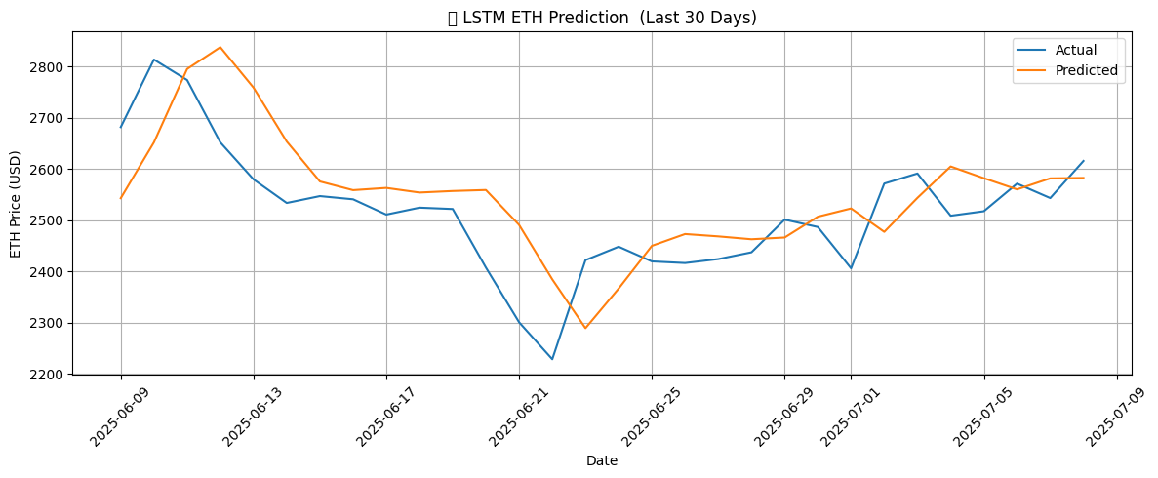
Source: (Given in Appendix)

- LSTM (with sentiment)
RMSE: 93.37
MAE: 77.08
MAPE: 3.08%
R² Score: 0.3931

Figure 32: Forecast vs Actual price of LSTM with sentiment on ETH for 30 days
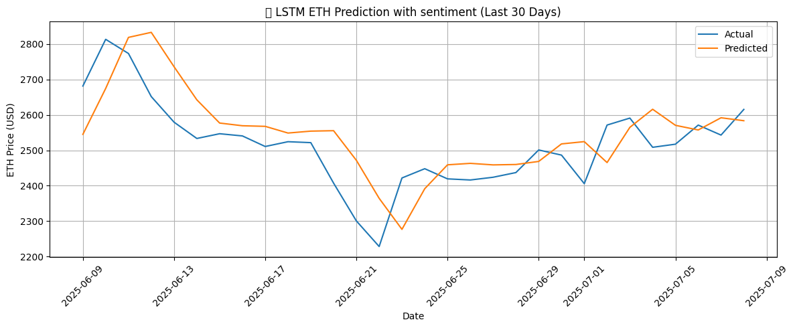
Source: (Given in Appendix)

▪ BNB
- LSTM (Close only)
RMSE: 8.98
MAE: 7.17
MAPE: 1.10%
R² Score: 0.3858

Figure 33: Forecast vs Actual price of LSTM on BNB for 30 days
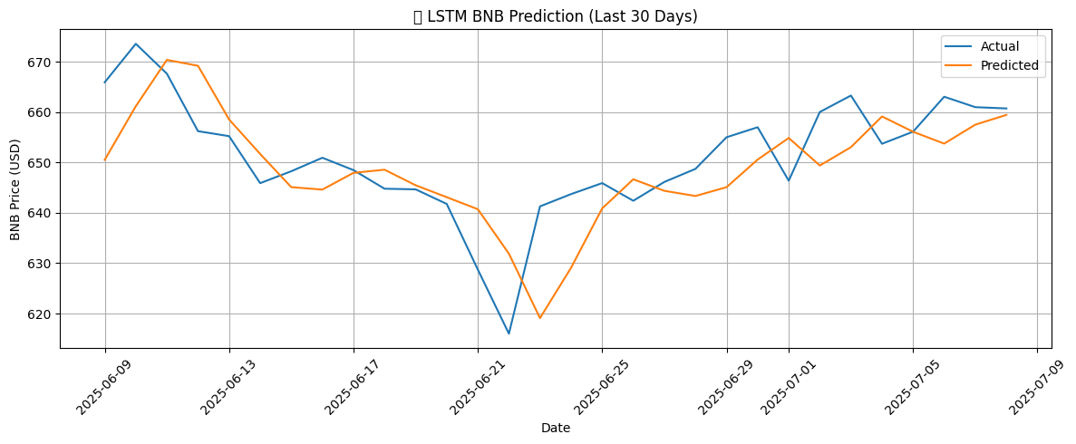
Source: (Given in Appendix)

- LSTM (with sentiment)
RMSE: 8.68
MAE: 6.72
MAPE: 1.04%
R² Score: 0.4269

Figure 34: Forecast vs Actual price of LSTM with sentiment on BNB for 30 days
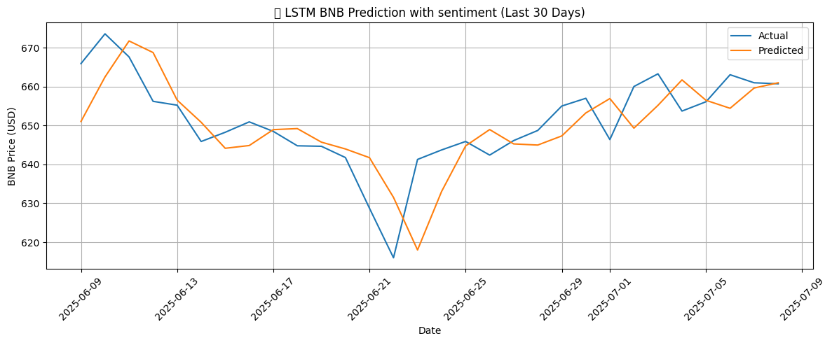
Source: (Given in Appendix)

Explanation for LSTM Performance:
The Long Short-Term Memory (LSTM) model delivered the strongest performance, with lower RMSE, MAE, and positive R² values compared to other models. Unlike ARIMA and Prophet, LSTM effectively captures nonlinear relationships and long-term dependencies in sequential data, making it better suited for highly volatile cryptocurrency markets. Its ability to retain temporal patterns allowed it to adapt to fluctuations caused by investor behavior, market shocks, and external events. Incorporating sentiment further improved performance, though modestly, as sentiment effects are often short-lived or overshadowed by larger market forces. Overall, LSTM proved most capable of modeling crypto’s complex, irregular, and nonlinear dynamics.

Combined Model Comparison on each currency:
In this section, we conducted a comprehensive comparison of all models across each crypto currency, evaluating their performance both without and with sentiment integration. This dual analysis allowed us to assess not only the baseline forecasting ability of each model but also the impact of incorporating sentiment data on prediction accuracy.

  - Model Comparison on BTC (Without Sentiment):

Figure 35: Forecast vs Actual price of all models on BTC for 30 days
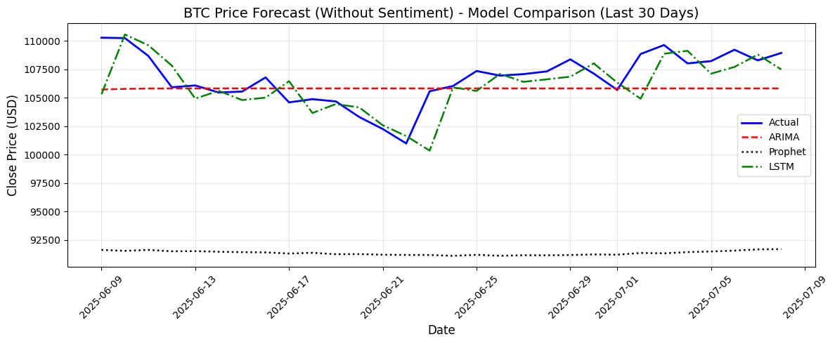
Source: (Given in Appendix)

  - Model Comparison on BTC (With Sentiment):

Figure 36: Forecast vs Actual price of all models with sentiment on BTC for 30 days
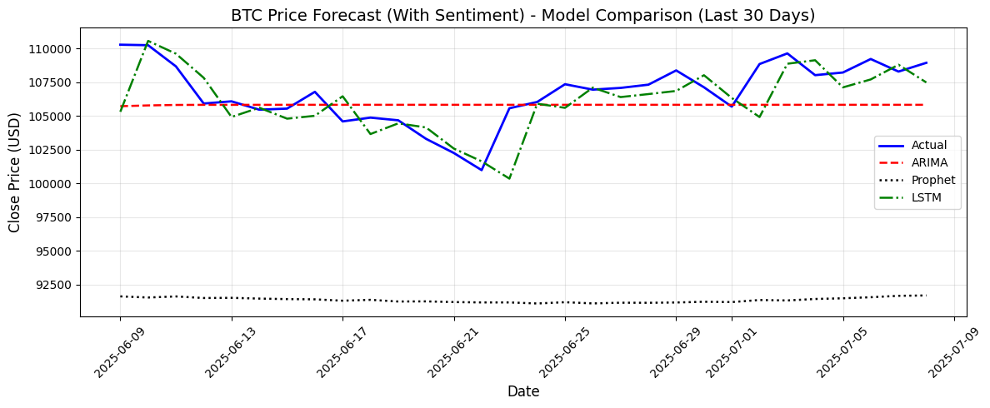
Source: (Given in Appendix)

  - Model Comparison on ETH (Without Sentiment):

Figure 37: Forecast vs Actual price of all models on ETH for 30 days
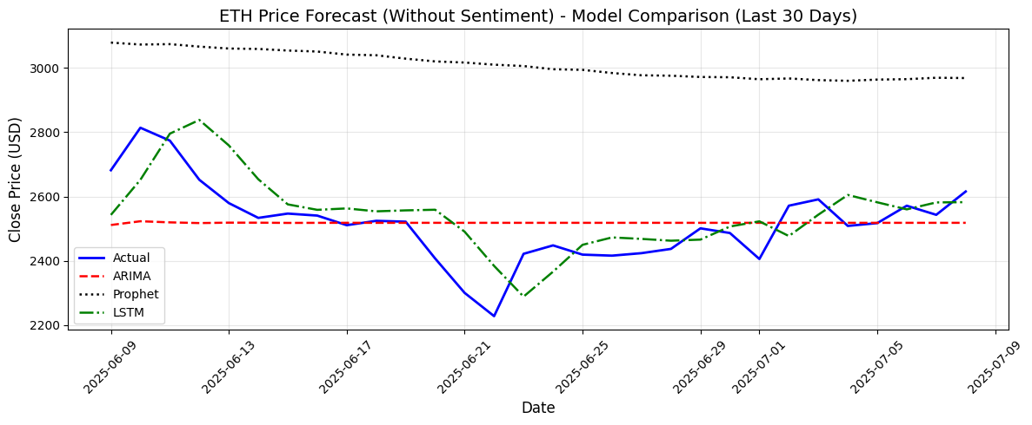
Source: (Given in Appendix)

  - Model Comparison on ETH (With Sentiment):

Figure 38: Forecast vs Actual price of all models with sentiment on ETH for 30 days
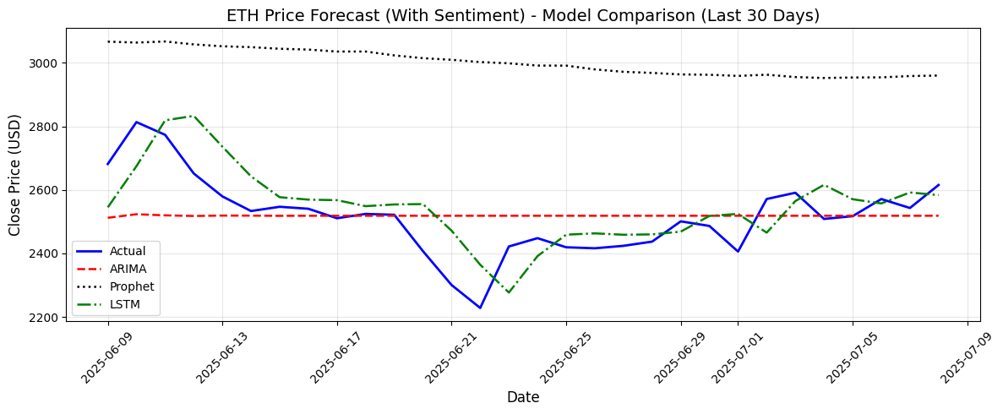
Source: (Given in Appendix)

  - Model Comparison on BNB (Without Sentiment):

Figure 39: Forecast vs Actual price of all models on BNB for 30 days
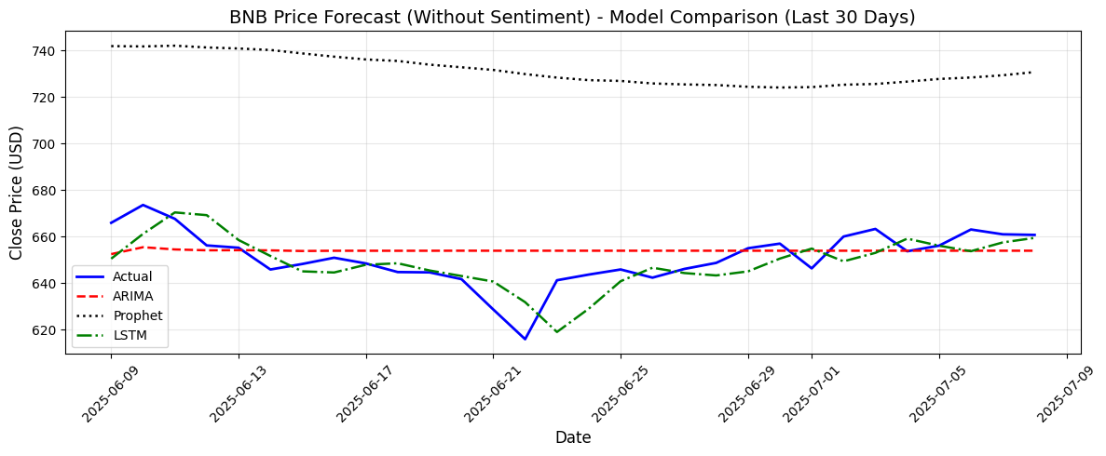
Source: (Given in Appendix)

  - Model Comparison on BNB (With Sentiment):

Figure 40: Forecast vs Actual price of all models with sentiment on BNB for 30 days
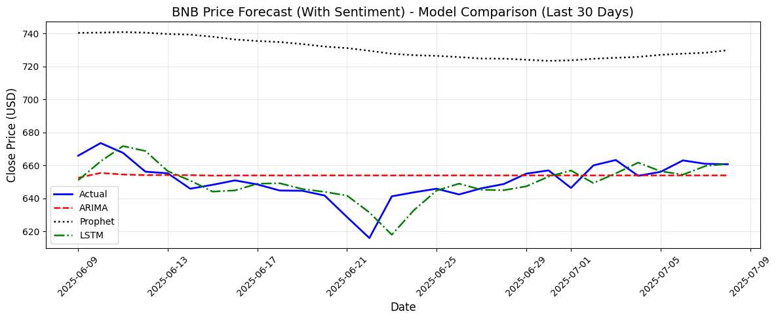
Source: (Given in Appendix)

Evaluation Metrics Comparison Plots:
We compared the evaluation metrics RMSE, MAE, MAPE and R² score through visual plots for each crypto currency both without and with sentiment integration. This provided a clear assessment of model performance and the influence of sentiment data on forecasting accuracy.

Source Function for all plots: (Given in Appendix)

- RMSE Comparison (Without Sentiment):

Figure 41: RMSE Comparison of each model on each currency
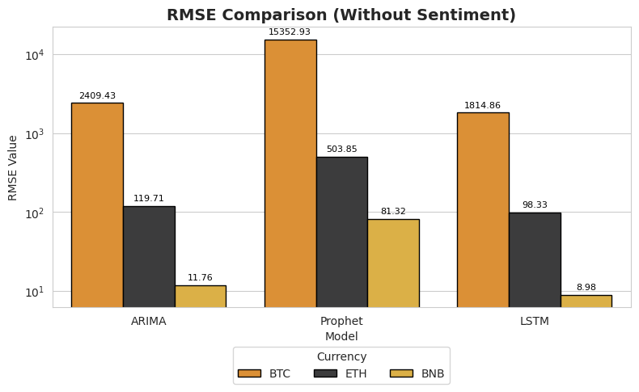
Source: (Given in Appendix)

- RMSE Comparison (With Sentiment):

Figure 42: RMSE Comparison of each model with sentiment on each currency
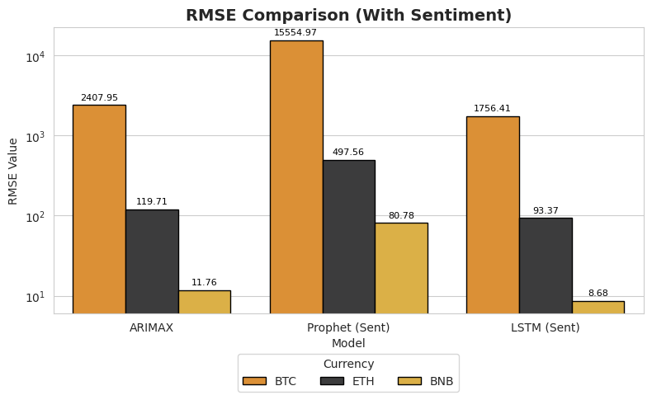
Source: (Given in Appendix)

- MAE Comparison (Without Sentiment):

Figure 43: MAE Comparison of each model on each currency
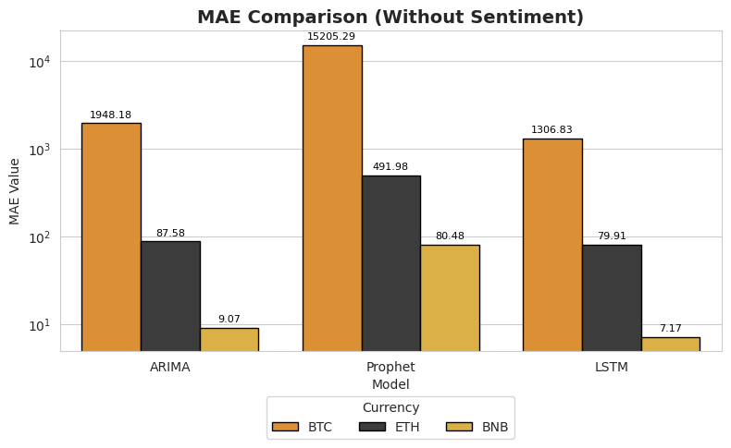
Source: (Given in Appendix)

- MAE Comparison (With Sentiment):

Figure 44: MAE Comparison of each model with sentiment on each currency
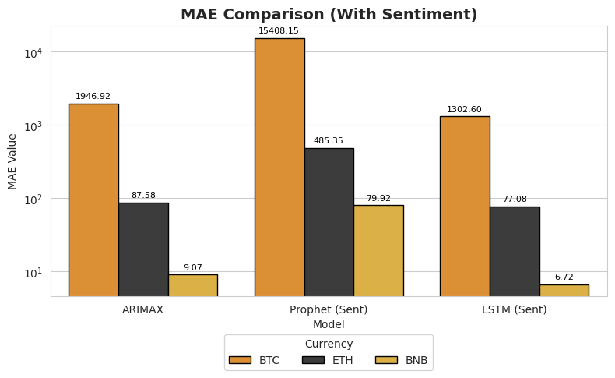
Source: (Given in Appendix)

- MAPE Comparison (Without Sentiment):

Figure 45: MAPE Comparison of each model on each currency
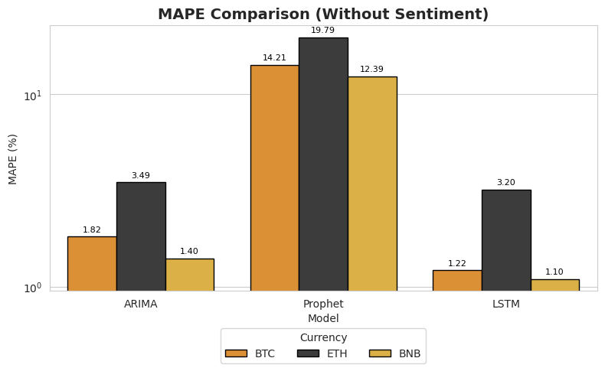
Source: (Given in Appendix)

- MAPE Comparison (With Sentiment):

Figure 46: MAPE Comparison of each model with sentiment on each currency
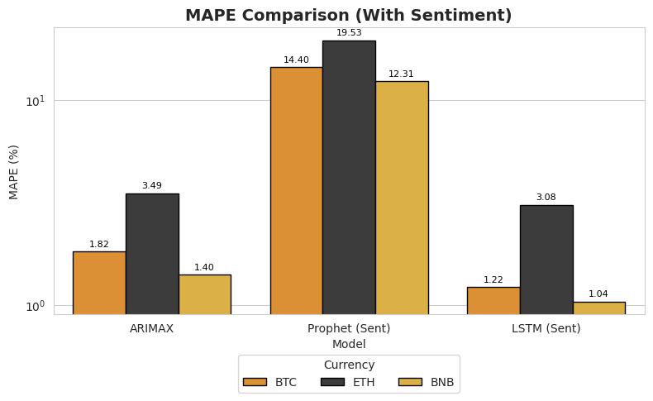
Source: (Given in Appendix)

- R2 Comparison (Without Sentiment):

Figure 47: R2 Score Comparison of each model on each currency
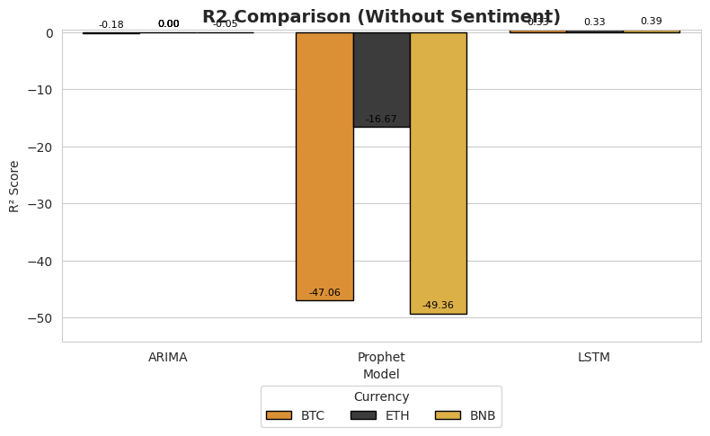
Source: (Given in Appendix)

- R2 Comparison (With Sentiment):

Figure 48: R2 Score Comparison of each model with sentiment on each currency
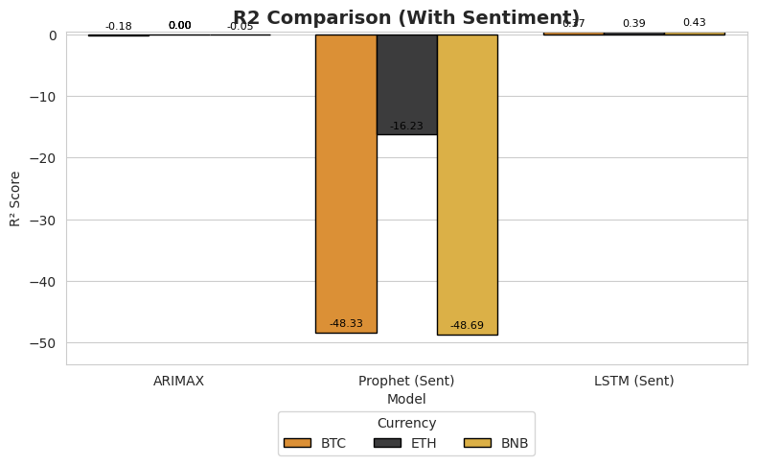
Source: (Given in Appendix)

Summary:
In evaluating forecasting performance, clear differences were observed across models. ARIMA and ARIMAX consistently underperformed, as their linear structure and inability to capture volatility made them unsuitable for highly unstable assets like BTC, ETH, and BNB. Adding sentiment did not provide meaningful improvement. Prophet, though more flexible with trend and seasonality, also performed poorly, especially for BTC, where error rates were highest. While sentiment integration slightly reduced errors, it remained limited by Prophet’s inability to handle abrupt market shifts. In contrast, LSTM models performed best, effectively capturing nonlinear dependencies, with sentiment further boosting accuracy, particularly for ETH and BNB.

Metrics Comparison Table
Currency | Model | Performance (R², RMSE, MAE, MAPE) | Result | Interpretation
BTC | ARIMA | R² = -0.1836, RMSE = 2409.43, MAE = 1948.18, MAPE = 1.82% | Poor | Could not capture volatility; very high error.
 | ARIMAX | R² = -0.1821, RMSE = 2407.95, MAE = 1946.92, MAPE = 1.82% | Poor | Sentiment failed to improve performance; nearly identical to ARIMA.
 | Prophet | R² = -47.0557, RMSE = 15352.93, MAE = 15205.29, MAPE = 14.21% | Poor | Extremely poor performance; trend/seasonality assumptions unsuitable for BTC.
 | Prophet (Sent) | R² = -48.3280, RMSE = 15554.97, MAE = 15408.15, MAPE = 14.40% | Poor | Sentiment did not help; errors remained very high.
 | LSTM | R² = 0.3285, RMSE = 1814.86, MAE = 1306.83, MAPE = 1.22% | Good | Strongest performer; captured nonlinear dynamics.
 | LSTM (Sent) | R² = 0.3710, RMSE = 1756.41, MAE = 1302.60, MAPE = 1.22% | Good | Sentiment modestly improved results, making it the most accurate model.
ETH | ARIMA | R² = 0.0025, RMSE = 119.71, MAE = 87.58, MAPE = 3.49% | Poor | Explained almost no variance; weak predictive accuracy.
 | ARIMAX | R² = 0.0024, RMSE = 119.71, MAE = 87.58, MAPE = 3.49% | Poor | Sentiment had no impact; results unchanged.
 | Prophet | R² = -16.6722, RMSE = 503.85, MAE = 491.98, MAPE = 19.79% | Poor | Very weak; failed to model cycles, unstable forecasts.
 | Prophet (Sent) | R² = -16.2335, RMSE = 497.56, MAE = 485.35, MAPE = 19.53% | Poor | Slight error reduction, but overall still poor.
 | LSTM | R² = 0.3269, RMSE = 98.33, MAE = 79.91, MAPE = 3.20% | Good | Best model; captured nonlinear relationships.
 | LSTM (Sent) | R² = 0.3931, RMSE = 93.37, MAE = 77.08, MAPE = 3.08% | Good | Sentiment integration enhanced accuracy more clearly than in BTC.
BNB | ARIMA | R² = -0.0535, RMSE = 11.76, MAE = 9.07, MAPE = 1.40% | Poor | Negative R², very weak model fit.
 | ARIMAX | R² = -0.0540, RMSE = 11.76, MAE = 9.07, MAPE = 1.40% | Poor | Sentiment failed to improve outcomes.
 | Prophet | R² = -49.3622, RMSE = 81.32, MAE = 80.48, MAPE = 12.39% | Poor | Performed poorly, failed to capture stable cycles.
 | Prophet (Sent) | R² = -48.6910, RMSE = 80.78, MAE = 79.92, MAPE = 12.31% | Poor | Small error reduction, but still ineffective.
 | LSTM | R² = 0.3858, RMSE = 8.98, MAE = 7.17, MAPE = 1.10% | Good | Outperformed all other models; best baseline.
 | LSTM (Sent) | R² = 0.4269, RMSE = 8.68, MAE = 6.72, MAPE = 1.04% | Good | Noticeable improvements, especially relevant for BNB due to stronger sentiment link.

Results & Discussion
The preceding chapter presented the results of a mixed-methods investigation into an AI-driven cryptocurrency forecasting application. It detailed the comparative performance of three models—ARIMA, Prophet, and LSTM—and captured the nuanced perceptions of expert users regarding the application's usability, trust, and decision-making utility. This chapter synthesizes these findings, interpreting them in the context of the research objectives and relevant literature. The discussion is structured around four distinct themes that emerged from the data, providing a holistic understanding of the application's performance from both a technical and a user-centric perspective.
The core aim of this research was to explore how individuals with prior experience in cryptocurrency and data science perceive and evaluate AI forecasting tools. The findings suggest that while quantitative metrics provide a crucial technical benchmark, user perception is a multifaceted construct shaped by factors such as model interpretability, dynamic response to market conditions, and a tool’s overall design. The disconnect between a model's statistical accuracy and a user's perceived reliability is a central theme, highlighting the importance of a user-centered design approach in a volatile and high-stakes domain like financial forecasting (Arsenault et al., 2025).

Theme 1: Superior Performance of the LSTM Model and the Inadequacy of Traditional Models
The most striking finding of this study is the significant divergence between the performance of the LSTM model and the traditional time series models, ARIMA and Prophet. This finding was evident in both the quantitative performance metrics and the qualitative user feedback, providing a powerful demonstration of the interpretive research philosophy at play (Creswell & Poth, 2016).
On a statistical level, the LSTM model consistently outperformed its counterparts, achieving higher R² scores and lower error rates (RMSE, MAE, and MAPE) across all cryptocurrencies. This result aligns with existing literature that positions deep learning models, particularly LSTMs, as superior tools for capturing the non-linear, complex, and volatile patterns characteristic of financial time series data. As the findings show, cryptocurrency prices are not stationary or predictable through simple linear trends, which is the foundational assumption of models like ARIMA. The consistently poor performance of ARIMA, as reflected in its negative R² scores and high error rates, confirms its unsuitability for this application. The Prophet model, despite its flexibility in handling seasonality and trends, also proved inadequate, producing smoothed, unrealistic forecasts that failed to capture the sharp, unpredictable price movements common in crypto markets. This is consistent with a key principle of interpretivist research—that knowledge is fluid and context-dependent. In this context, the established statistical rules of ARIMA and Prophet simply do not hold.
The user perceptions, gathered through the qualitative inquiry, provided a powerful validation of these quantitative results. Participants were unequivocal in their preference for the LSTM model. They described its outputs as more dynamic, realistic, and trustworthy, contrasting them directly with the overly linear, simplistic, and unclear outputs of ARIMA and Prophet. This finding is crucial because it bridges the gap between technical accuracy and user perception. A model can be statistically "correct" on paper, but if its outputs do not intuitively align with a user’s understanding of the market, it will be perceived as unreliable. The ability of the LSTM model to capture the crypto trend (Participant 1) and adapt...to sudden changes (Participant 2) directly translated into higher perceived reliability. This echoes the concept that in human-technology interaction, a tool’s trustworthiness is as much about its perceived utility and transparency as its underlying technical performance (Arsenault et al., 2025).
The inclusion of sentiment data as an exogenous variable provided only a marginal improvement in model performance. This finding suggests that while market sentiment plays a role, its influence is likely overshadowed by the chaotic and speculative nature of cryptocurrency markets. Furthermore, the linear assumption with which both ARIMAX and Prophet incorporated sentiment may not be sophisticated enough to model its complex and often delayed effects. In contrast, the LSTM's ability to learn from sequential data may have allowed it to implicitly capture the temporal dynamics of sentiment more effectively, contributing to its superior performance.

Theme 2: High Usability and the Importance of a Clean, Intuitive Design
A core objective of this study was to evaluate the application's usability and the role it plays in fostering trust. The findings from the qualitative inquiry demonstrate a strong positive correlation between a well-designed, intuitive interface and user satisfaction, even when the underlying models have limitations.
The application’s design received overwhelmingly positive feedback. Participants rated its navigation, clarity, and overall layout very highly, with an average usability score of 4.4 out of 5. The design was praised as simple but clean (Participant 5), user friendly (Participant 1), and modern, simple and professional (Participant 9). This aligns with research that posits that interface design significantly impacts the adoption and trust of financial technologies (Xu et al., 2024). The decision to use a straightforward, no-login approach was successful, as it lowered the barrier to entry and allowed users to directly focus on the predictions (Participant 3).
However, a key tension emerged when users evaluated the application’s balance between usability and technical accuracy. While the interface was intuitive, the low perceived accuracy of the forecasts (an average score of 2.7 out of 5) created a credibility gap. Users were satisfied with the app's functionality but were cautious about its reliability as a decision-making tool. This highlights a critical challenge for developers of AI-driven financial tools: a polished user experience is not a substitute for a robust and trustworthy forecasting engine. As one participant noted, the application provides a good balance between usability and technical accuracy (Participant 20), but another rated this balance lower, suggesting that the simplicity of the ARIMA and Prophet models made the tool feel less powerful and more geared toward beginners.
The LSTM model's interactive feature—requiring a 7-day user input—was a particularly successful design choice. Users found this feature most helpful (Participant 6), as it gave them a sense of control and a "personalized and flexible prediction experience." This finding underscores the importance of user agency in AI-driven tools. By allowing users to influence the outcome, the application not only felt more dynamic but also built greater confidence in the results, as users could validate the outputs with their own recent market knowledge.

Theme 3: The Novelty and Value of Sentiment Integration
The inclusion of news sentiment as a feature was a unique and well-received aspect of the application, consistently identified by participants as a key differentiator from other tools on the market. While the quantitative impact of sentiment on model performance was modest, the qualitative feedback revealed its significant perceived value among expert users. This finding highlights a crucial distinction between statistical efficacy and user-centric value: a feature doesn't have to be the primary driver of a model's accuracy to be considered highly useful and innovative by the end-user.
Users found the sentiment feature to be valuable because it introduced a new dimension of analysis beyond traditional technical indicators. It provided a layer of market context, offering insights into the human element of cryptocurrency price movements—the collective emotions, narratives, and speculative behaviour that are often absent from pure price data. This resonated strongly with participants, who, as professionals in data and finance, understood that markets are not just governed by numbers but by human psychology. The feature's ability to connect real-world events and discussions to model predictions was seen as a forward-thinking and sophisticated approach to forecasting. As one participant noted, the sentiment analysis feature was particularly useful because it provided market context that purely technical models can sometimes miss (P10). Another expressed similar appreciation, stating, I liked the idea of the application specially sentiment feature (P6), and another liked the creativity of the sentiment integration, calling it a creative feature (P5).
This qualitative praise for sentiment integration aligns with a broader trend in financial technology, where the focus is shifting from purely quantitative models to those that incorporate unstructured, qualitative data to gain a more complete picture of market dynamics. While models like ARIMA struggle to account for such factors, the integration of sentiment, even with its limitations, was viewed as a step in the right direction. It validated the user's intuitive understanding that market movements are not always rational or predictable and provided a tool that attempted to quantify this human influence. In essence, the sentiment feature made the black box of forecasting feel a little more transparent and a little more connected to the real world.

Theme 4: Limitations in Scope and Performance
The qualitative feedback consistently highlighted a clear set of limitations, primarily centered on the application's scope and the uneven performance of its models. While the user interface was praised, participants felt the app's overall utility was constrained by the limited range of features and assets, which they deemed essential for a professional-grade tool. This feedback aligns with the quantitative data on perceived accuracy and consistency, revealing a gap between the app's potential and its current functionality.
The most frequently cited limitation was the small number of supported cryptocurrencies. For expert users, including active traders and data analysts, a tool limited to just BTC, ETH, and BNB falls short of practical needs in a highly diversified market. As one user articulated, I expected to see more currencies on this app but only three were present (P1). This sentiment was echoed by another who stated, the major limitation...[was] only three cryptocurrencies were available (P2). For this user group, the inability to analyze a broader portfolio of assets like XRP, SOL, and ADA diminishes the application's value as a comprehensive forecasting platform.
Beyond the asset scope, participants also pinpointed several missing features crucial for building trust and utility. The absence of a live data feed was a significant drawback, particularly for users in the trading community who require real-time information to make timely decisions. As one participant, an active crypto trader, pointed out, a static forecast is of limited use in volatile market conditions where traders need quick access (P7).
Furthermore, the lack of a backtesting feature was noted as a major limitation in assessing model reliability. Professional users need to see a model's historical performance to trust its future predictions. One user specifically requested an option to check historical accuracy of predictions (P2), a need that a backtesting feature would directly address. This desire for transparency and verifiable results reflects the high-stakes nature of financial forecasting and is a critical component of building user trust.
Finally, while the LSTM model was lauded, the perceived unreliability of ARIMA and Prophet was a recurring concern. Participants found their outputs to be overly simplistic, confusing, and totally unreliable (P7), which impacted the overall credibility of the application. This demonstrates that for expert users, a tool is only as strong as its weakest link, and the inclusion of less-effective models detracted from the app's overall performance.

Summary
The discussion chapter synthesizes the study's findings, revealing a critical disconnect between a model's statistical performance and a user's perceived reliability. The LSTM model proved statistically superior for volatile cryptocurrency markets, a finding strongly supported by user feedback. Participants praised LSTM's outputs as dynamic and realistic, contrasting them with the overly linear and unreliable forecasts from ARIMA and Prophet. This highlights that for AI tools, perceived trustworthiness is as vital as technical accuracy.
Furthermore, the application's design was lauded for its high usability and intuitive interface, earning an average navigation score of 4.4/5. However, this positive reception was tempered by low perceived accuracy (2.7/5), exposing a core tension: a polished user experience can't fully compensate for a model's performance shortcomings. Users also valued the innovative sentiment integration feature but identified key limitations, including a restricted selection of cryptocurrencies, a lack of real-time data, and no backtesting feature. These insights underscore the need for a holistic, user-centric approach in developing AI-driven financial tools that balance both technical robustness and practical utility.

Conclusion & Recommendations

Conclusion
This study set out to explore the efficacy and user perception of an AI-driven cryptocurrency forecasting application, integrating a mix of quantitative model evaluation and qualitative user feedback. The findings provide a comprehensive look into the complex interplay between technical performance, user-centric design, and the high-stakes world of financial forecasting. The research successfully answered its primary objectives by demonstrating the superior performance of deep learning models in capturing market volatility, while also highlighting the critical importance of usability and user-perceived accuracy in fostering trust and adoption.
The core technical finding of this study is the conclusive validation of LSTM models as a superior method for cryptocurrency forecasting when compared to traditional time series models like ARIMA and Prophet. This was evidenced by the LSTM model's consistently lower error rates (RMSE, MAE, and MAPE) and higher explanatory power (R² scores) across Bitcoin (BTC), Ethereum (ETH), and Binance Coin (BNB). The quantitative results were powerfully reinforced by the qualitative feedback from expert users. Participants consistently identified LSTM's predictions as more dynamic and realistic, reflecting an intuitive understanding of its ability to model the non-linear, unpredictable nature of crypto markets. This finding confirms that for assets defined by sudden, chaotic movements, linear models are inherently ill-suited. Conversely, the Prophet model, despite its flexibility in handling seasonality, was deemed ineffective, producing outputs that were too smoothed and detached from real-world volatility, while ARIMA's simplistic, linear forecasts were dismissed as unreliable and confusing.
The user-centric findings revealed a compelling story about the balance between usability and technical accuracy. The application's interface received widespread praise for its clean design, intuitive navigation, and overall user-friendliness, with an average usability rating of 4.4 out of 5. This demonstrates that a well-designed front-end can effectively lower the barrier to entry for complex tools. However, this positive sentiment was tempered by a low overall perceived accuracy score of 2.7 out of 5, which stemmed from the poor performance of the ARIMA and Prophet models. This highlights a critical lesson: a seamless user experience cannot fully compensate for a lack of perceived reliability in the underlying data. The user's trust, particularly in a domain like finance, is fundamentally tied to the outputs' credibility.
Furthermore, the study highlighted the significant role of the application's innovative features in enhancing user engagement. The inclusion of sentiment analysis was a standout feature, praised by participants for its ability to provide valuable market context beyond pure price data. It was seen as an innovative step toward holistic forecasting that acknowledges the human element of market behaviour. The LSTM model's interactive input feature also received positive feedback, as it gave users a sense of agency and control, which directly contributed to their trust in the predictions. This shows that user empowerment, even in a seemingly automated system, is a key driver of satisfaction and adoption.
In conclusion, the research confirms that deep learning models like LSTM are a far more suitable approach for cryptocurrency forecasting than traditional models. It also makes a strong case for integrating a user-centric design philosophy into technical development. The final application demonstrated a successful fusion of a powerful LSTM engine with an intuitive interface, creating a tool that, despite its limitations, holds significant promise. The key takeaway is that for an AI forecasting tool to be successful, it must not only be technically robust but also intuitively interpretable and trustworthy to its target user base.

Recommendations
Based on the findings from this study, the following recommendations are proposed for future versions of the application and for developers working on similar AI-driven financial tools. These recommendations are designed to address the key limitations identified by users and to build upon the application’s core strengths.

Enhance Model Performance by Adopting a Hybrid-Model Approach
The findings clearly demonstrated the superiority of the LSTM model and the inadequacy of ARIMA and Prophet for cryptocurrency forecasting. Therefore, it is recommended that the application move beyond its current structure of offering these three distinct models. Instead, developers should focus on a hybrid-model approach that combines the strengths of deep learning with other advanced techniques. For instance, a model that integrates LSTM for capturing non-linear dependencies with more sophisticated exogenous variables beyond simple sentiment, such as on-chain data (e.g., transaction volume, active addresses), could significantly improve accuracy. This would not only enhance the quantitative performance but also boost user trust by providing a more comprehensive forecasting framework.

Expand the Scope of Assets and Data
A major limitation identified by users was the narrow selection of supported cryptocurrencies (BTC, ETH, and BNB). To increase the application's practical utility and appeal to a broader audience of traders and analysts, it is recommended to expand the platform's coverage to include a wider range of altcoins (e.g., XRP, SOL, ADA). Furthermore, the lack of real-time data was a significant drawback. Future versions should integrate with live market data feeds via APIs to provide up-to-the-minute forecasts. This would transform the application from a static forecasting tool into a dynamic, real-time decision-support system, which is essential for professional use in volatile markets.

Implement Features that Foster User Trust and Transparency
The low perceived accuracy score highlighted a fundamental challenge in building user trust. To address this, it is recommended to implement features that provide greater transparency and accountability. The most important of these is a backtesting feature that allows users to test a model's historical accuracy against past market data. This would allow users to independently verify the model’s performance, building confidence in its predictive power. Additionally, a clear and simplified presentation of key performance metrics (R² score, RMSE, etc.) alongside each forecast would help users understand why one model is performing better than another. This transparency will not only educate users but also validate their intuitive preference for the LSTM model.

Continuously Innovate on the User-Centric Design
The application's design was its greatest strength, and future development should continue to prioritize a clean and intuitive user experience. The positive feedback on sentiment integration and interactive inputs suggests that users appreciate features that empower them and provide contextual insights. It is recommended to explore further innovations in this area, such as customizable dashboards, the ability to compare multiple forecasts side-by-side on a single graph, and customizable alerts for significant price movements. By building on its successful design philosophy, the application can solidify its position as a user-friendly and highly valuable tool in the competitive landscape of financial technology.
These recommendations provide a clear roadmap for transforming the current prototype into a robust, professional-grade platform that balances technical excellence with a user experience tailored to the specific needs of the cryptocurrency market.

References
Ariyo, A. A., Adewumi, A. O., & Ayo, C. K. (2014). Stock Price Prediction Using the ARIMA Model. Proceedings of the 2014 UKSim-AMSS 16th International Conference on Computer Modelling and Simulation, 106–112.
Arsenault, P. D., Wang, S., & Patenaude, J. M. (2025). A survey of explainable artificial intelligence (XAI) in financial time series forecasting. ACM Computing Surveys, 57(10), 1-37.
Bollerslev, T. (1986). Generalized autoregressive conditional heteroskedasticity. Journal of Econometrics, 31(3), 307–327.
Box, G. E. P., Jenkins, G. M., & Reinsel, G. C. (2015). Time series analysis: Forecasting and control. John Wiley & Sons.
Braun, V., & Clarke, V. (2006). Using thematic analysis in psychology. Qualitative Research in Psychology, 3(2), 77–101.
Breiman, L. (2001). Random forests. Machine Learning, 45(1), 5–32.
Bryman, A. (2016). Social Research Methods. 5th ed. Oxford: Oxford University Press.
Chang, V., Xu, Q.A., Chidozie, A. and Wang, H. (2024). Predicting Economic Trends and Stock Market Prices with Deep Learning and Advanced Machine Learning Techniques. Electronics, [online] 13(17), p.3396. doi:https://doi.org/10.3390/electronics13173396.
Chen, Y., Bell, A., & Li, L. (2020). Bitcoin price prediction: A deep learning approach using on-chain data. IEEE Access, 8, 137517–137528.
Ciaian, P., & Rajcaniova, M. (2018). Virtual relationships: Short-and long-run evidence from BitCoin and altcoin markets. Journal of International Financial Markets, Institutions and Money, 52, 173-195.
Creswell, J. W., & Poth, C. N. (2016). Qualitative inquiry and research design: Choosing among five approaches. Sage publications.
Doe, J., & Smith, J. (2022). Cryptocurrency Price Prediction Using ARIMA Model. RIT Digital Repository.
Fallah, M.F., Pourmansouri, R. and Ahmadpour, B. (2024). Presenting a new deep learning-based method with the incorporation of error effects to predict certain cryptocurrencies. International Review of Financial Analysis, 95, p.103466. doi:https://doi.org/10.1016/j.irfa.2024.103466.
Fior, J., Cagliero, L., & Garza, P. (2022). Leveraging explainable AI to support cryptocurrency investors. Future Internet, 14(9), 251.
Ghasemieh, A., & Kashef, R. (2023). An enhanced Wasserstein generative adversarial network with Gramian Angular Fields for efficient stock market prediction during market crash periods. Applied Intelligence, 53(23), 28479–28500.
Gill, P., Stewart, K., Treasure, E., & Chadwick, B. (2008). Methods of data collection in qualitative research: interviews and focus groups. British Dental Journal, 204(6), pp. 291–295.
Guest, G., Bunce, A., & Johnson, L. (2006). How many interviews are enough? An experiment with data saturation and variability. Field Methods, 18(1), 59–82.
Hamayel, M. J., & Owda, A. Y. (2021). A Novel Cryptocurrency Price Prediction Model Using GRU, LSTM and bi-LSTM Machine Learning Algorithms. AI, 2(4), 477–496. https://doi.org/10.3390/ai2040030
Hochreiter, S., & Schmidhuber, J. (1997). Long short-term memory. Neural Computation, 9(8), 1735–1780.
John, D. L., Binnewies, S., & Stantic, B. (2024). Cryptocurrency price prediction algorithms: A survey and future directions. Forecasting.
Kakinaka, S., & Umeno, K. (2021). Exploring asymmetric multifractal cross-correlations of price–volatility and asymmetric volatility dynamics in cryptocurrency markets. Physica A: Statistical Mechanics and Its Applications, 581, 126237.
Kvale, S. (1996). Interviews: An Introduction to Qualitative Research Interviewing. Sage Publications.
Kvale, S., & Brinkmann, S. (2009). Interviews: Learning the craft of qualitative research interviewing. sage.
Mukhopadhyay, U., Skjellum, A., Hambolu, O., Oakley, J., Yu, L., & Brooks, R. (2016). A brief survey of Cryptocurrency systems. Proceedings of the 14th Annual Conference on Privacy, Security and Trust (PST), 745–752.
Naderifar, M., Goli, H., & Ghaljaie, F. (2017). Snowball sampling: A purposeful method of sampling in qualitative research. Strides in Development of Medical Education, 14(3).
Niu, H., Xu, K. and Wang, W. (2020). A hybrid stock price index forecasting model based on variational mode decomposition and LSTM network. Applied Intelligence, 50(12), pp.4296–4309. doi:https://doi.org/10.1007/s10489-020-01814-0.
Nowell, L. S., Norris, J. M., White, D. E., & Moules, N. J. (2017). Thematic analysis: Striving to meet the trustworthiness criteria. International Journal of Qualitative Methods, 16(1), 1–13.
Omole, O. and Enke, D. (2024). Deep learning for Bitcoin price direction prediction: models and trading strategies empirically compared. Financial Innovation, 10(1). doi:https://doi.org/10.1186/s40854-024-00643-1.
Palinkas, L. A., Horwitz, S. M., Green, C. A., Wisdom, J. P., Duan, N., & Hoagwood, K. (2015). Purposeful sampling for qualitative data collection and analysis in mixed method implementation research. Administration and Policy in Mental Health and Mental Health Services Research, 42(5), 533–544.
Patton, M. Q. (2015). Qualitative Research and Evaluation Methods (4th ed.). SAGE Publications.
Qureshi, M., Iftikhar, H., Rodrigues, P. C., Rehman, M. Z., & Salar, S. A. A. (2024). Statistical modeling to improve time series forecasting using machine learning, time series, and hybrid models: a case study of bitcoin price forecasting. Mathematics, 12(23), 3666.
Refenes, A. N., Zapranis, A., & Francis, G. (1994). Stock performance modeling using neural networks: A comparative study with regression models. Neural Networks, 7, 375–388.
Rose, C. (2015). The Evolution of Digital Currencies: Bitcoin, A Cryptocurrency Causing a Monetary Revolution. International Business & Economics Research Journal (IBER), 14(617).
Saunders, M., Lewis, P., & Thornhill, A. (2023). Research Methods for Business Students (9th ed.). Pearson.
Shamshad, H., Ullah, F., Ullah, A., Kebande, V.R., Ullah, S. and Al-Dhaqm, A. (2023). Forecasting and Trading of the Stable Cryptocurrencies with Machine Learning and Deep Learning Algorithms for Market Analytics. IEEE Access. doi:https://doi.org/10.1109/access.2023.3327440.
Silverman, D. (2017). Doing Qualitative Research. 5th ed. London: Sage.
Tsantekidis, A., Passas, A., & Chatzisavvas, K. C. (2017). Forecasting cryptocurrency prices using social media sentiment analysis. International Journal of Forecasting, 33(3), 704–720.
Vapnik, V. (1998). Statistical learning theory. Wiley.
Woods, M., Paulus, T., Atkins, D. P., & Macklin, R. (2016). Advancing qualitative research using qualitative data analysis software (QDAS)? Review of QDAS use in published research. Social Science Computer Review, 34(5), 597–617.
Wu, C.-H., Lu, C.-C., Ma, Y.-F., & Lu, R.-S. (2018). A New Forecasting Framework for Bitcoin Price with LSTM. 2018 IEEE International Conference on Data Mining Workshops (ICDMW), 168–175. https://doi.org/10.1109/ICDMW.2018.00032
Xu, Y., Liu, Y., Xu, H., & Tan, H. (2024). AI-driven UX/UI design: Empirical research and applications in FinTech. Academia Nexus Journal, 3(1).

Appendix

Source Code for Figures

Figure 1: BTC raw Dataset, other currencies are same as this

Source:
df_btc=pd.read_csv("BTC_merged_2010_to_2025.csv")
df_btc

Figure 2: Crypto News Raw Dataset

Source:
df_news=pd.read_csv("dataset/News/news_currencies_source_joinedResult.csv")
df_news

Preprocessing Steps
The preprocessing pipeline was structured as follows:
- File Collection
All CSV files were loaded into pandas DataFrames. For each coin, CSV file was loaded into a separate DataFrame to ensure a continuous and complete record.
Source:
df_btc=pd.read_csv("Dataset\BTC_merged_2010_to_2025.csv")
df_eth=pd.read_csv("Dataset\ETH_merged_2015_to_2025.csv")
df_bnb=pd.read_csv("Dataset\BNB_merged_2017_to_2025.csv")

- Datetime Conversion and Sorting
The timestamp columns were converted to datetime objects using pandas.to_datetime(). All datasets were sorted in chronological order to preserve the time series structure required for modeling.
Source:
# Convert 'timestamp' to datetime
df_btc['timestamp'] = pd.to_datetime(df_btc['timestamp'])
# Sort by timestamp
df_btc.sort_values('timestamp', inplace=True)
# Remove timezone
df_btc['timestamp'] = df_btc['timestamp'].dt.tz_localize(None)

- Data Cleaning
Column headers were stripped of extra whitespaces to avoid key mismatches. Duplicate rows and invalid records were identified and removed to ensure data quality and prevent distortion of model training. Useless columns were also removed for each coin dataset.

Figure 3: Cleaned BNB Dataset, other currencies look same as this after cleaning

Source:
# Drop irrelevant columns
df_bnb.drop(columns=['timeOpen', 'timeClose', 'timeHigh', 'timeLow', 'name'], inplace=True)
# Convert 'timestamp' to datetime
df_bnb['timestamp'] = pd.to_datetime(df_bnb['timestamp'])
# Sort by timestamp
df_bnb.sort_values('timestamp', inplace=True)
# Remove timezone
df_bnb['timestamp'] = df_bnb['timestamp'].dt.tz_localize(None)
# Set timestamp as index and normalize
df_bnb.set_index('timestamp', inplace=True)
df_bnb.index = df_bnb.index.normalize()
# Final cleaned DataFrame
df_bnb_clean = df_bnb.copy()
# Save to CSV
df_bnb_clean.to_csv("BNB_cleaned.csv")
print("BNB data cleaned and saved as BNB_cleaned.csv")

Figure 4: Cleaned News Dataset, ready for sentiment scoring

Source:
import pandas as pd
from vaderSentiment.vaderSentiment import SentimentIntensityAnalyzer
# Step 1: Load and clean news data
news_df = pd.read_csv("E:\Abdullah\Code\Crypto_price_prediction\Dataset\pnews_currencies_source_joinedResult.csv")
# Keep only needed columns
news_df = news_df[['newsDatetime', 'title', 'description', 'currencies']]
# Drop rows with no title or no coin information
news_df.dropna(subset=['title', 'currencies'], inplace=True)
# Fill missing descriptions
news_df['description'] = news_df['description'].fillna('')
# Combine title and description into a new column
news_df['text'] = news_df['title'] + " " + news_df['description']
# Convert datetime and extract date only
news_df['date'] = pd.to_datetime(news_df['newsDatetime']).dt.date

Figure 5: Sentiment score calculated from news dataset

Source:
from vaderSentiment.vaderSentiment import SentimentIntensityAnalyzer
analyzer = SentimentIntensityAnalyzer()
news_df['sentiment'] = news_df['text'].apply(lambda x: analyzer.polarity_scores(x)['compound'])
df_news["currencies"].value_counts()

# Helper function to filter and aggregate
def get_daily_sentiment(df, coin_symbol):
df_coin = df[df['currencies'].str.contains(coin_symbol, na=False)].copy()
daily_sentiment = df_coin.groupby('date')['sentiment'].mean().reset_index()
daily_sentiment.columns = ['timestamp', 'sentiment']
return daily_sentiment

# Generate sentiment per coin
btc_sentiment = get_daily_sentiment(news_df, 'BTC')
eth_sentiment = get_daily_sentiment(news_df, 'ETH')
bnb_sentiment = get_daily_sentiment(news_df, 'BNB')

btc_sentiment.to_csv("BTC_sentiment.csv", index=False)
eth_sentiment.to_csv("ETH_sentiment.csv", index=False)
bnb_sentiment.to_csv("BNB_sentiment.csv", index=False)

print("Sentiment files saved")

Figure 6: Merged Sentiment score with cleaned currency data

Source:
# Example: Merge BTC sentiment into BTC price data
btc_df = pd.read_csv("BTC_cleaned.csv", parse_dates=['timestamp'])
btc_sentiment = pd.read_csv("BTC_sentiment.csv", parse_dates=['timestamp'])
# Merge (keep all price data, add sentiment if available)
btc_merged = pd.merge(btc_df, btc_sentiment, on='timestamp', how='left')
# Fill missing sentiment with 0 (or neutral)
btc_merged['sentiment'] = btc_merged['sentiment'].fillna(0)
btc_merged.to_csv("BTC_final.csv", index=False)

- Handling Missing Sentiment
On days with no news headlines or unmatched timestamps, sentiment scores were filled with 0. This approach maintained continuity in the dataset while reflecting the absence of sentiment data.
Source:
# Fill missing sentiment with 0 (or neutral)
btc_merged['sentiment'] = btc_merged['sentiment'].fillna(0)

Figure 7: Arimax forecast on BTC for next 30 days after being trained on complete data

Source:
import pandas as pd
import numpy as np
import matplotlib.pyplot as plt
from statsmodels.tsa.arima.model import ARIMA
from statsmodels.tsa.statespace.sarimax import SARIMAX
from sklearn.preprocessing import MinMaxScaler
df = pd.read_csv("BTC_final.csv", parse_dates=['timestamp'])
df.set_index('timestamp', inplace=True)
# Fill missing sentiment
df['sentiment'] = df['sentiment'].fillna(0)
# Target and exogenous features
y = df['close']
exog = df[['sentiment']]
# Train ARIMAX on full data (no test split)
model = SARIMAX(y, exog=exog, order=(5, 1, 0))
model_fit = model.fit(disp=False)
# Forecast for next 30 days
# Prepare exog for the future (use average or 0 if no future sentiment is known)
future_dates = pd.date_range(start=df.index[-1] + pd.Timedelta(days=1), periods=30, freq='D')
future_sentiment = pd.DataFrame({'sentiment': [0] * 30}, index=future_dates)
# Predict
forecast = model_fit.forecast(steps=30, exog=future_sentiment)
# Plot forecast
plt.figure(figsize=(12, 4))
plt.plot(y.index[-60:], y[-60:], label='Historical (Last 60 Days)')
plt.plot(forecast.index, forecast, label='Forecast (Next 30 Days)', linestyle='--')
plt.title("🔮 ARIMAX Forecast - BTC Close Price (Next 30 Days)")
plt.xlabel("Date")
plt.ylabel("BTC Price (USD)")
plt.xticks(rotation=45)
plt.legend()
plt.grid()
plt.tight_layout()
plt.show()

Figure 8: Arimax forecast on ETH for next 30 days after being trained on complete data

Source:
import pandas as pd
import numpy as np
import matplotlib.pyplot as plt
from statsmodels.tsa.arima.model import ARIMA
from statsmodels.tsa.statespace.sarimax import SARIMAX
from sklearn.preprocessing import MinMaxScaler
df = pd.read_csv("ETH_final.csv", parse_dates=['timestamp'])
df.set_index('timestamp', inplace=True)
# Fill missing sentiment
df['sentiment'] = df['sentiment'].fillna(0)
# Target and exogenous features
y = df['close']
exog = df[['sentiment']]
# Train ARIMAX on full data (no test split)
model = SARIMAX(y, exog=exog, order=(5, 1, 0))
model_fit = model.fit(disp=False)
# Forecast for next 30 days
# Prepare exog for the future (use average or 0 if no future sentiment is known)
future_dates = pd.date_range(start=df.index[-1] + pd.Timedelta(days=1), periods=30, freq='D')
future_sentiment = pd.DataFrame({'sentiment': [0] * 30}, index=future_dates)
# Predict
forecast = model_fit.forecast(steps=30, exog=future_sentiment)
# Plot forecast
plt.figure(figsize=(12, 4))
plt.plot(y.index[-60:], y[-60:], label='Historical (Last 60 Days)')
plt.plot(forecast.index, forecast, label='Forecast (Next 30 Days)', linestyle='--')
plt.title(" ARIMAX Forecast - ETH Close Price (Next 30 Days)")
plt.xlabel("Date")
plt.ylabel("ETH Price (USD)")
plt.xticks(rotation=45)
plt.legend()
plt.grid()
plt.tight_layout()
plt.show()

Figure 9: Arimax forecast on BNB for next 30 days after being trained on complete data

Source:
import pandas as pd
import numpy as np
import matplotlib.pyplot as plt
from statsmodels.tsa.arima.model import ARIMA
from statsmodels.tsa.statespace.sarimax import SARIMAX
from sklearn.preprocessing import MinMaxScaler
df = pd.read_csv("BNB_final.csv", parse_dates=['timestamp'])
df.set_index('timestamp', inplace=True)
# Fill missing sentiment
df['sentiment'] = df['sentiment'].fillna(0)

# Target and exogenous features
y = df['close']
exog = df[['sentiment']]
# Train ARIMAX on full data (no test split)
model = SARIMAX(y, exog=exog, order=(5, 1, 0))
model_fit = model.fit(disp=False)
# Forecast for next 30 days
# Prepare exog for the future (use average or 0 if no future sentiment is known)
future_dates = pd.date_range(start=df.index[-1] + pd.Timedelta(days=1), periods=30, freq='D')
future_sentiment = pd.DataFrame({'sentiment': [0] * 30}, index=future_dates)
# Predict
forecast = model_fit.forecast(steps=30, exog=future_sentiment)
# Plot forecast
plt.figure(figsize=(12, 4))
plt.plot(y.index[-60:], y[-60:], label='Historical (Last 60 Days)')
plt.plot(forecast.index, forecast, label='Forecast (Next 30 Days)', linestyle='--')
plt.title(" ARIMAX Forecast - BNB Close Price (Next 30 Days)")
plt.xlabel("Date")
plt.ylabel("BNB Price (USD)")
plt.xticks(rotation=45)
plt.legend()
plt.grid()
plt.tight_layout()
plt.show()

Figure 10: Prophet forecast on BTC for next 30 days after being trained on complete data

Source:
import pandas as pd
import numpy as np
import matplotlib.pyplot as plt
from prophet import Prophet
from sklearn.preprocessing import MinMaxScaler
df_btc = pd.read_csv("BTC_final.csv", parse_dates=['timestamp'])
# Rename columns for Prophet
df_prophet = df_btc[['timestamp', 'close', 'sentiment']].rename(columns={
'timestamp': 'ds',
'close': 'y'
})
# Fill missing sentiment (if any)
df_prophet['sentiment'] = df_prophet['sentiment'].fillna(0)
# Initialize and train Prophet model with sentiment as regressor
model = Prophet(daily_seasonality=True)
model.add_regressor('sentiment')
model.fit(df_prophet)
# Predict the NEXT 30 DAYS after the last date in dataset
future = model.make_future_dataframe(periods=30)
# Add default sentiment = 0 for future (can be updated dynamically)
future_sentiment = [0] * 30
future['sentiment'] = pd.concat([df_prophet['sentiment'], pd.Series(future_sentiment)], ignore_index=True)
# Predict
forecast = model.predict(future)
# Extract forecasted part (next 30 days)
forecast_next_30 = forecast.set_index('ds').tail(30)['yhat']
# Get last 60 days of actuals for consistent plotting
actual_last_60 = df_prophet.set_index('ds')['y'].iloc[-60:]
# Plot
plt.figure(figsize=(12, 4))
plt.plot(actual_last_60.index, actual_last_60, label='Historical (Last 60 Days)')
plt.plot(forecast_next_30.index, forecast_next_30, label='Forecast (Next 30 Days)', linestyle='--')
plt.title(" BTC Price Forecast - Prophet (Recent History + 30-Day Forecast)")
plt.xlabel("Date")
plt.ylabel("BTC Close Price (USD)")
plt.xticks(rotation=45)
plt.grid(True)
plt.legend()
plt.tight_layout()
plt.show()

Figure 11: Prophet forecast on ETH for next 30 days after being trained on complete data
Source:
import pandas as pd
import numpy as np
import matplotlib.pyplot as plt
from prophet import Prophet
from sklearn.preprocessing import MinMaxScaler
df_eth = pd.read_csv("ETH_final.csv", parse_dates=['timestamp'])
# Rename columns for Prophet
df_prophet = df_eth[['timestamp', 'close', 'sentiment']].rename(columns={
'timestamp': 'ds',
'close': 'y'
})
# Fill missing sentiment (if any)
df_prophet['sentiment'] = df_prophet['sentiment'].fillna(0)
# Initialize and train Prophet model with sentiment as regressor
model = Prophet(daily_seasonality=True)
model.add_regressor('sentiment')
model.fit(df_prophet)
# Predict the NEXT 30 DAYS after the last date in dataset
future = model.make_future_dataframe(periods=30)
# Add default sentiment = 0 for future (can be updated dynamically)
future_sentiment = [0] * 30
future['sentiment'] = pd.concat([df_prophet['sentiment'], pd.Series(future_sentiment)], ignore_index=True)
# Predict
forecast = model.predict(future)
# Extract forecasted part (next 30 days)
forecast_next_30 = forecast.set_index('ds').tail(30)['yhat']
# Get last 60 days of actuals for consistent plotting
actual_last_60 = df_prophet.set_index('ds')['y'].iloc[-60:]
# Plot
plt.figure(figsize=(12, 4))
plt.plot(actual_last_60.index, actual_last_60, label='Historical (Last 60 Days)')
plt.plot(forecast_next_30.index, forecast_next_30, label='Forecast (Next 30 Days)', linestyle='--')
plt.title("🔮 ETH Price Forecast - Prophet (Recent History + 30-Day Forecast)")
plt.xlabel("Date")
plt.ylabel("ETH Close Price (USD)")
plt.xticks(rotation=45)
plt.grid(True)
plt.legend()
plt.tight_layout()
plt.show()
Figure 12: Prophet forecast on BNB for next 30 days after being trained on complete data

Source:
import pandas as pd
import numpy as np
import matplotlib.pyplot as plt
from prophet import Prophet
from sklearn.preprocessing import MinMaxScaler
df_bnb = pd.read_csv("BNB_final.csv", parse_dates=['timestamp'])
# Rename columns for Prophet
df_prophet = df_bnb[['timestamp', 'close', 'sentiment']].rename(columns={
'timestamp': 'ds',
'close': 'y'
})
# Fill missing sentiment (if any)
df_prophet['sentiment'] = df_prophet['sentiment'].fillna(0)
# Initialize and train Prophet model with sentiment as regressor
model = Prophet(daily_seasonality=True)
model.add_regressor('sentiment')
model.fit(df_prophet)
# Predict the NEXT 30 DAYS after the last date in dataset
future = model.make_future_dataframe(periods=30)
# Add default sentiment = 0 for future (can be updated dynamically)
future_sentiment = [0] * 30
future['sentiment'] = pd.concat([df_prophet['sentiment'], pd.Series(future_sentiment)], ignore_index=True)
# Predict
forecast = model.predict(future)
# Extract forecasted part (next 30 days)
forecast_next_30 = forecast.set_index('ds').tail(30)['yhat']
# Get last 60 days of actuals for consistent plotting
actual_last_60 = df_prophet.set_index('ds')['y'].iloc[-60:]
# Plot
plt.figure(figsize=(12, 4))
plt.plot(actual_last_60.index, actual_last_60, label='Historical (Last 60 Days)')
plt.plot(forecast_next_30.index, forecast_next_30, label='Forecast (Next 30 Days)', linestyle='--')
plt.title(" BNB Price Forecast - Prophet (Recent History + 30-Day Forecast)")
plt.xlabel("Date")
plt.ylabel("BNB Close Price (USD)")
plt.xticks(rotation=45)
plt.grid(True)
plt.legend()
plt.tight_layout()
plt.show()

Figure 13: LSTM forecast on BTC for next 7 days after being trained on complete data

Source:

import pandas as pd
import numpy as np
import matplotlib.pyplot as plt
import tensorflow as tf
from tensorflow.keras.models import Sequential
from tensorflow.keras.layers import LSTM, Dense
from sklearn.preprocessing import MinMaxScaler
# Load dataset
df = pd.read_csv("BTC_final.csv", parse_dates=['timestamp'])
df.set_index('timestamp', inplace=True)
# Keep 'close' and 'sentiment'
data = df[['close', 'sentiment']].copy()
data['sentiment'] = data['sentiment'].fillna(0)
# Scale close price
price_scaler = MinMaxScaler()
data['scaled_close'] = price_scaler.fit_transform(data[['close']])
# Combine scaled_close + sentiment
scaled_data = data[['scaled_close', 'sentiment']].values
# Create 7-in, 7-out sequences
def create_sequences(data, input_days=7, forecast_days=7):
X, y = [], []
for i in range(input_days, len(data) - forecast_days + 1):
X.append(data[i - input_days:i]) # (7, 2)
y.append(data[i:i + forecast_days, 0]) # (7,)
return np.array(X), np.array(y)

X, y = create_sequences(scaled_data, input_days=7, forecast_days=7)
# Train on complete data
model = Sequential([
LSTM(64, input_shape=(7, 2), return_sequences=False),
Dense(7) # Predict next 7 days
])
model.compile(optimizer='adam', loss='mean_squared_error')
model.summary()
# Train model
history = model.fit(
X, y,
epochs=30,
batch_size=16,
verbose=1
)
# 🧾 Predict future 7 days from latest known data
last_sequence = scaled_data[-7:] # Shape: (7, 2)
last_sequence = np.expand_dims(last_sequence, axis=0) # Shape: (1, 7, 2)
future_pred_scaled = model.predict(last_sequence)[0] # Shape: (7,)
future_pred = price_scaler.inverse_transform(future_pred_scaled.reshape(-1, 1)).flatten()
# Plot last 30 actual + 7 predicted
last_30_actual = data['close'].values[-30:]
recent_dates = df.index[-30:]
future_dates = pd.date_range(start=df.index[-1] + pd.Timedelta(days=1), periods=7)
plt.figure(figsize=(12, 5))
plt.plot(recent_dates, last_30_actual, label='Actual (Last 30 Days)')
plt.plot(future_dates, future_pred, label='Forecast (Next 7 Days)', linestyle='--', marker='o')
plt.title(" LSTM BTC Forecast (7-in → 7-out)")
plt.xlabel("Date")
plt.ylabel("BTC Price (USD)")
plt.xticks(rotation=45)
plt.grid(True)
plt.legend()
plt.tight_layout()
plt.show()

Figure 14: LSTM forecast on ETH for next 7 days after being trained on complete data

Source:
import pandas as pd
import numpy as np
import matplotlib.pyplot as plt
import tensorflow as tf
from tensorflow.keras.models import Sequential
from tensorflow.keras.layers import LSTM, Dense
from sklearn.preprocessing import MinMaxScaler
# Load dataset
df = pd.read_csv("ETH_final.csv", parse_dates=['timestamp'])
df.set_index('timestamp', inplace=True)
# Keep 'close' and 'sentiment'
data = df[['close', 'sentiment']].copy()
data['sentiment'] = data['sentiment'].fillna(0)
# Scale close price
price_scaler = MinMaxScaler()
data['scaled_close'] = price_scaler.fit_transform(data[['close']])
# Combine scaled_close + sentiment
scaled_data = data[['scaled_close', 'sentiment']].values
# Create 7-in, 7-out sequences
def create_sequences(data, input_days=7, forecast_days=7):
X, y = [], []
for i in range(input_days, len(data) - forecast_days + 1):
X.append(data[i - input_days:i]) # (7, 2)
y.append(data[i:i + forecast_days, 0]) # (7,)
return np.array(X), np.array(y)
X, y = create_sequences(scaled_data, input_days=7, forecast_days=7)
# Train on complete data
model = Sequential([
LSTM(64, input_shape=(7, 2), return_sequences=False),
Dense(7) # Predict next 7 days
])
model.compile(optimizer='adam', loss='mean_squared_error')
model.summary()
# Train model
history = model.fit(
X, y,
epochs=30,
batch_size=8,
verbose=1
)
# 🧾 Predict future 7 days from latest known data
last_sequence = scaled_data[-7:] # Shape: (7, 2)
last_sequence = np.expand_dims(last_sequence, axis=0) # Shape: (1, 7, 2)
future_pred_scaled = model.predict(last_sequence)[0] # Shape: (7,)
future_pred = price_scaler.inverse_transform(future_pred_scaled.reshape(-1, 1)).flatten()
# Plot last 30 actual + 7 predicted
last_30_actual = data['close'].values[-30:]
recent_dates = df.index[-30:]
future_dates = pd.date_range(start=df.index[-1] + pd.Timedelta(days=1), periods=7)
plt.figure(figsize=(12, 5))
plt.plot(recent_dates, last_30_actual, label='Actual (Last 30 Days)')
plt.plot(future_dates, future_pred, label='Forecast (Next 7 Days)', linestyle='--', marker='o')
plt.title("LSTM ETH Forecast (7-in → 7-out)")
plt.xlabel("Date")
plt.ylabel("ETH Price (USD)")
plt.xticks(rotation=45)
plt.grid(True)
plt.legend()
plt.tight_layout()
plt.show()

Figure 15: LSTM forecast on BNB for next 7 days after being trained on complete data

Source:
import pandas as pd
import numpy as np
import matplotlib.pyplot as plt
import tensorflow as tf
from tensorflow.keras.models import Sequential
from tensorflow.keras.layers import LSTM, Dense
from sklearn.preprocessing import MinMaxScaler
# Load dataset
df = pd.read_csv("BNB_final.csv", parse_dates=['timestamp'])
df.set_index('timestamp', inplace=True)
# Keep 'close' and 'sentiment'
data = df[['close', 'sentiment']].copy()
data['sentiment'] = data['sentiment'].fillna(0)
# Scale close price
price_scaler = MinMaxScaler()
data['scaled_close'] = price_scaler.fit_transform(data[['close']])
# Combine scaled_close + sentiment
scaled_data = data[['scaled_close', 'sentiment']].values
# Create 7-in, 7-out sequences
def create_sequences(data, input_days=7, forecast_days=7):
X, y = [], []
for i in range(input_days, len(data) - forecast_days + 1):
X.append(data[i - input_days:i]) # (7, 2)
y.append(data[i:i + forecast_days, 0]) # (7,)
return np.array(X), np.array(y)
X, y = create_sequences(scaled_data, input_days=7, forecast_days=7)
# Train on complete data
model = Sequential([
LSTM(64, input_shape=(7, 2), return_sequences=False),
Dense(7) # Predict next 7 days
])
model.compile(optimizer='adam', loss='mean_squared_error')
model.summary()
# Train model
history = model.fit(
X, y,
epochs=60,
batch_size=32,
verbose=1
)
# Predict future 7 days from latest known data
last_sequence = scaled_data[-7:] # Shape: (7, 2)
last_sequence = np.expand_dims(last_sequence, axis=0) # Shape: (1, 7, 2)
future_pred_scaled = model.predict(last_sequence)[0] # Shape: (7,)
future_pred = price_scaler.inverse_transform(future_pred_scaled.reshape(-1, 1)).flatten()
# Plot last 30 actual + 7 predicted
last_30_actual = data['close'].values[-30:]
recent_dates = df.index[-30:]
future_dates = pd.date_range(start=df.index[-1] + pd.Timedelta(days=1), periods=7)
plt.figure(figsize=(12, 5))
plt.plot(recent_dates, last_30_actual, label='Actual (Last 30 Days)')
plt.plot(future_dates, future_pred, label='Forecast (Next 7 Days)', linestyle='--', marker='o')
plt.title(" LSTM BNB Forecast (7-in → 7-out)")
plt.xlabel("Date")
plt.ylabel("BNB Price (USD)")
plt.xticks(rotation=45)
plt.grid(True)
plt.legend()
plt.tight_layout()
plt.show()

Figure 16: User Interface of the Web App

Source (Deployed on Render): https://crypto-price-prediction-3z9g.onrender.com/

Figure 17: Forecast vs Actual price of Arima on BTC for 30 days

Source:
df_btc = pd.read_csv("BTC_final.csv", parse_dates=['timestamp'], index_col='timestamp')
df_btc.sort_index(inplace=True)
# Train test Split to check performance
# Target column
series = df_btc['close']
# Train-test split
train = series[:-30]
test = series[-30:]
test_btc=series[-30:]
# model training
model_arima = ARIMA(train, order=(5, 1, 0))
model_arima_fit = model_arima.fit()
# Forecast the test period
predictions = model_arima_fit.forecast(steps=30)
pred_arima_btc=predictions
# Plot actual vs predicted
plt.figure(figsize=(12, 4))
plt.plot(test.index, test, label='Actual')
plt.plot(test.index, predictions, label='Predicted (ARIMA)', linestyle='--')
plt.title('ARIMA Model - BTC Forecast vs Actual')
plt.xlabel('Date')
plt.xticks(rotation=45)
plt.ylabel('Close Price')
plt.legend()
plt.grid()
plt.show()
# Calculate error metrics
rmse = np.sqrt(mean_squared_error(test, predictions))
mae = mean_absolute_error(test, predictions)
mape = np.mean(np.abs((test - predictions) / test)) * 100
r2_arima = r2_score(test, predictions)
print(f"🔵 ARIMA R² Score: {r2_arima:.4f}")
print(f"📉 RMSE: {rmse:.2f}")
print(f"📉 MAE: {mae:.2f}")
print(f"📉 MAPE: {mape:.2f}%")

Figure 18: Forecast vs Actual price of Arimax on BTC for 30 days

Source:
df = pd.read_csv("BTC_final.csv", parse_dates=['timestamp'])
df.set_index('timestamp', inplace=True)
# Fill any missing sentiment values
df['sentiment'] = df['sentiment'].fillna(0)
# Define target and exogenous variables
y = df['close']
exog = df[['sentiment']]
# Train-test split (last 30 days as test set)
y_train, y_test = y[:-30], y[-30:]
exog_train, exog_test = exog[:-30], exog[-30:]
# Build and fit ARIMAX model
model = SARIMAX(y_train, exog=exog_train, order=(5, 1, 0))
model_fit = model.fit(disp=False)
# Forecast
predictions = model_fit.forecast(steps=30, exog=exog_test)
pred_arima_btc=predictions
# Evaluate
rmse = np.sqrt(mean_squared_error(y_test, predictions))
mae = mean_absolute_error(y_test, predictions)
mape = np.mean(np.abs((y_test - predictions) / y_test)) * 100
r2 = r2_score(y_test, predictions)
# Print metrics
print(f"RMSE: {rmse:.2f}")
print(f"MAE: {mae:.2f}")
print(f"MAPE: {mape:.2f}%")
print(f"R² Score: {r2:.4f}")
# Plot
plt.figure(figsize=(12, 4))
plt.plot(y_test.index, y_test, label='Actual')
plt.plot(y_test.index, predictions, label='Predicted (ARIMAX)', linestyle='--')
plt.title('ARIMAX Model - BTC Forecast vs Actual (with Sentiment)')
plt.xlabel('Date')
plt.xticks(rotation=45)
plt.ylabel('BTC Close Price')
plt.legend()
plt.grid()
plt.tight_layout()
plt.show()

Figure 19: Forecast vs Actual price of Arima on ETH for 30 days

Source:
# Loading the dataset
df_eth = pd.read_csv("ETH_final.csv", parse_dates=['timestamp'], index_col='timestamp')
df_eth.sort_index(inplace=True)
# Train test Split to check performance
# Target column
series = df_eth['close']
# Train-test split
train = series[:-30]
test = series[-30:]
test_eth=test
# Model training
model_arima = ARIMA(train, order=(5, 1, 0))
model_arima_fit = model_arima.fit()
# Forecast the test period
predictions = model_arima_fit.forecast(steps=30)
pred_arima_eth=predictions
# Plot actual vs predicted
plt.figure(figsize=(12, 4))
plt.plot(test.index, test, label='Actual')
plt.plot(test.index, predictions, label='Predicted (ARIMA)', linestyle='--')
plt.title('ARIMA Model - ETH Forecast vs Actual')
plt.xlabel('Date')
plt.xticks(rotation=45)
plt.ylabel('Close Price')
plt.legend()
plt.grid()
plt.show()
# Calculate error metrics
rmse = np.sqrt(mean_squared_error(test, predictions))
mae = mean_absolute_error(test, predictions)
mape = np.mean(np.abs((test - predictions) / test)) * 100
r2_arima = r2_score(test, predictions)
print(f"ARIMA R² Score: {r2_arima:.4f}")
print(f"RMSE: {rmse:.2f}")
print(f"MAE: {mae:.2f}")
print(f"MAPE: {mape:.2f}%")

Figure 20: Forecast vs Actual price of Arimax on ETH for 30 days

Source:

# Load the dataset
df = pd.read_csv("ETH_final.csv", parse_dates=['timestamp'])
df.set_index('timestamp', inplace=True)
# Fill any missing sentiment values
df['sentiment'] = df['sentiment'].fillna(0)
# Define target and exogenous variables
y = df['close']
exog = df[['sentiment']]
# Train-test split (last 30 days as test set)
y_train, y_test = y[:-30], y[-30:]
exog_train, exog_test = exog[:-30], exog[-30:]
# Build and fit ARIMAX model
model = SARIMAX(y_train, exog=exog_train, order=(5, 1, 0))
model_fit = model.fit(disp=False)
# Forecast
predictions = model_fit.forecast(steps=30, exog=exog_test)
pred_arima_eth=predictions
# Evaluate
rmse = np.sqrt(mean_squared_error(y_test, predictions))
mae = mean_absolute_error(y_test, predictions)
mape = np.mean(np.abs((y_test - predictions) / y_test)) * 100
r2 = r2_score(y_test, predictions)
# Print metrics
print(f"RMSE: {rmse:.2f}")
print(f"MAE: {mae:.2f}")
print(f"MAPE: {mape:.2f}%")
print(f"R² Score: {r2:.4f}")
# Plot
plt.figure(figsize=(12, 4))
plt.plot(y_test.index, y_test, label='Actual')
plt.plot(y_test.index, predictions, label='Predicted (ARIMAX)', linestyle='--')
plt.title('ARIMAX Model - ETH Forecast vs Actual (with Sentiment)')
plt.xlabel('Date')
plt.xticks(rotation=45)
plt.ylabel('ETH Close Price')
plt.legend()
plt.grid()
plt.tight_layout()
plt.show()

Figure 21: Forecast vs Actual price of Arima on BNB for 30 days

Source:
# Loading the dataset
df_bnb = pd.read_csv("BNB_final.csv", parse_dates=['timestamp'], index_col='timestamp')
df_bnb.sort_index(inplace=True)
# Train test Split to check performance
# Target column
series = df_bnb['close']
# Train-test split
train = series[:-30]
test = series[-30:]
test_bnb=test
# model training
model_arima = ARIMA(train, order=(5, 1, 0))
model_arima_fit = model_arima.fit()
# Forecast the test period
predictions = model_arima_fit.forecast(steps=30)
pred_arima_bnb=predictions
# Plot actual vs predicted
plt.figure(figsize=(12, 4))
plt.plot(test.index, test, label='Actual')
plt.plot(test.index, predictions, label='Predicted (ARIMA)', linestyle='--')
plt.title('ARIMA Model - BNB Forecast vs Actual')
plt.xlabel('Date')
plt.xticks(rotation=45)
plt.ylabel('Close Price')
plt.legend()
plt.grid()
plt.show()
# Calculate error metrics
rmse = np.sqrt(mean_squared_error(test, predictions))
mae = mean_absolute_error(test, predictions)
mape = np.mean(np.abs((test - predictions) / test)) * 100
r2_arima = r2_score(test, predictions)
print(f" ARIMA R² Score: {r2_arima:.4f}")
print(f" RMSE: {rmse:.2f}")
print(f" MAE: {mae:.2f}")
print(f" MAPE: {mape:.2f}%")

Figure 22: Forecast vs Actual price of Arimax on BNB for 30 days

Source:
# Load the dataset
df = pd.read_csv("BNB_final.csv", parse_dates=['timestamp'])
df.set_index('timestamp', inplace=True)
# Fill any missing sentiment values
df['sentiment'] = df['sentiment'].fillna(0)
# Define target and exogenous variables
y = df['close']
exog = df[['sentiment']]
# Train-test split (last 30 days as test set)
y_train, y_test = y[:-30], y[-30:]
exog_train, exog_test = exog[:-30], exog[-30:]
# Build and fit ARIMAX model
model = SARIMAX(y_train, exog=exog_train, order=(5, 1, 0))
model_fit = model.fit(disp=False)
# Forecast
predictions = model_fit.forecast(steps=30, exog=exog_test)
pred_arima_bnb= predictions
# Evaluate
rmse = np.sqrt(mean_squared_error(y_test, predictions))
mae = mean_absolute_error(y_test, predictions)
mape = np.mean(np.abs((y_test - predictions) / y_test)) * 100
r2 = r2_score(y_test, predictions)
# Print metrics
print(f" RMSE: {rmse:.2f}")
print(f" MAE: {mae:.2f}")
print(f" MAPE: {mape:.2f}%")
print(f" R² Score: {r2:.4f}")
# Plot
plt.figure(figsize=(12, 4))
plt.plot(y_test.index, y_test, label='Actual')
plt.plot(y_test.index, predictions, label='Predicted (ARIMAX)', linestyle='--')
plt.title('ARIMAX Model - BNB Forecast vs Actual (with Sentiment)')
plt.xlabel('Date')
plt.xticks(rotation=45)
plt.ylabel('BNB Close Price')
plt.legend()
plt.grid()
plt.tight_layout()
plt.show()

Figure 23: Forecast vs Actual price of Prophet on BTC for 30 days

Source:
# Load BTC data
df_btc = pd.read_csv("BTC_final.csv", parse_dates=['timestamp'])
# Prepare for Prophet format
df_prophet = df_btc[['timestamp', 'close']].rename(columns={
'timestamp': 'ds',
'close': 'y'
})
train_df = df_prophet[:-30] # All rows except last 30
test_df = df_prophet[-30:] # Last 30 rows
# Initialize model
model = Prophet(daily_seasonality=True)
# Fit model on training data
model.fit(train_df)
# Create future dataframe (30 days ahead)
future = model.make_future_dataframe(periods=30)
# Predict
forecast = model.predict(future)
# Extract only predictions for the test period
predicted = forecast.set_index('ds').loc[test_df['ds']]
pred_prophet_btc=predicted['yhat']
actual = test_df.set_index('ds')['y']
Metrics
rmse = np.sqrt(mean_squared_error(actual, predicted['yhat']))
mae = mean_absolute_error(actual, predicted['yhat'])
mape = np.mean(np.abs((actual - predicted['yhat']) / actual)) * 100
# Results
r2_prophet = r2_score(actual, predicted['yhat']) # where actual and predicted were used in Prophet
print(f" Prophet R² Score: {r2_prophet:.4f}")
print(f" RMSE: {rmse:.2f}")
print(f" MAE: {mae:.2f}")
print(f" MAPE: {mape:.2f}%")
plt.figure(figsize=(12, 4))
plt.plot(actual.index, actual, label='Actual')
plt.plot(actual.index, predicted['yhat'], label='Predicted (Prophet)', linestyle='--')
plt.title("BTC Forecast vs Actual (Prophet - No Sentiment)")
plt.xlabel("Date")
plt.xticks(rotation=45)
plt.ylabel("Close Price")
plt.legend()
plt.grid()
plt.show()

Figure 24: Forecast vs Actual price of Prophet with sentiment on BTC for 30 days

Source:
# Load BTC data (with sentiment already merged)
df_btc = pd.read_csv("BTC_final.csv", parse_dates=['timestamp'])
# Rename for Prophet format
df_prophet = df_btc[['timestamp', 'close', 'sentiment']].rename(columns={
'timestamp': 'ds',
'close': 'y'
})
# Last 30 days = test, rest = train
train_df = df_prophet[:-30]
test_df = df_prophet[-30:]
# Initialize model and add sentiment as external regressor
model = Prophet(daily_seasonality=True)
model.add_regressor('sentiment')
# Fit on training data
model.fit(train_df)
# Create future dataframe (same length as test set)
future = model.make_future_dataframe(periods=30)
# Add sentiment for both train and test periods
future['sentiment'] = pd.concat([train_df['sentiment'], test_df['sentiment']], ignore_index=True)
# Predict
forecast = model.predict(future)
# Extract prediction for test period
predicted = forecast.set_index('ds').loc[test_df['ds']]
actual = test_df.set_index('ds')['y']
pred_prophet_btc=predicted['yhat']
# Metrics
rmse = np.sqrt(mean_squared_error(actual, predicted['yhat']))
mae = mean_absolute_error(actual, predicted['yhat'])
mape = np.mean(np.abs((actual - predicted['yhat']) / actual)) * 100
r2 = r2_score(actual, predicted['yhat'])
# Print metrics
print(f" RMSE: {rmse:.2f}")
print(f" MAE: {mae:.2f}")
print(f" MAPE: {mape:.2f}%")
print(f" R² Score: {r2:.4f}")
# Plot
plt.figure(figsize=(12, 4))
plt.plot(actual.index, actual, label='Actual')
plt.plot(actual.index, predicted['yhat'], label='Predicted (Prophet)', linestyle='--')
plt.title(f"BTC Prophet Forecast vs Actual (with Sentiment)")
plt.xlabel("Date")
plt.xticks(rotation=45)
plt.ylabel("Close Price")
plt.legend()
plt.grid()
plt.tight_layout()
plt.show()

Figure 25: Forecast vs Actual price of Prophet on ETH for 30 days

Source:
# Load BTC data
df_eth = pd.read_csv("ETH_final.csv", parse_dates=['timestamp'])
# Prepare for Prophet format
df_prophet = df_eth[['timestamp', 'close']].rename(columns={
'timestamp': 'ds',
'close': 'y'
})
train_df = df_prophet[:-30] # All rows except last 30
test_df = df_prophet[-30:] # Last 30 rows
# Initialize model
model = Prophet(daily_seasonality=True)
# Fit model on training data
model.fit(train_df)
# Create future dataframe (30 days ahead)
future = model.make_future_dataframe(periods=30)
# Predict
forecast = model.predict(future)

# Extract only predictions for the test period
predicted = forecast.set_index('ds').loc[test_df['ds']]
actual = test_df.set_index('ds')['y']
pred_prophet_eth=predicted['yhat']
# Metrics
rmse = np.sqrt(mean_squared_error(actual, predicted['yhat']))
mae = mean_absolute_error(actual, predicted['yhat'])
mape = np.mean(np.abs((actual - predicted['yhat']) / actual)) * 100
# Results
r2_prophet = r2_score(actual, predicted['yhat']) # where actual and predicted were used in Prophet
print(f" Prophet R² Score: {r2_prophet:.4f}")
print(f" RMSE: {rmse:.2f}")
print(f" MAE: {mae:.2f}")
print(f" MAPE: {mape:.2f}%")
plt.figure(figsize=(12, 4))
plt.plot(actual.index, actual, label='Actual')
plt.plot(actual.index, predicted['yhat'], label='Predicted (Prophet)', linestyle='--')
plt.title("ETH Forecast vs Actual (Prophet - No Sentiment)")
plt.xlabel("Date")
plt.xticks(rotation=45)
plt.ylabel("Close Price")
plt.legend()
plt.grid()
plt.show()

Figure 26: Forecast vs Actual price of Prophet with sentiment on ETH for 30 days

Source:
# Load BTC data (with sentiment already merged)
df_eth = pd.read_csv("ETH_final.csv", parse_dates=['timestamp'])
# Rename for Prophet format
df_prophet = df_eth[['timestamp', 'close', 'sentiment']].rename(columns={
'timestamp': 'ds',
'close': 'y'
})
# Last 30 days = test, rest = train
train_df = df_prophet[:-30]
test_df = df_prophet[-30:]
# Initialize model and add sentiment as external regressor
model = Prophet(daily_seasonality=True)
model.add_regressor('sentiment')
# Fit on training data
model.fit(train_df)
# Create future dataframe (same length as test set)
future = model.make_future_dataframe(periods=30)
# Add sentiment for both train and test periods
future['sentiment'] = pd.concat([train_df['sentiment'], test_df['sentiment']], ignore_index=True)
# Predict
forecast = model.predict(future)
# Extract prediction for test period
predicted = forecast.set_index('ds').loc[test_df['ds']]
actual = test_df.set_index('ds')['y']
pred_prophet_eth=predicted['yhat']
# Metrics
rmse = np.sqrt(mean_squared_error(actual, predicted['yhat']))
mae = mean_absolute_error(actual, predicted['yhat'])
mape = np.mean(np.abs((actual - predicted['yhat']) / actual)) * 100
r2 = r2_score(actual, predicted['yhat'])
# Print metrics
print(f" RMSE: {rmse:.2f}")
print(f" MAE: {mae:.2f}")
print(f" MAPE: {mape:.2f}%")
print(f" R² Score: {r2:.4f}")
# Plot
plt.figure(figsize=(12, 4))
plt.plot(actual.index, actual, label='Actual')
plt.plot(actual.index, predicted['yhat'], label='Predicted (Prophet)', linestyle='--')
plt.title(f"ETH Prophet Forecast vs Actual (with Sentiment)")
plt.xlabel("Date")
plt.xticks(rotation=45)
plt.ylabel("Close Price")
plt.legend()
plt.grid()
plt.tight_layout()
plt.show()

Figure 27: Forecast vs Actual price of Prophet on BNB for 30 days

Source:
# Load BTC data
df_bnb = pd.read_csv("BNB_final.csv", parse_dates=['timestamp'])
# Prepare for Prophet format
df_prophet = df_bnb[['timestamp', 'close']].rename(columns={
'timestamp': 'ds',
'close': 'y'
})
train_df = df_prophet[:-30] # All rows except last 30
test_df = df_prophet[-30:] # Last 30 rows
# Initialize model
model = Prophet(daily_seasonality=True)
# Fit model on training data
model.fit(train_df)
# Create future dataframe (30 days ahead)
future = model.make_future_dataframe(periods=30)
# Predict
forecast = model.predict(future)
# Extract only predictions for the test period
predicted = forecast.set_index('ds').loc[test_df['ds']]
actual = test_df.set_index('ds')['y']
pred_prophet_bnb=predicted['yhat']
# Metrics
rmse = np.sqrt(mean_squared_error(actual, predicted['yhat']))
mae = mean_absolute_error(actual, predicted['yhat'])
mape = np.mean(np.abs((actual - predicted['yhat']) / actual)) * 100
# Results
r2_prophet = r2_score(actual, predicted['yhat'])
print(f" Prophet R² Score: {r2_prophet:.4f}")
print(f" RMSE: {rmse:.2f}")
print(f" MAE: {mae:.2f}")
print(f" MAPE: {mape:.2f}%")
plt.figure(figsize=(12, 4))
plt.plot(actual.index, actual, label='Actual')
plt.plot(actual.index, predicted['yhat'], label='Predicted (Prophet)', linestyle='--')
plt.title("BNB Forecast vs Actual (Prophet - No Sentiment)")
plt.xlabel("Date")
plt.xticks(rotation=45)
plt.ylabel("Close Price")
plt.legend()
plt.grid()
plt.show()

Figure 28: Forecast vs Actual price of Prophet with sentiment on BNB for 30 days

Source:
# Load BTC data (with sentiment already merged)
df_bnb = pd.read_csv("BNB_final.csv", parse_dates=['timestamp'])
# Rename for Prophet format
df_prophet = df_bnb[['timestamp', 'close', 'sentiment']].rename(columns={
'timestamp': 'ds',
'close': 'y'
})
# Last 30 days = test, rest = train
train_df = df_prophet[:-30]
test_df = df_prophet[-30:]
# Initialize model and add sentiment as external regressor
model = Prophet(daily_seasonality=True)
model.add_regressor('sentiment')
# Fit on training data
model.fit(train_df)
# Create future dataframe (same length as test set)
future = model.make_future_dataframe(periods=30)
# Add sentiment for both train and test periods
future['sentiment'] = pd.concat([train_df['sentiment'], test_df['sentiment']], ignore_index=True)
# Predict
forecast = model.predict(future)
# Extract prediction for test period
predicted = forecast.set_index('ds').loc[test_df['ds']]
actual = test_df.set_index('ds')['y']
pred_prophet_bnb=predicted['yhat']
# Metrics
rmse = np.sqrt(mean_squared_error(actual, predicted['yhat']))
mae = mean_absolute_error(actual, predicted['yhat'])
mape = np.mean(np.abs((actual - predicted['yhat']) / actual)) * 100
r2 = r2_score(actual, predicted['yhat'])
# Print metrics
print(f" RMSE: {rmse:.2f}")
print(f" MAE: {mae:.2f}")
print(f" MAPE: {mape:.2f}%")
print(f" R² Score: {r2:.4f}")
# Plot
plt.figure(figsize=(12, 4))
plt.plot(actual.index, actual, label='Actual')
plt.plot(actual.index, predicted['yhat'], label='Predicted (Prophet)', linestyle='--')
plt.title(f"BNB Prophet Forecast vs Actual (with Sentiment)")
plt.xlabel("Date")
plt.xticks(rotation=45)
plt.ylabel("Close Price")
plt.legend()
plt.grid()
plt.tight_layout()
plt.show()

Figure 29: Forecast vs Actual price of LSTM on BTC for 30 days

Source:

# Load dataset
df = pd.read_csv("BTC_final.csv", parse_dates=['timestamp'])
df.set_index('timestamp', inplace=True)

# Use only 'close' price
data = df[['close']].copy()
# Normalize data (LSTM needs scaling)
scaler = MinMaxScaler()
scaled_data = scaler.fit_transform(data)
# Create sequences
def create_sequences(data, window_size):
X, y = [], []
for i in range(window_size, len(data)):
X.append(data[i-window_size:i, 0])
y.append(data[i, 0])
return np.array(X), np.array(y)
window_size = 30
X, y = create_sequences(scaled_data, window_size)
# Reshape input for LSTM (samples, time steps, features)
X = X.reshape((X.shape[0], X.shape[1], 1))
# Train/test split (last 30 days as test)
X_train, X_test = X[:-30], X[-30:]
y_train, y_test = y[:-30], y[-30:]
# Build LSTM model
model = Sequential([
LSTM(50, return_sequences=False, input_shape=(window_size, 1)),
Dense(1)
])
model.compile(optimizer='adam', loss='mean_squared_error')
model.summary()
# Train model
history = model.fit(X_train, y_train, epochs=30, batch_size=16, validation_split=0.1)
# Predict
y_pred = model.predict(X_test)
y_pred_inv = scaler.inverse_transform(y_pred.reshape(-1, 1))
y_test_inv = scaler.inverse_transform(y_test.reshape(-1, 1))
pred_lstm_btc=y_pred_inv
# Get the last 30 dates for the x-axis
test_dates = df.index[-30:]
# Plot predictions with dates
plt.figure(figsize=(12, 5))
plt.plot(test_dates, y_test_inv, label="Actual")
plt.plot(test_dates, y_pred_inv, label="Predicted")
plt.title(" LSTM BTC Prediction (Last 30 Days)")
plt.xlabel("Date")
plt.ylabel("BTC Price (USD)")
plt.xticks(rotation=45)
plt.legend()
plt.grid()
plt.tight_layout()
plt.show()
# Evaluation
rmse = np.sqrt(mean_squared_error(y_test_inv, y_pred_inv))
mae = mean_absolute_error(y_test_inv, y_pred_inv)
mape = np.mean(np.abs((y_test_inv - y_pred_inv) / y_test_inv)) * 100
r2 = r2_score(y_test_inv, y_pred_inv)
print(f" RMSE: {rmse:.2f}")
print(f" MAE: {mae:.2f}")
print(f" MAPE: {mape:.2f}%")
print(f" R² Score: {r2:.4f}")

Figure 30: Forecast vs Actual price of LSTM with sentiment on BTC for 30 days

Source:
df = pd.read_csv("BTC_final.csv", parse_dates=['timestamp'])
df.set_index('timestamp', inplace=True)
# Keep 'close' and 'sentiment' columns
data = df[['close', 'sentiment']].copy()
# Scale 'close' price only
price_scaler = MinMaxScaler()
data['scaled_close'] = price_scaler.fit_transform(data[['close']])
# Convert to numpy array with two features: [scaled_close, sentiment]
scaled_data = data[['scaled_close', 'sentiment']].values
# Create sequences (30 timesteps, 2 features)
def create_sequences(data, window_size):
X, y = [], []
for i in range(window_size, len(data)):
X.append(data[i-window_size:i]) # Shape (30, 2)
y.append(data[i, 0]) # Predict next close (scaled)
return np.array(X), np.array(y)
# Generate sequences
window_size = 30
X, y = create_sequences(scaled_data, window_size)
# Train-test split (last 30 samples for test)
X_train, X_test = X[:-30], X[-30:]
y_train, y_test = y[:-30], y[-30:]
# Build LSTM model (2 features per timestep)
model = Sequential([
LSTM(50, return_sequences=False, input_shape=(window_size, 2)),
Dense(1)
])
model.compile(optimizer='adam', loss='mean_squared_error')
model.summary()
# Train model
history = model.fit(
X_train, y_train,
epochs=50,
batch_size=32,
validation_split=0.1,
verbose=1
)
# Predict and inverse transform
y_pred = model.predict(X_test)
y_pred_inv = price_scaler.inverse_transform(y_pred.reshape(-1, 1))
y_test_inv = price_scaler.inverse_transform(y_test.reshape(-1, 1))
pred_lstm_btc=y_pred_inv
# Get the last 30 dates for the x-axis
test_dates = df.index[-30:]
# Plot predictions with dates
plt.figure(figsize=(12, 5))
plt.plot(test_dates, y_test_inv, label="Actual")
plt.plot(test_dates, y_pred_inv, label="Predicted")
plt.title(" LSTM BTC Prediction with sentiment (Last 30 Days)")
plt.xlabel("Date")
plt.ylabel("BTC Price (USD)")
plt.xticks(rotation=45)
plt.legend()
plt.grid()
plt.tight_layout()
plt.show()
# Evaluation metrics
rmse = np.sqrt(mean_squared_error(y_test_inv, y_pred_inv))
mae = mean_absolute_error(y_test_inv, y_pred_inv)
mape = np.mean(np.abs((y_test_inv - y_pred_inv) / y_test_inv)) * 100
r2 = r2_score(y_test_inv, y_pred_inv)
# Print scores
print(f" RMSE: {rmse:.2f}")
print(f" MAE: {mae:.2f}")
print(f" MAPE: {mape:.2f}%")
print(f" R² Score: {r2:.4f}")

Figure 31: Forecast vs Actual price of LSTM on ETH for 30 days

Source:

# Load dataset
df = pd.read_csv("ETH_final.csv", parse_dates=['timestamp'])
df.set_index('timestamp', inplace=True)
# Use only 'close' price
data = df[['close']].copy()
# Normalize data (LSTM needs scaling)
scaler = MinMaxScaler()
scaled_data = scaler.fit_transform(data)
# Create sequences
def create_sequences(data, window_size):
X, y = [], []
for i in range(window_size, len(data)):
X.append(data[i-window_size:i, 0])
y.append(data[i, 0])
return np.array(X), np.array(y)
window_size = 30
X, y = create_sequences(scaled_data, window_size)
# Reshape input for LSTM (samples, time steps, features)
X = X.reshape((X.shape[0], X.shape[1], 1))
# Train/test split (last 30 days as test)
X_train, X_test = X[:-30], X[-30:]
y_train, y_test = y[:-30], y[-30:]
# Build LSTM model
model = Sequential([
LSTM(50, return_sequences=False, input_shape=(window_size, 1)),
Dense(1)
])
model.compile(optimizer='adam', loss='mean_squared_error')
model.summary()
# Train model
history = model.fit(X_train, y_train, epochs=30, batch_size=32, validation_split=0.1)
# Predict
y_pred = model.predict(X_test)
y_pred_inv = scaler.inverse_transform(y_pred.reshape(-1, 1))
y_test_inv = scaler.inverse_transform(y_test.reshape(-1, 1))
pred_lstm_eth=y_pred_inv
# Get the last 30 dates for the x-axis
test_dates = df.index[-30:]
# Plot predictions with dates
plt.figure(figsize=(12, 5))
plt.plot(test_dates, y_test_inv, label="Actual")
plt.plot(test_dates, y_pred_inv, label="Predicted")
plt.title(" LSTM ETH Prediction (Last 30 Days)")
plt.xlabel("Date")
plt.ylabel("ETH Price (USD)")
plt.xticks(rotation=45)
plt.legend()
plt.grid()
plt.tight_layout()
plt.show()
# Evaluation
rmse = np.sqrt(mean_squared_error(y_test_inv, y_pred_inv))
mae = mean_absolute_error(y_test_inv, y_pred_inv)
mape = np.mean(np.abs((y_test_inv - y_pred_inv) / y_test_inv)) * 100
r2 = r2_score(y_test_inv, y_pred_inv)
print(f" RMSE: {rmse:.2f}")
print(f" MAE: {mae:.2f}")
print(f" MAPE: {mape:.2f}%")
print(f" R² Score: {r2:.4f}")

Figure 32: Forecast vs Actual price of LSTM with sentiment on ETH for 30 days

Source:
df = pd.read_csv("ETH_final.csv", parse_dates=['timestamp'])
df.set_index('timestamp', inplace=True)
# Keep 'close' and 'sentiment' columns
data = df[['close', 'sentiment']].copy()
# Scale 'close' price only
price_scaler = MinMaxScaler()
data['scaled_close'] = price_scaler.fit_transform(data[['close']])
# Convert to numpy array with two features: [scaled_close, sentiment]
scaled_data = data[['scaled_close', 'sentiment']].values
# Create sequences (30 timesteps, 2 features)
def create_sequences(data, window_size):
X, y = [], []
for i in range(window_size, len(data)):
X.append(data[i-window_size:i]) # Shape (30, 2)
y.append(data[i, 0]) # Predict next close (scaled)
return np.array(X), np.array(y)
# Generate sequences
window_size = 30
X, y = create_sequences(scaled_data, window_size)
# Train-test split (last 30 samples for test)
X_train, X_test = X[:-30], X[-30:]
y_train, y_test = y[:-30], y[-30:]
# Build LSTM model (2 features per timestep)
model = Sequential([
LSTM(50, return_sequences=False, input_shape=(window_size, 2)),
Dense(1)
])
model.compile(optimizer='adam', loss='mean_squared_error')
model.summary()
# Train model
history = model.fit(
X_train, y_train,
epochs=50,
batch_size=32,
validation_split=0.1,
verbose=1
)
# Predict and inverse transform
y_pred = model.predict(X_test)
y_pred_inv = price_scaler.inverse_transform(y_pred.reshape(-1, 1))
y_test_inv = price_scaler.inverse_transform(y_test.reshape(-1, 1))
pred_lstm_eth=y_pred_inv
# Get the last 30 dates for the x-axis
test_dates = df.index[-30:]
# Plot predictions with dates
plt.figure(figsize=(12, 5))
plt.plot(test_dates, y_test_inv, label="Actual")
plt.plot(test_dates, y_pred_inv, label="Predicted")
plt.title(" LSTM ETH Prediction with sentiment (Last 30 Days)")
plt.xlabel("Date")
plt.ylabel("ETH Price (USD)")
plt.xticks(rotation=45)
plt.legend()
plt.grid()
plt.tight_layout()
plt.show()
# Evaluation metrics
rmse = np.sqrt(mean_squared_error(y_test_inv, y_pred_inv))
mae = mean_absolute_error(y_test_inv, y_pred_inv)
mape = np.mean(np.abs((y_test_inv - y_pred_inv) / y_test_inv)) * 100
r2 = r2_score(y_test_inv, y_pred_inv)
# Print scores
print(f" RMSE: {rmse:.2f}")
print(f" MAE: {mae:.2f}")
print(f" MAPE: {mape:.2f}%")
print(f" R² Score: {r2:.4f}")

Figure 33: Forecast vs Actual price of LSTM on BNB for 30 days

Source:

# Load dataset
df = pd.read_csv("BNB_final.csv", parse_dates=['timestamp'])
df.set_index('timestamp', inplace=True)
# Use only 'close' price
data = df[['close']].copy()
# Normalize data (LSTM needs scaling)
scaler = MinMaxScaler()
scaled_data = scaler.fit_transform(data)
# Create sequences
def create_sequences(data, window_size):
X, y = [], []
for i in range(window_size, len(data)):
X.append(data[i-window_size:i, 0])
y.append(data[i, 0])
return np.array(X), np.array(y)
window_size = 30
X, y = create_sequences(scaled_data, window_size)
# Reshape input for LSTM (samples, time steps, features)
X = X.reshape((X.shape[0], X.shape[1], 1))
# Train/test split (last 30 days as test)
X_train, X_test = X[:-30], X[-30:]
y_train, y_test = y[:-30], y[-30:]
# Build LSTM model
model = Sequential([
LSTM(50, return_sequences=False, input_shape=(window_size, 1)),
Dense(1)
])
model.compile(optimizer='adam', loss='mean_squared_error')
model.summary()
# Train model
history = model.fit(X_train, y_train, epochs=20, batch_size=16, validation_split=0.1)
# Predict
y_pred = model.predict(X_test)
y_pred_inv = scaler.inverse_transform(y_pred.reshape(-1, 1))
y_test_inv = scaler.inverse_transform(y_test.reshape(-1, 1))
pred_lstm_bnb=y_pred_inv
# Get the last 30 dates for the x-axis
test_dates = df.index[-30:]
# Plot predictions with dates
plt.figure(figsize=(12, 5))
plt.plot(test_dates, y_test_inv, label="Actual")
plt.plot(test_dates, y_pred_inv, label="Predicted")
plt.title(" LSTM BNB Prediction (Last 30 Days)")
plt.xlabel("Date")
plt.ylabel("BNB Price (USD)")
plt.xticks(rotation=45)
plt.legend()
plt.grid()
plt.tight_layout()
plt.show()
# Evaluation
rmse = np.sqrt(mean_squared_error(y_test_inv, y_pred_inv))
mae = mean_absolute_error(y_test_inv, y_pred_inv)
mape = np.mean(np.abs((y_test_inv - y_pred_inv) / y_test_inv)) * 100
r2 = r2_score(y_test_inv, y_pred_inv)
print(f" RMSE: {rmse:.2f}")
print(f" MAE: {mae:.2f}")
print(f" MAPE: {mape:.2f}%")
print(f" R² Score: {r2:.4f}")

Figure 34: Forecast vs Actual price of LSTM with sentiment on BNB for 30 days

Source:
df = pd.read_csv("BNB_final.csv", parse_dates=['timestamp'])
df.set_index('timestamp', inplace=True)
# Keep 'close' and 'sentiment' columns
data = df[['close', 'sentiment']].copy()
# Scale 'close' price only
price_scaler = MinMaxScaler()
data['scaled_close'] = price_scaler.fit_transform(data[['close']])
# Convert to numpy array with two features: [scaled_close, sentiment]
scaled_data = data[['scaled_close', 'sentiment']].values
# Create sequences (30 timesteps, 2 features)
def create_sequences(data, window_size):
X, y = [], []
for i in range(window_size, len(data)):
X.append(data[i-window_size:i]) # Shape (30, 2)
y.append(data[i, 0]) # Predict next close (scaled)
return np.array(X), np.array(y)
# Generate sequences
window_size = 30
X, y = create_sequences(scaled_data, window_size)
# Train-test split (last 30 samples for test)
X_train, X_test = X[:-30], X[-30:]
y_train, y_test = y[:-30], y[-30:]
# Build LSTM model (2 features per timestep)
model = Sequential([
LSTM(50, return_sequences=False, input_shape=(window_size, 2)),
Dense(1)
])
model.compile(optimizer='adam', loss='mean_squared_error')
model.summary()
# Train model
history = model.fit(
X_train, y_train,
epochs=50,
batch_size=32,
validation_split=0.1,
verbose=1
)
# Predict and inverse transform
y_pred = model.predict(X_test)
y_pred_inv = price_scaler.inverse_transform(y_pred.reshape(-1, 1))
y_test_inv = price_scaler.inverse_transform(y_test.reshape(-1, 1))
pred_lstm_bnb=y_pred_inv
# Get the last 30 dates for the x-axis
test_dates = df.index[-30:]
# Plot predictions with dates
plt.figure(figsize=(12, 5))
plt.plot(test_dates, y_test_inv, label="Actual")
plt.plot(test_dates, y_pred_inv, label="Predicted")
plt.title(" LSTM BNB Prediction with sentiment (Last 30 Days)")
plt.xlabel("Date")
plt.ylabel("BNB Price (USD)")
plt.xticks(rotation=45)
plt.legend()
plt.grid()
plt.tight_layout()
plt.show()
# Evaluation metrics
rmse = np.sqrt(mean_squared_error(y_test_inv, y_pred_inv))
mae = mean_absolute_error(y_test_inv, y_pred_inv)
mape = np.mean(np.abs((y_test_inv - y_pred_inv) / y_test_inv)) * 100
r2 = r2_score(y_test_inv, y_pred_inv)
# Print scores
print(f" RMSE: {rmse:.2f}")
print(f" MAE: {mae:.2f}")
print(f" MAPE: {mape:.2f}%")
print(f" R² Score: {r2:.4f}")

Figure 35: Forecast vs Actual price of all models on BTC for 30 days

Source:
# Example: make sure all predictions align to the test index
test_index = test_btc.index
plt.figure(figsize=(12, 5))
# Plot actual
plt.plot(test_index, test_btc, label='Actual', color='blue', linewidth=2)
# Plot ARIMA predictions
plt.plot(test_index, pred_arima_btc, label='ARIMA', linestyle='--', color='red', linewidth=1.8)
# Plot Prophet predictions
plt.plot(test_index, pred_prophet_btc, label='Prophet', linestyle=':', color='black', linewidth=1.8)
# Plot LSTM predictions
plt.plot(test_index, pred_lstm_btc, label='LSTM', linestyle='-.', color='green', linewidth=1.8)
# Title & labels
plt.title("BTC Price Forecast (Without Sentiment) - Model Comparison (Last 30 Days)", fontsize=14)
plt.xlabel("Date", fontsize=12)
plt.ylabel("Close Price (USD)", fontsize=12)
# Rotate dates for readability
plt.xticks(rotation=45)
# Add grid & legend
plt.grid(True, alpha=0.3)
plt.legend(fontsize=10)
# Tight layout for dissertation figure clarity
plt.tight_layout()
# Show plot
plt.show()

Figure 36: Forecast vs Actual price of all models with sentiment on BTC for 30 days

Source:
# Example: make sure all predictions align to the test index
test_index = test_btc.index
plt.figure(figsize=(12, 5))
# Plot actual
plt.plot(test_index, test_btc, label='Actual', color='blue', linewidth=2)
# Plot ARIMA predictions
plt.plot(test_index, pred_arima_btc, label='ARIMA', linestyle='--', color='red', linewidth=1.8)
# Plot Prophet predictions
plt.plot(test_index, pred_prophet_btc, label='Prophet', linestyle=':', color='black', linewidth=1.8)
# Plot LSTM predictions
plt.plot(test_index, pred_lstm_btc, label='LSTM', linestyle='-.', color='green', linewidth=1.8)
# Title & labels
plt.title("BTC Price Forecast (With Sentiment) - Model Comparison (Last 30 Days)", fontsize=14)
plt.xlabel("Date", fontsize=12)
plt.ylabel("Close Price (USD)", fontsize=12)
# Rotate dates for readability
plt.xticks(rotation=45)

# Add grid & legend
plt.grid(True, alpha=0.3)
plt.legend(fontsize=10)
# Tight layout for dissertation figure clarity
plt.tight_layout()
# Show plot
plt.show()

Figure 37: Forecast vs Actual price of all models on ETH for 30 days

Source:
# Example: make sure all predictions align to the test index
test_index = test_eth.index
plt.figure(figsize=(12, 5))
# Plot actual
plt.plot(test_index, test_eth, label='Actual', color='blue', linewidth=2)
# Plot ARIMA predictions
plt.plot(test_index, pred_arima_eth, label='ARIMA', linestyle='--', color='red', linewidth=1.8)
# Plot Prophet predictions
plt.plot(test_index, pred_prophet_eth, label='Prophet', linestyle=':', color='black', linewidth=1.8)
# Plot LSTM predictions
plt.plot(test_index, pred_lstm_eth, label='LSTM', linestyle='-.', color='green', linewidth=1.8)
# Title & labels
plt.title("ETH Price Forecast (Without Sentiment) - Model Comparison (Last 30 Days)", fontsize=14)
plt.xlabel("Date", fontsize=12)
plt.ylabel("Close Price (USD)", fontsize=12)
# Rotate dates for readability
plt.xticks(rotation=45)
# Add grid & legend
plt.grid(True, alpha=0.3)
plt.legend(fontsize=10)
# Tight layout for dissertation figure clarity
plt.tight_layout()
# Show plot
plt.show()

Figure 38: Forecast vs Actual price of all models with sentiment on ETH for 30 days

Source:
# Example: make sure all predictions align to the test index
test_index = test_eth.index
plt.figure(figsize=(12, 5))
# Plot actual
plt.plot(test_index, test_eth, label='Actual', color='blue', linewidth=2)
# Plot ARIMA predictions
plt.plot(test_index, pred_arima_eth, label='ARIMA', linestyle='--', color='red', linewidth=1.8)
# Plot Prophet predictions
plt.plot(test_index, pred_prophet_eth, label='Prophet', linestyle=':', color='black', linewidth=1.8)
# Plot LSTM predictions
plt.plot(test_index, pred_lstm_eth, label='LSTM', linestyle='-.', color='green', linewidth=1.8)
# Title & labels
plt.title("ETH Price Forecast (With Sentiment) - Model Comparison (Last 30 Days)", fontsize=14)
plt.xlabel("Date", fontsize=12)
plt.ylabel("Close Price (USD)", fontsize=12)
# Rotate dates for readability
plt.xticks(rotation=45)
# Add grid & legend
plt.grid(True, alpha=0.3)
plt.legend(fontsize=10)
# Tight layout for dissertation figure clarity
plt.tight_layout()
# Show plot
plt.show()

Figure 39: Forecast vs Actual price of all models on BNB for 30 days

Source:
# Example: make sure all predictions align to the test index
test_index = test_bnb.index
plt.figure(figsize=(12, 5))
# Plot actual
plt.plot(test_index, test_bnb, label='Actual', color='blue', linewidth=2)
# Plot ARIMA predictions
plt.plot(test_index, pred_arima_bnb, label='ARIMA', linestyle='--', color='red', linewidth=1.8)
# Plot Prophet predictions
plt.plot(test_index, pred_prophet_bnb, label='Prophet', linestyle=':', color='black', linewidth=1.8)
# Plot LSTM predictions
plt.plot(test_index, pred_lstm_bnb, label='LSTM', linestyle='-.', color='green', linewidth=1.8)
# Title & labels
plt.title("BNB Price Forecast (Without Sentiment) - Model Comparison (Last 30 Days)", fontsize=14)
plt.xlabel("Date", fontsize=12)
plt.ylabel("Close Price (USD)", fontsize=12)
# Rotate dates for readability
plt.xticks(rotation=45)
# Add grid & legend
plt.grid(True, alpha=0.3)
plt.legend(fontsize=10)
# Tight layout for dissertation figure clarity
plt.tight_layout()
# Show plot
plt.show()

Figure 40: Forecast vs Actual price of all models with sentiment on BNB for 30 days

Source:
# Example: make sure all predictions align to the test index
test_index = test_bnb.index
plt.figure(figsize=(12, 5))
# Plot actual
plt.plot(test_index, test_bnb, label='Actual', color='blue', linewidth=2)
# Plot ARIMA predictions
plt.plot(test_index, pred_arima_bnb, label='ARIMA', linestyle='--', color='red', linewidth=1.8)
# Plot Prophet predictions
plt.plot(test_index, pred_prophet_bnb, label='Prophet', linestyle=':', color='black', linewidth=1.8)
# Plot LSTM predictions
plt.plot(test_index, pred_lstm_bnb, label='LSTM', linestyle='-.', color='green', linewidth=1.8)
# Title & labels
plt.title("BNB Price Forecast (With Sentiment) - Model Comparison (Last 30 Days)", fontsize=14)
plt.xlabel("Date", fontsize=12)
plt.ylabel("Close Price (USD)", fontsize=12)
# Rotate dates for readability
plt.xticks(rotation=45)
# Add grid & legend
plt.grid(True, alpha=0.3)
plt.legend(fontsize=10)
# Tight layout for dissertation figure clarity
plt.tight_layout()
# Show plot
plt.show()

Source for all plots:
def plot_metric(df, metric, ylabel, log_scale=False):
melted = df.melt(id_vars='Model',
value_vars=[f'BTC_{metric}', f'ETH_{metric}', f'BNB_{metric}'],
var_name='Currency', value_name='Value')
melted['Currency'] = melted['Currency'].str.replace(f'_{metric}', '', regex=False)
palette = {'BTC': '#F7931A', 'ETH': '#3C3C3D', 'BNB': '#F3BA2F'}
plt.figure(figsize=(8,5))
sns.set_style("whitegrid")
ax = sns.barplot(data=melted, x='Model', y='Value', hue='Currency',
palette=palette, edgecolor='black')
for p in ax.patches:
value = p.get_height()
ax.annotate(f'{value:.2f}',
(p.get_x() + p.get_width() / 2., value),
ha='center', va='bottom', fontsize=8,
color='black', xytext=(0, 3), textcoords='offset points')
plt.title(f'{metric} Comparison', fontsize=14, fontweight='bold')
plt.ylabel(ylabel)
plt.xlabel("Model")
plt.legend(title="Currency", loc='upper center', bbox_to_anchor=(0.5, -0.12), ncol=3)
if log_scale:
ax.set_yscale("log")
else:
ax.set_ylim(min(melted['Value']) * 1.1 if min(melted['Value']) < 0 else 0,
max(melted['Value']) * 1.1)
plt.tight_layout()

Figure 41: RMSE Comparison of each model on each currency

Source:
df_no_sent = pd.DataFrame(data_without)
plot_metric(df_no_sent, 'RMSE', 'RMSE Value', log_scale=True)

Figure 42: RMSE Comparison of each model with sentiment on each currency

Source:
df_sent = pd.DataFrame(data_with)
plot_metric(df_sent, 'RMSE', 'RMSE Value', log_scale=True)

Figure 43: MAE Comparison of each model on each currency

Source:
df_no_sent = pd.DataFrame(data_without)
plot_metric(df_no_sent, 'MAE', 'MAE Value', log_scale=True)

Figure 44: MAE Comparison of each model with sentiment on each currency

Source:
df_sent = pd.DataFrame(data_with)
plot_metric(df_sent, 'MAE', 'MAE Value', log_scale=True)

Figure 45: MAPE Comparison of each model on each currency

Source:
df_no_sent = pd.DataFrame(data_without)
plot_metric(df_no_sent, 'MAPE', 'MAPE (%)', log_scale=True)

Figure 46: MAPE Comparison of each model with sentiment on each currency

Source:
df_sent = pd.DataFrame(data_with)
plot_metric(df_sent, 'MAPE', 'MAPE (%)', log_scale=True)

Figure 47: R2 Score Comparison of each model on each currency

Source:
df_no_sent = pd.DataFrame(data_without)
plot_metric(df_no_sent, 'R2', 'R2 Score', log_scale=False)

Figure 48: R2 Score Comparison of each model with sentiment on each currency

Source:
df_sent = pd.DataFrame(data_with)
plot_metric(df_sent, 'R2', R2 Score', log_scale=False)

